Name: Anubhav Singh

Roll No.: 210163

Analyzing the level of pollution in coal mines

We are given a dataset of various readings over the span of 3 months from 1 Feb. 2023 to 1 May 2023 taken every 15 minutes. In order to make the box plot of individual columns we group the readings of an hour and take their average, since plotting 96 box plots on single graph will create quite a mess and by taking the readings for an hour reduces the number of boxes to 24.

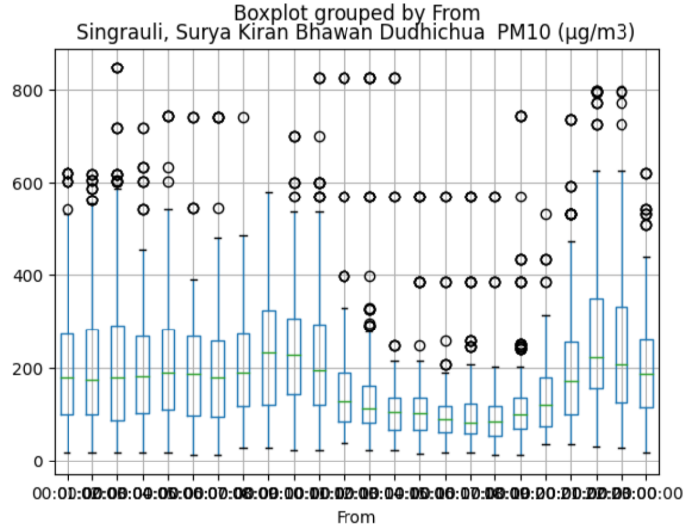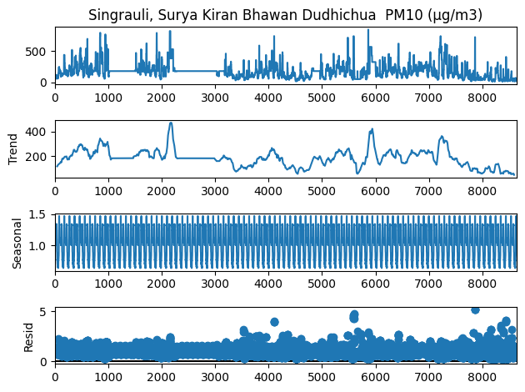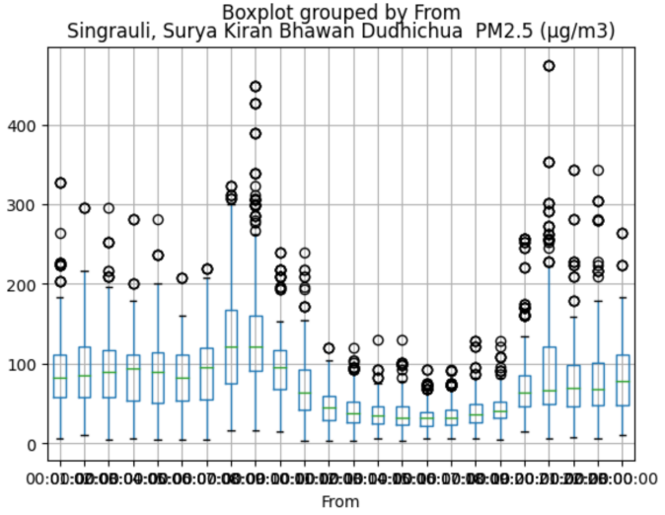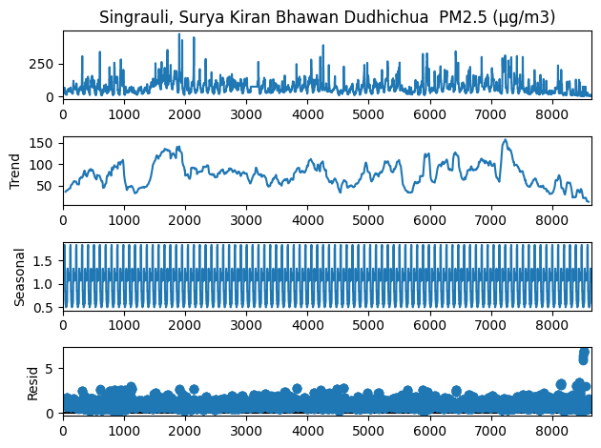

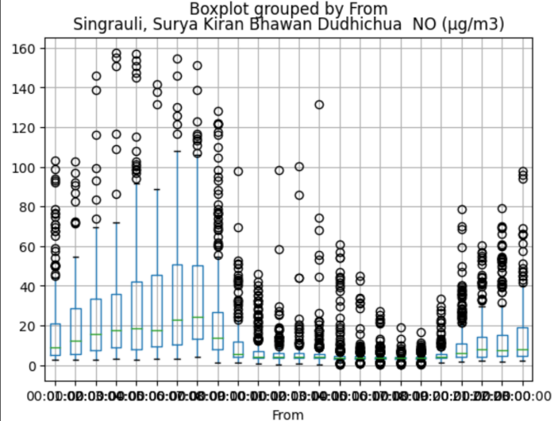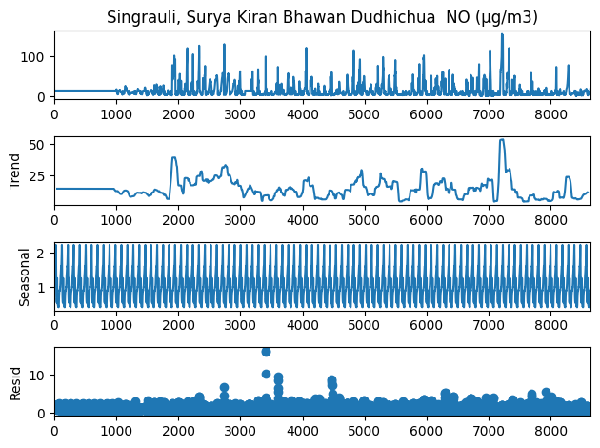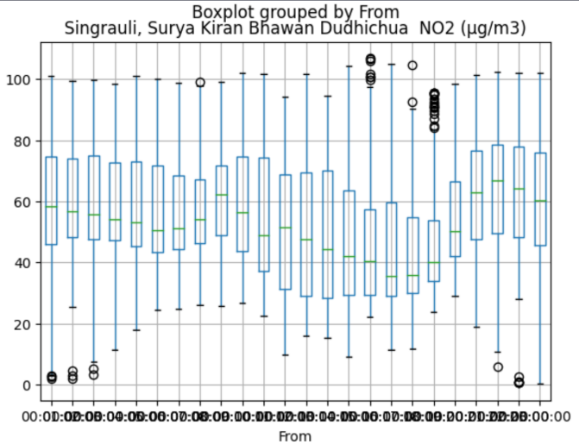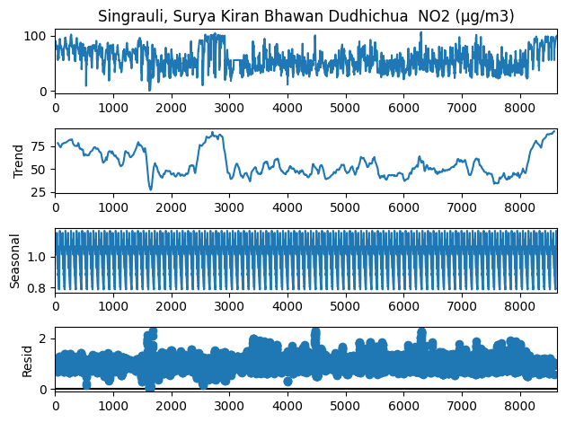

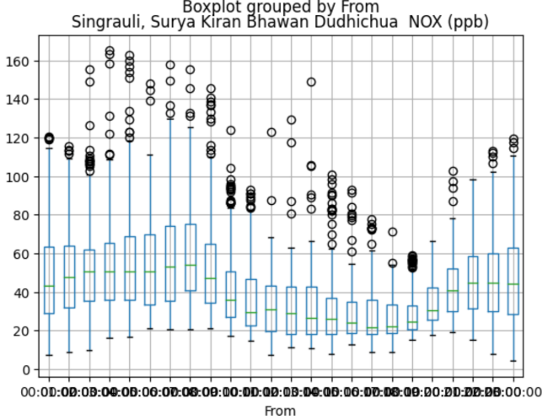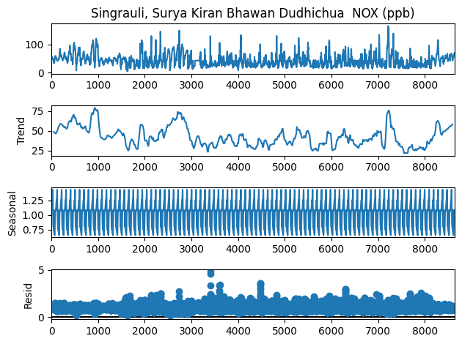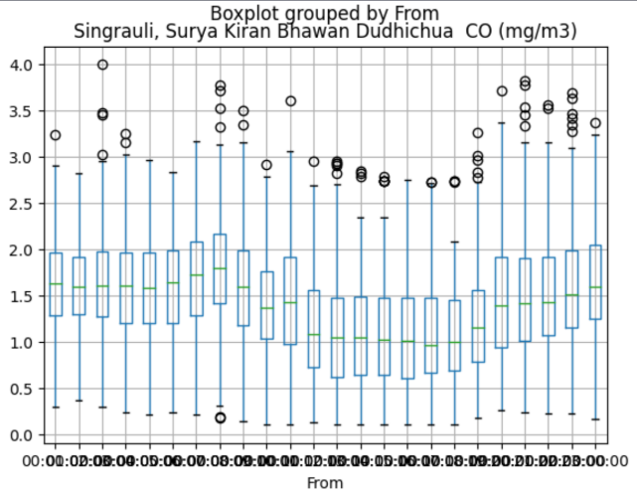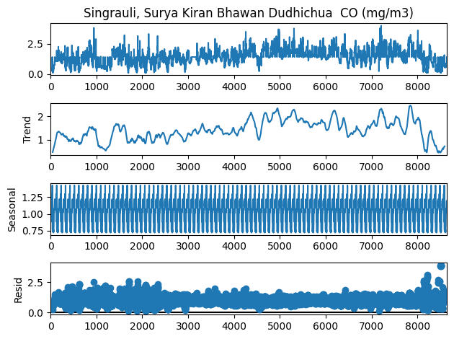

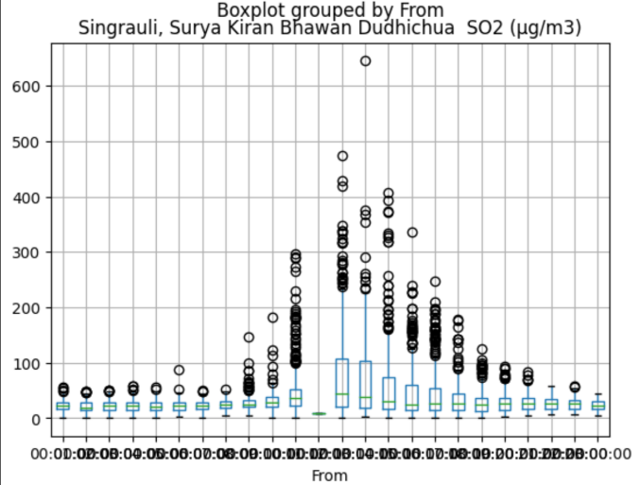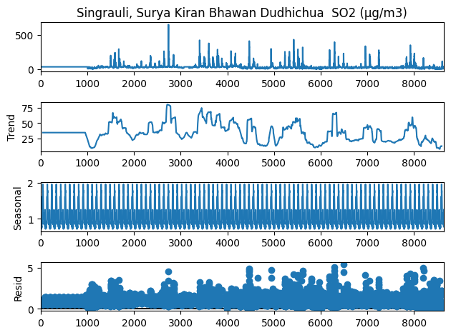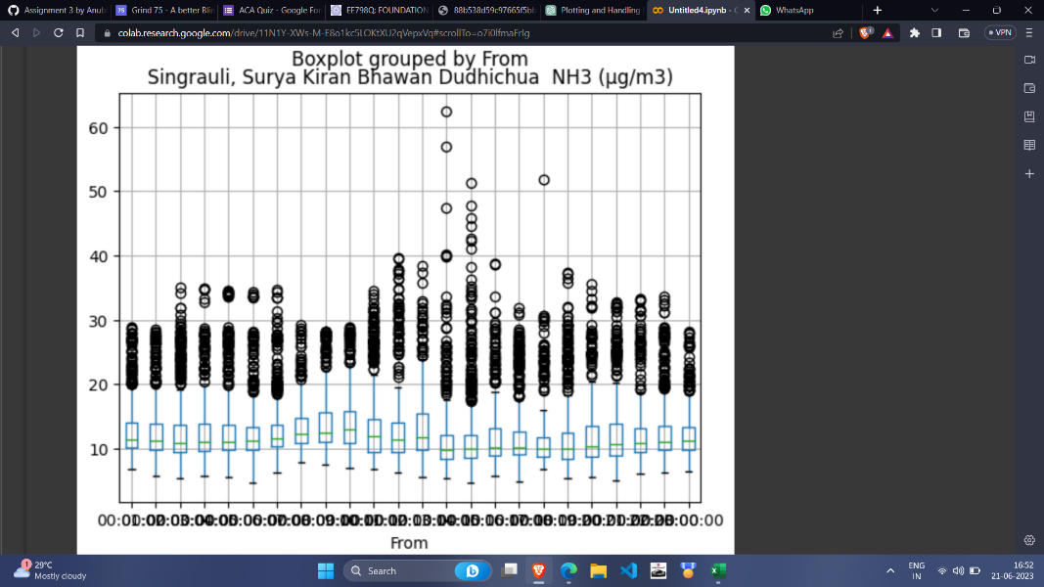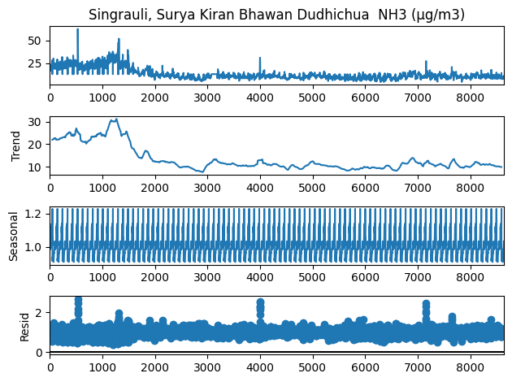

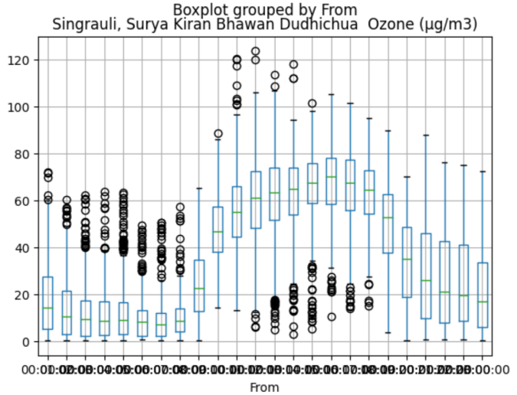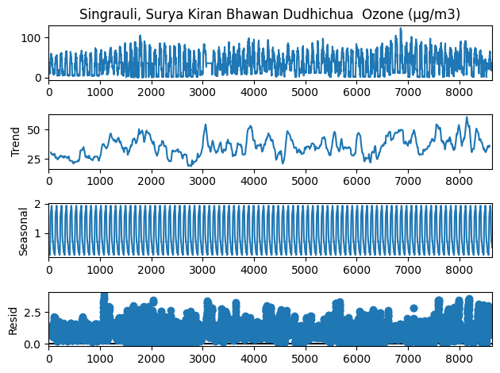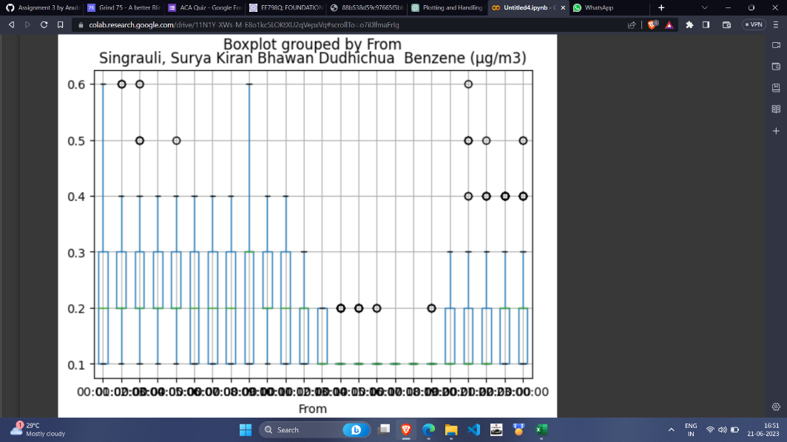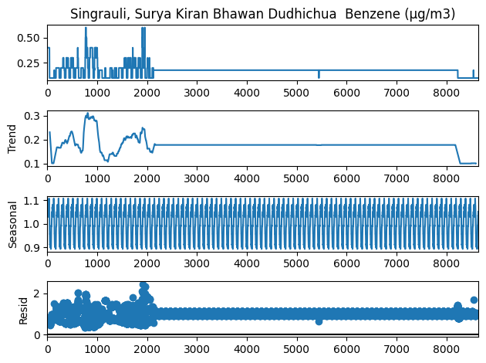

The trend appears to be random but the seasonality graph exhibits certain patterns, which means that the time series exhibit recurring patterns or cycles at regular intervals. While it may be challenging to make long-term predictions based on the random trend, the presence of strong seasonality allows for short-term forecasting. Seasonal patterns provide valuable information for forecasting future values within each seasonal cycle. It is useful to decompose the time series into its individual components, such as trend, seasonality, and residual, to better understand their contributions. The random trend suggests focusing on modeling the seasonality component explicitly.

**ADF Test for all columns:**

**For PM10:**

ADF Test Statistic : -9.171345660019199

p-value : 2.38370370455468e-15

#Lags Used : 36

Number of Observations : 8603

**For PM2.5:**

ADF Test Statistic : -11.367889949056975

p-value : 9.130839033627584e-21

#Lags Used : 36

Number of Observations : 8603

**For NO:**

ADF Test Statistic : -14.930705243413781

p-value : 1.3676912706990601e-27

#Lags Used : 33

Number of Observations : 8606

**For NO2:**

ADF Test Statistic : -9.293483577374921

p-value : 1.1627919469091126e-15

#Lags Used : 22

Number of Observations : 8617

**For NOx:**

ADF Test Statistic : -13.666290645984654

p-value : 1.4885340882694023e-25

#Lags Used : 6

Number of Observations : 8633

**For CO:**

ADF Test Statistic: -10.629880377910965

p-value: 5.247722594941879e-19

#Lags Used: 9

Number of Observations: 8633

**For SO2:**

ADF Test Statistic : -10.603903354574722

p-value : 6.0717675220156405e-19

#Lags Used : 9

Number of Observations : 8630

**For NH3:**

ADF Test Statistic : -18.460626131210866

p-value : 2.14701657430078e-30

#Lags Used : 5

Number of Observations : 8634

**For Ozone:**

ADF Test Statistic : -2.935049332384365

p-value : 0.04142141867412076

#Lags Used : 30

Number of Observations : 8609

**For Benzene:**

ADF Test Statistic : -11.67670055466348

p-value : 1.781078463128166e-21

#Lags Used : 37

Number of Observations : 8602

These box plots are made from the raw data without changing anything. We are told that the time of pit blasting time is around 13:45 to 14:45, this means that all the readings for all the pollutants should increase during that time but from the above graphs it is observed that for some pollutants the readings are decreasing at that time this is because we dropped all the NA values during plotting all these graphs. Also, during plotting the linear time series or the multivariate ones we observe large gaps wherever NA values are encountered. Thus, taking NA values to be zero or neglecting them changes the box plot a lot as it shrinks the box and mean also drops as quite easily observed in the graph of Benzene concentration vs Time.

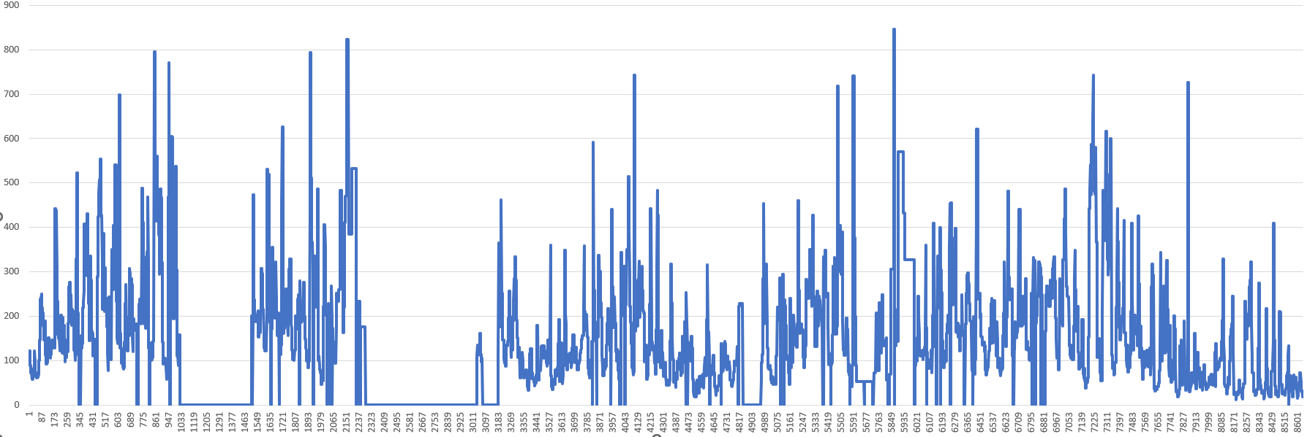

Linear Time Series graph for PM10 (while considering NA values to be zero)

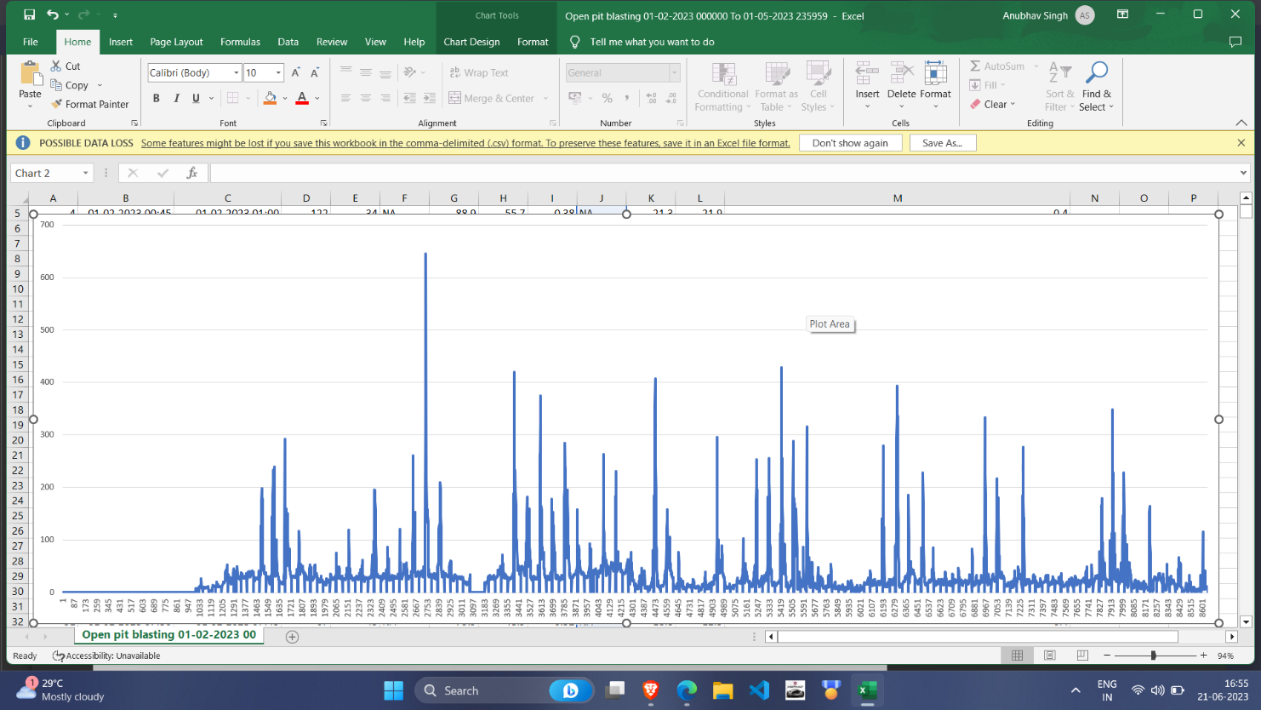

Linear Time Series graph for SO2 (while considering NA values to be zero)

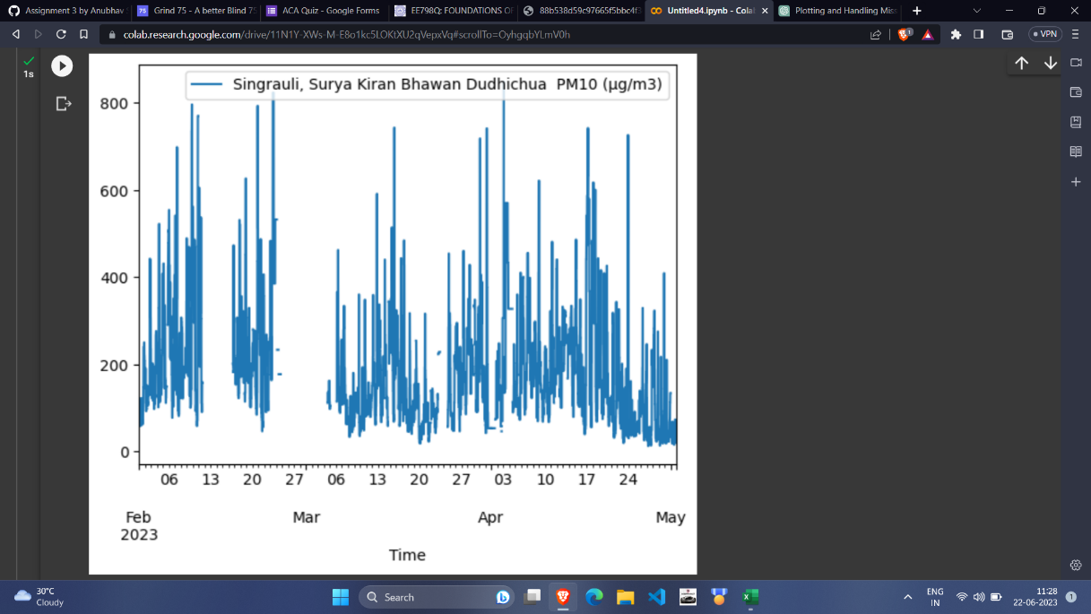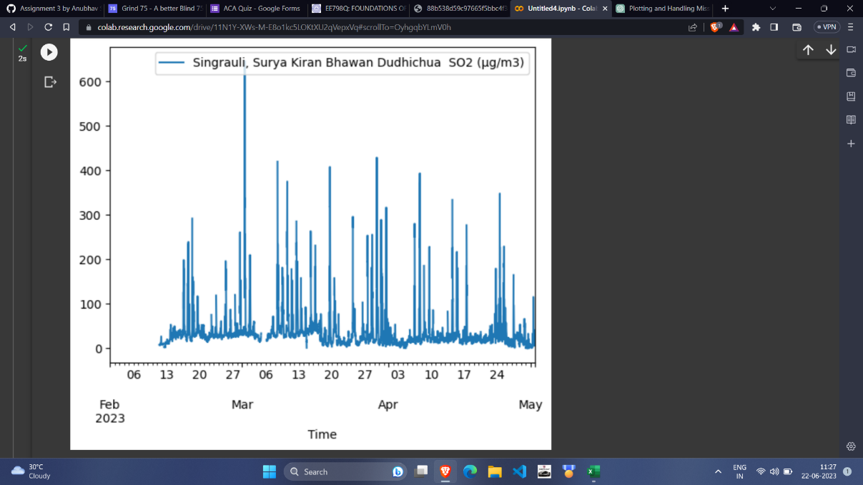

There are various strategies which can be used to replace all the missing values. Some of them are:

1. Replace with mean: We can replace all the NA values with mean of all the non-NA values of the columns. But given the dataset neither we observe much change nor we get desired results by using this practice. Also, for linear time series plot all the gaps left due to NA values are just filled by a straight line of value equal to their mean.

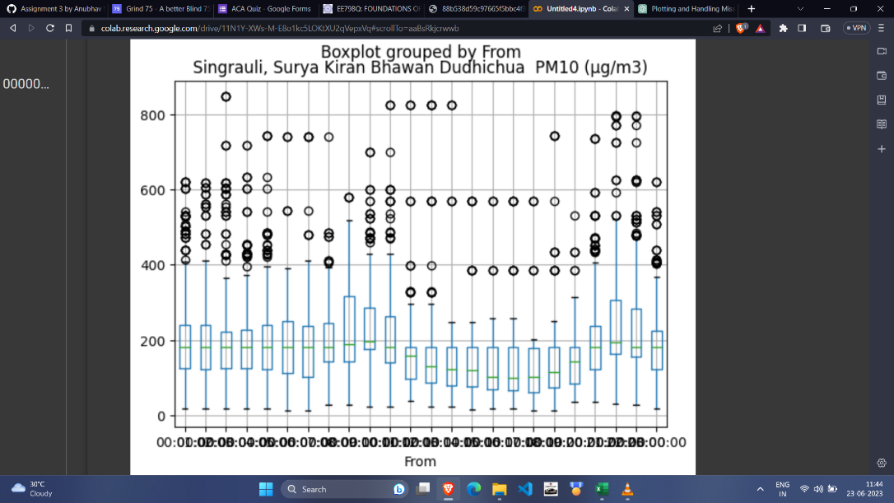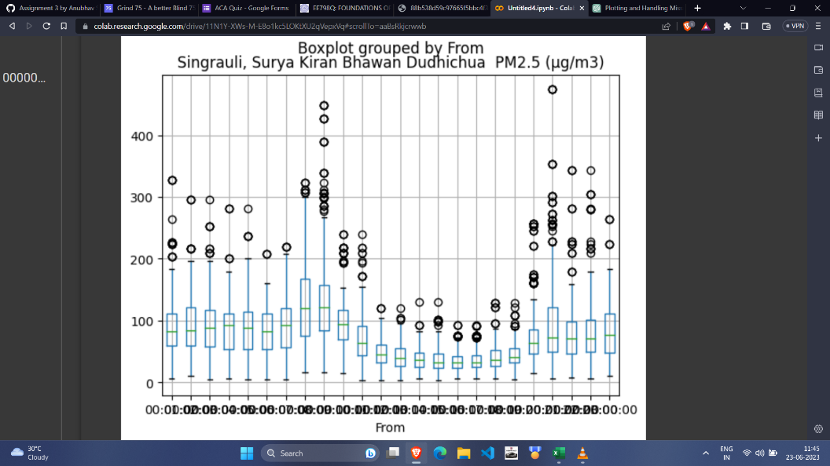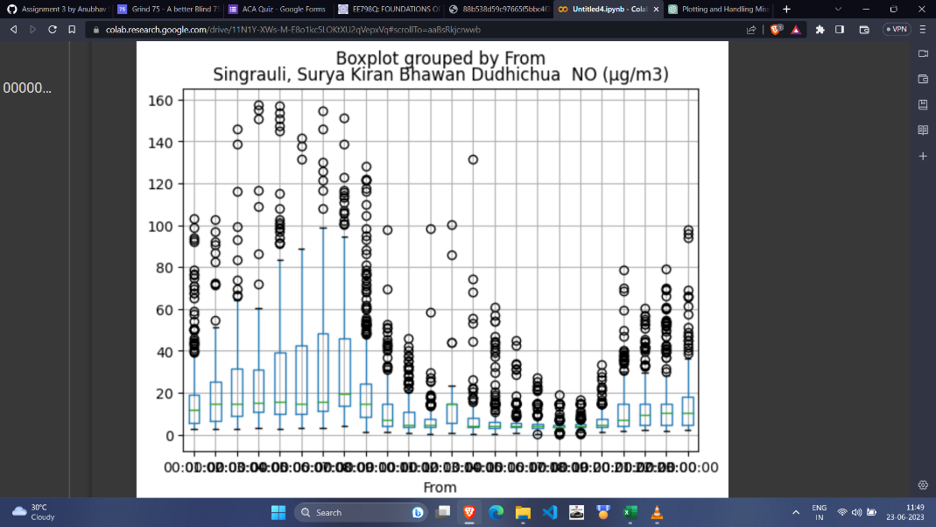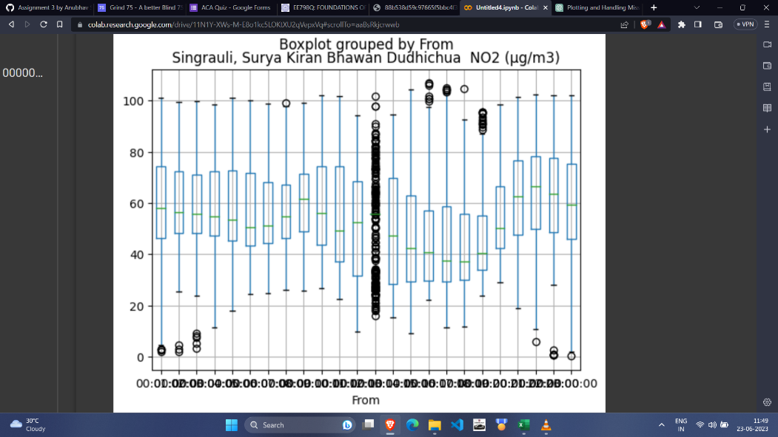

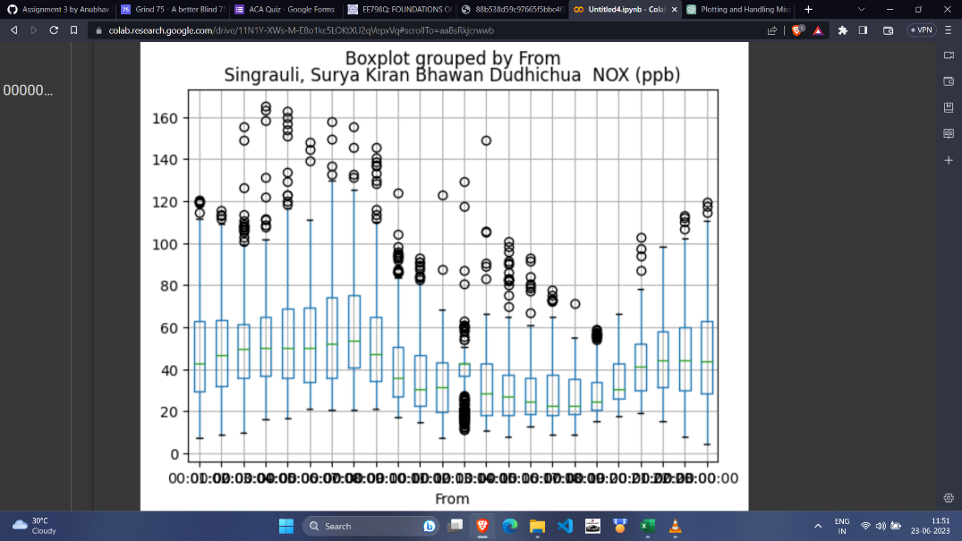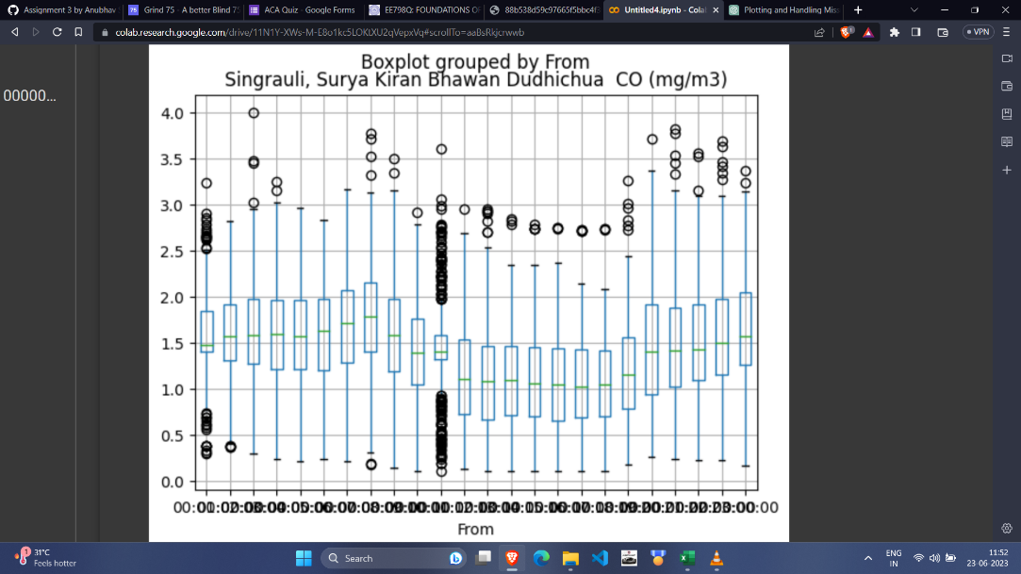

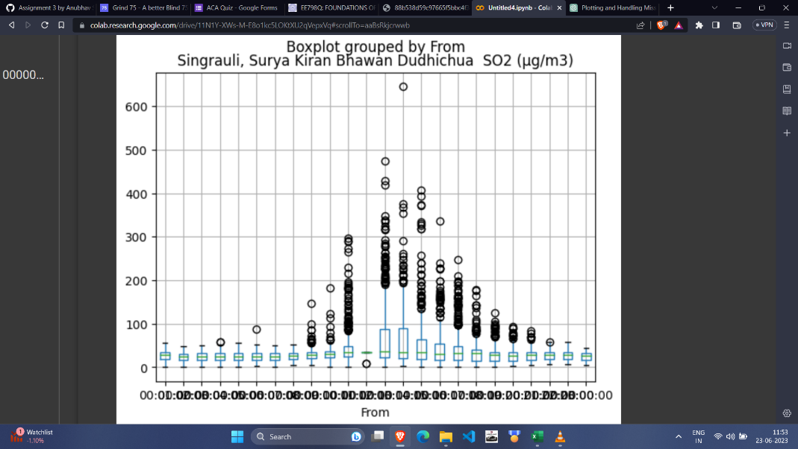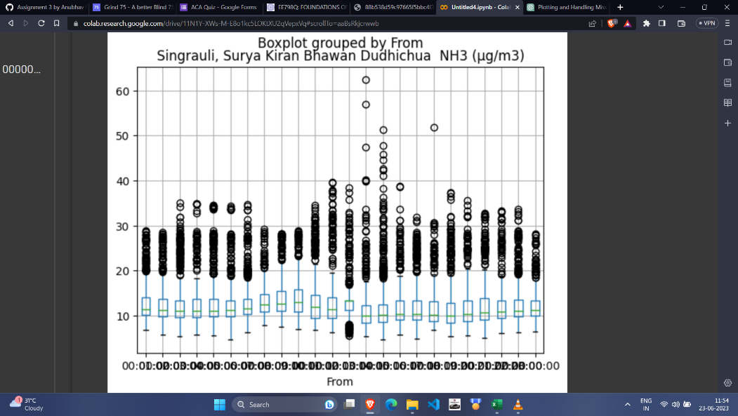

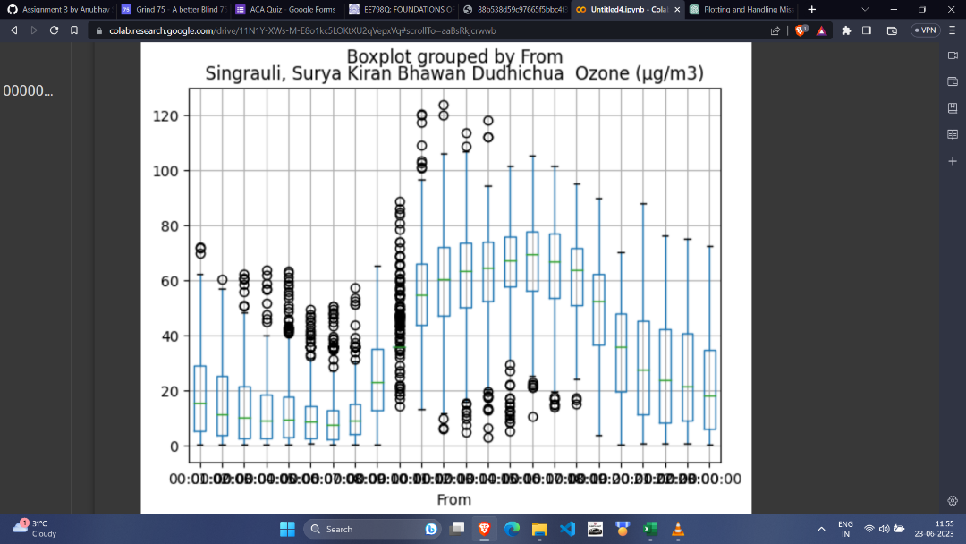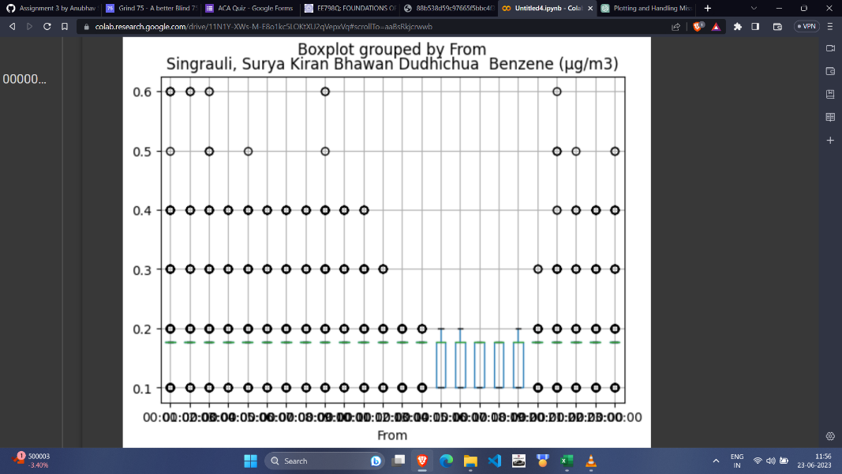

1. Replace with median or mode: This can also be a method but it didn’t for this dataset.
2. Regression imputation: Using regression models to predict missing values based on other variables in the dataset. But we can’t use it here since for this method we need to use other variables too but data is missing in all the columns and if we drop all the rows with missing values most of the data will be lost. Although this method can be applied with a modification where we can replace the missing values with their mean but this will also not work since this will again give the wrong values in the regression equation as mean is not the correct value to be trained from.
3. Filling missing values using back fill or forward fill: We try to fill the missing values with the last known observation or the observation to be known here.

Training the ARMA/ARIMA model: For the given dataset we try to train a per column ARMA/ARIMA model for some of the given column and to check the optimized value of p, d and q, we will use Akaike’s Information Criterion (AIC).

* Singrauli, Surya Kiran Bhawan Dudhichua PM10 (µg/m3):

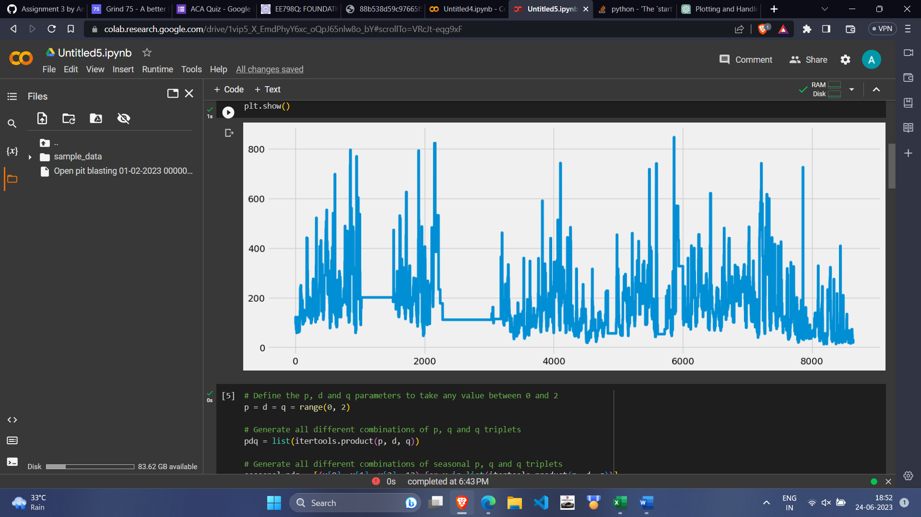

From all the AIC values, we get the most optimised model of ARIMA (1,1,1) and seasonal order (1,0,1,12). Thus, on training for that we get:

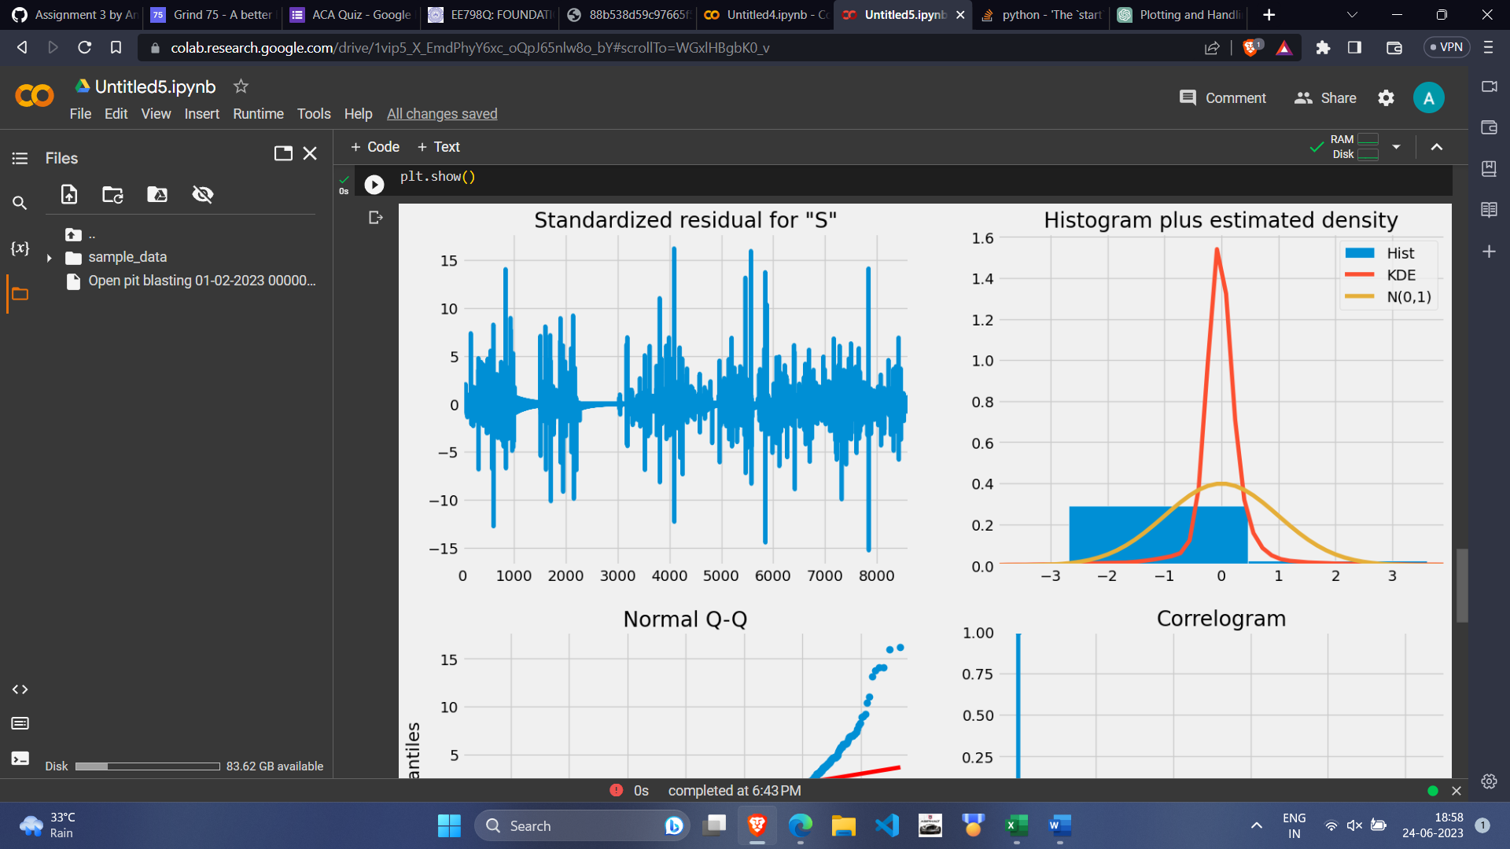

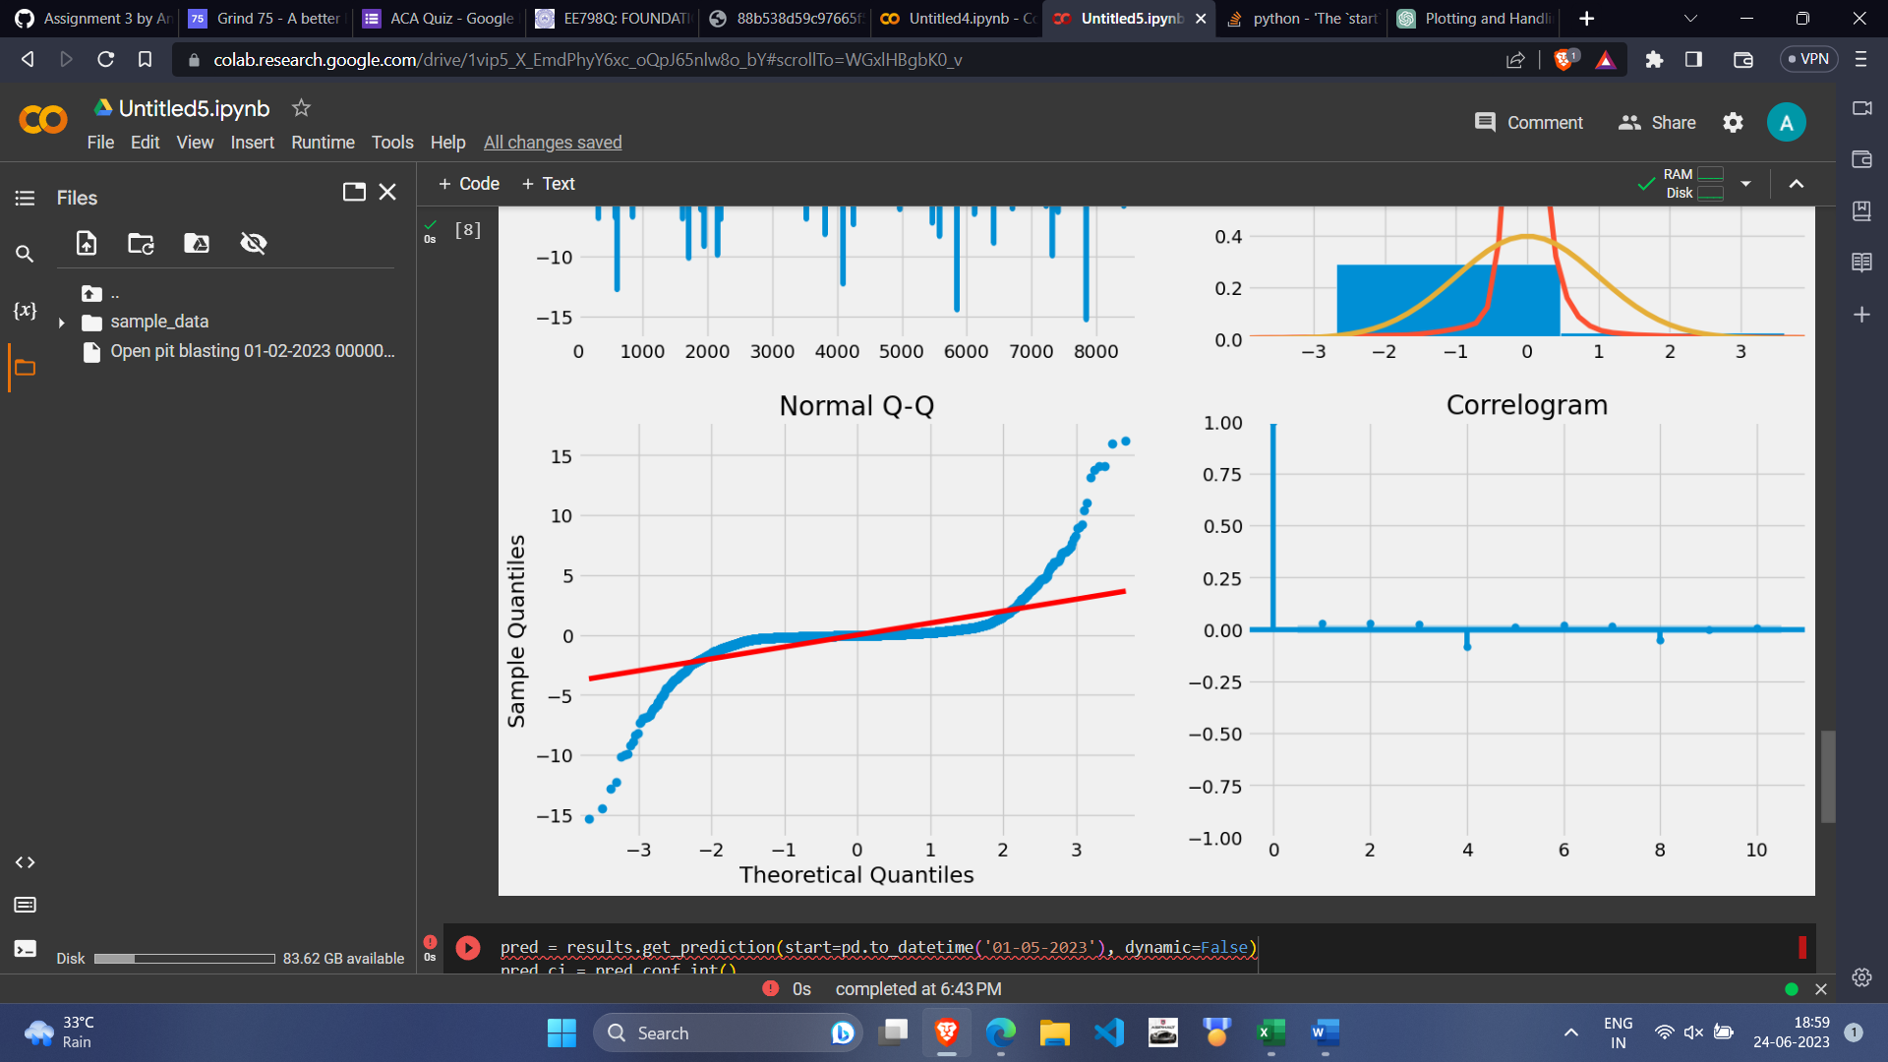

Thus, from the normal QQ Plot we observe that it does not follow a normal distribution and the values are not that much dependent on their previous values.

* Singrauli, Surya Kiran Bhawan Dudhichua SO2 (µg/m3):

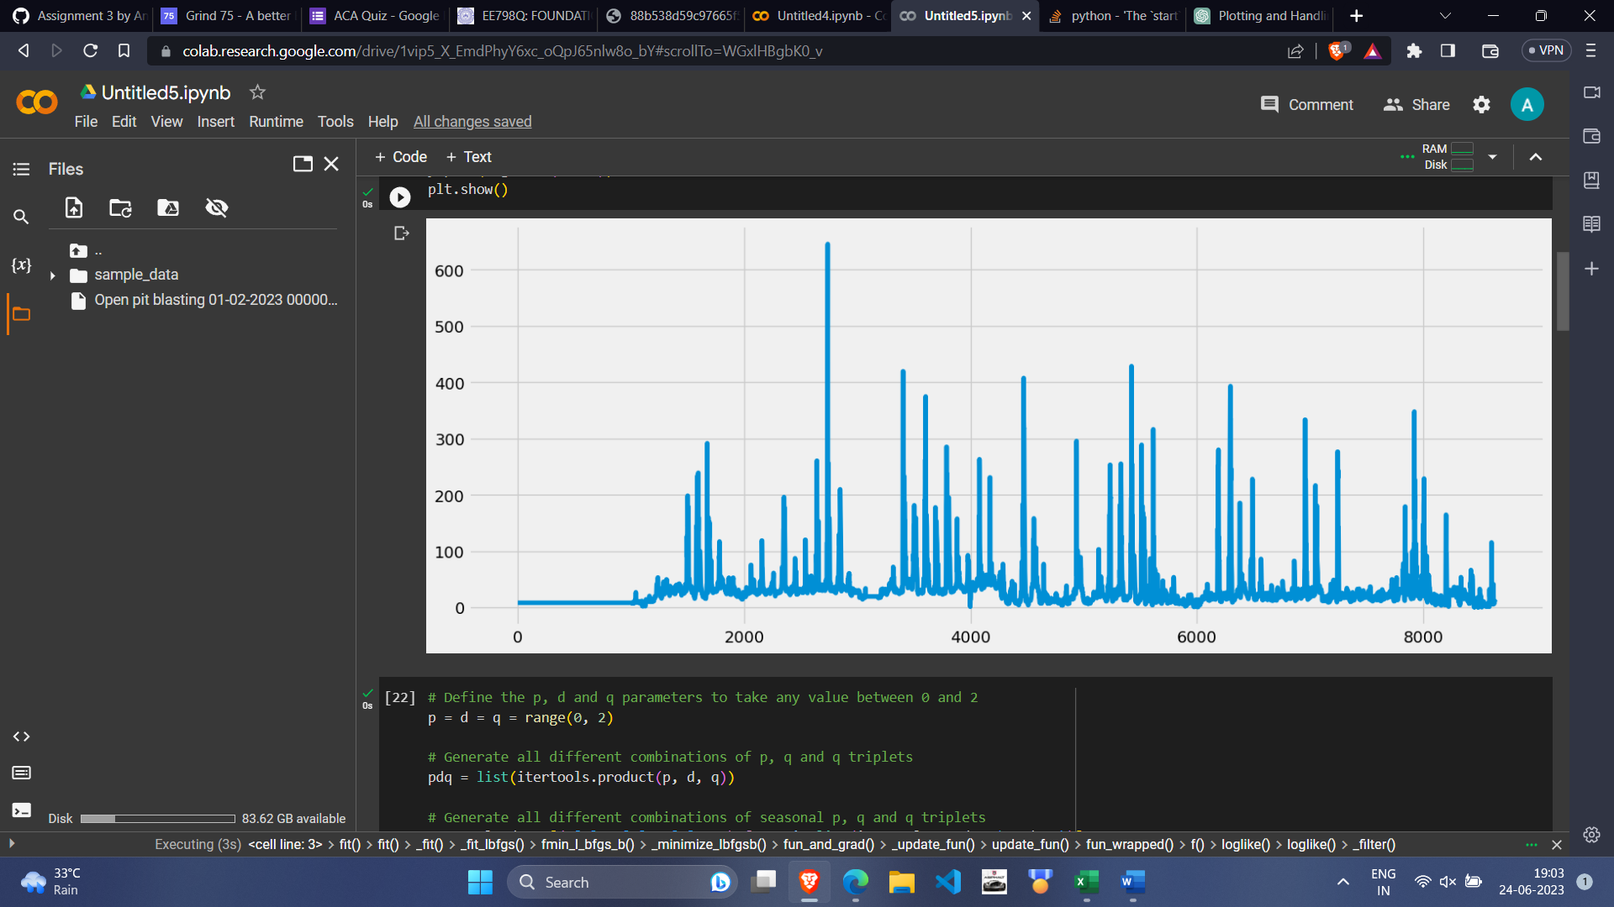

From all the AIC values, we get the most optimised model of ARIMA (1,0,1) and seasonal order (0,1,1,12). Thus, on training for that we get:

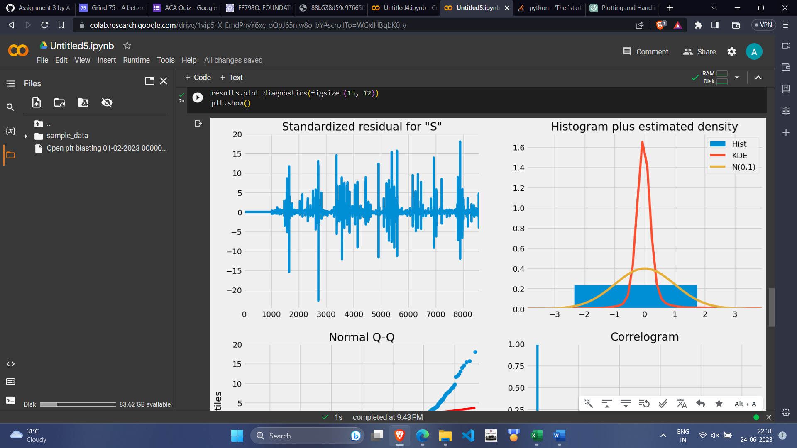

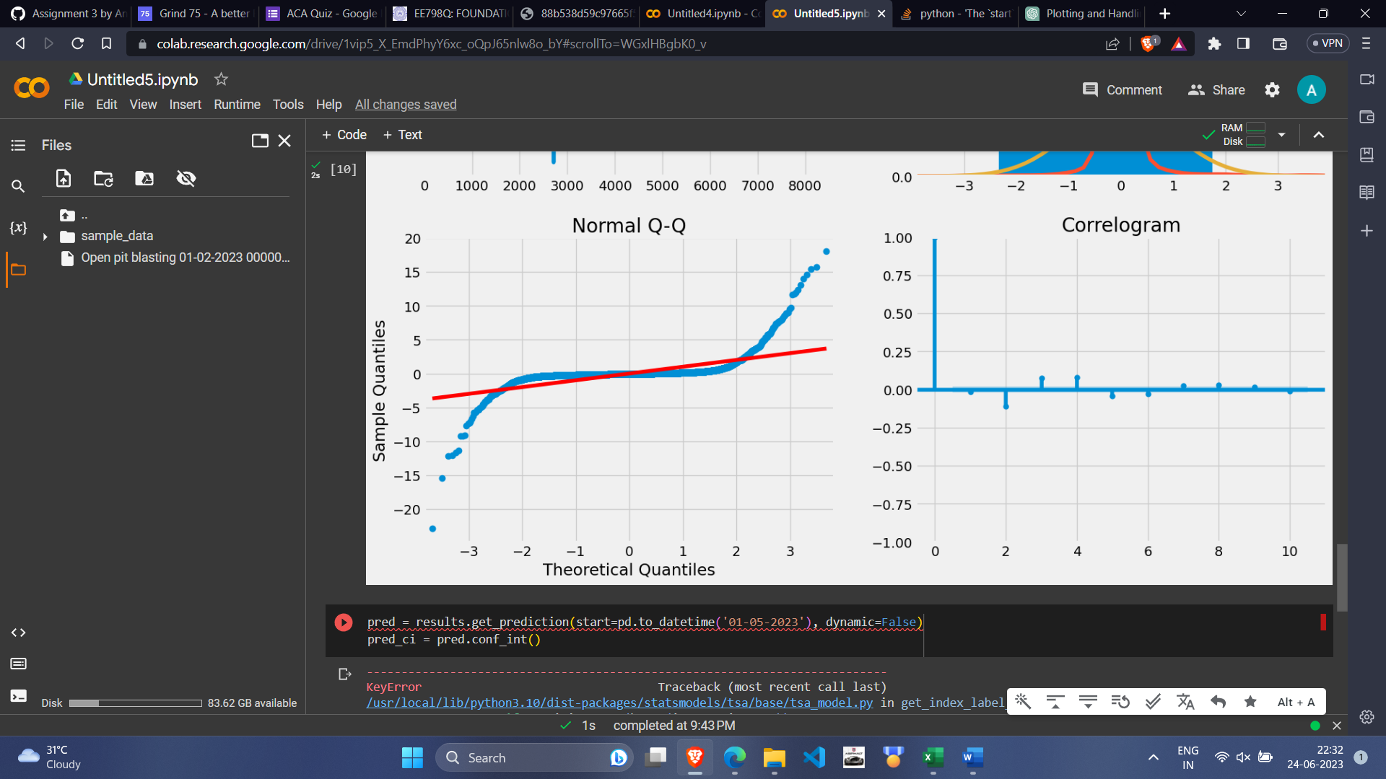

Thus, from the normal QQ Plot we observe that it does not follow a normal distribution and the values are not that much dependent on their previous values.

* Singrauli, Surya Kiran Bhawan Dudhichua Benzene (µg/m3):

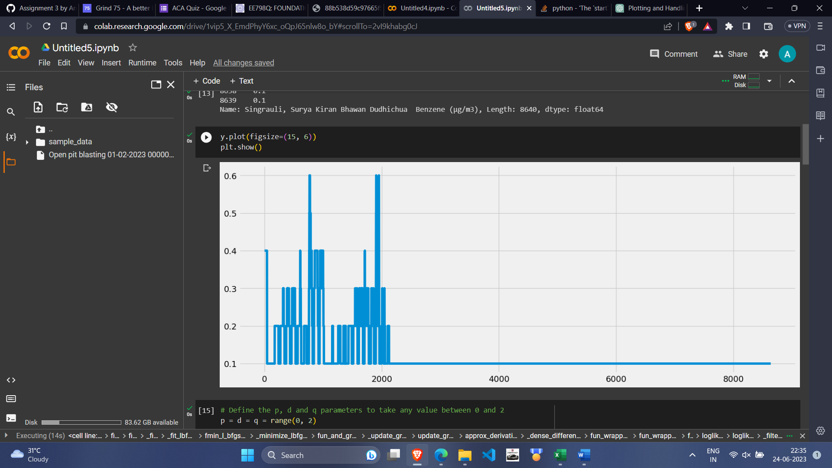

From all the AIC values and we get the most optimised model of ARIMA (1,0,1) and seasonal order (0,1,1,12). Thus, on training for that we get:

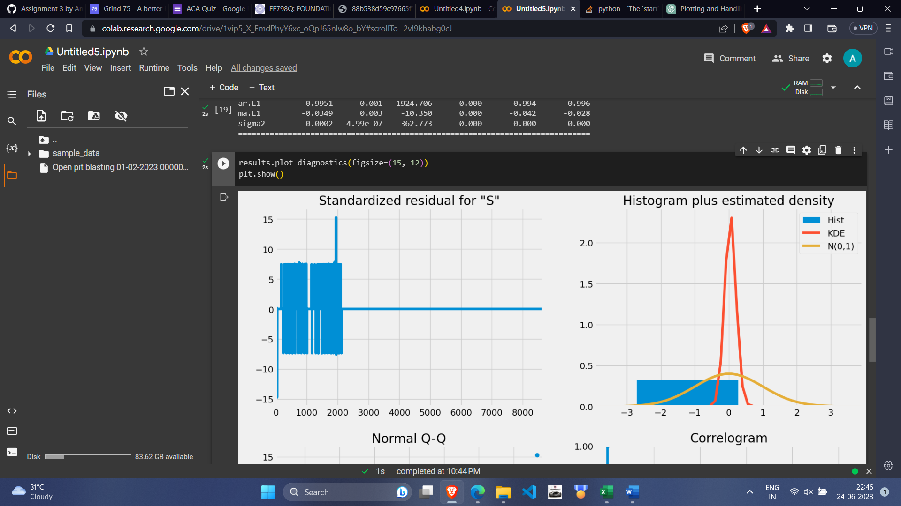

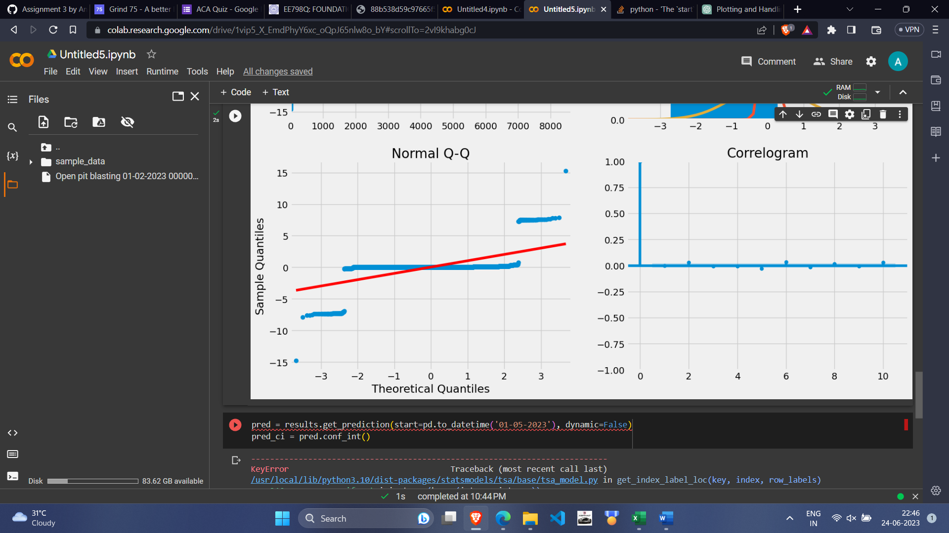

Thus, from the normal QQ Plot we observe that it does not follow a normal distribution and the values are not that much dependent on their previous values.

Training ARMA/ARIMA with Different interpolation methods

* Using Linear Interpolation:

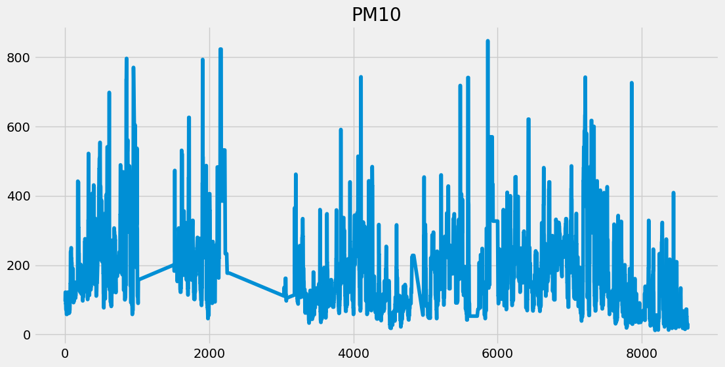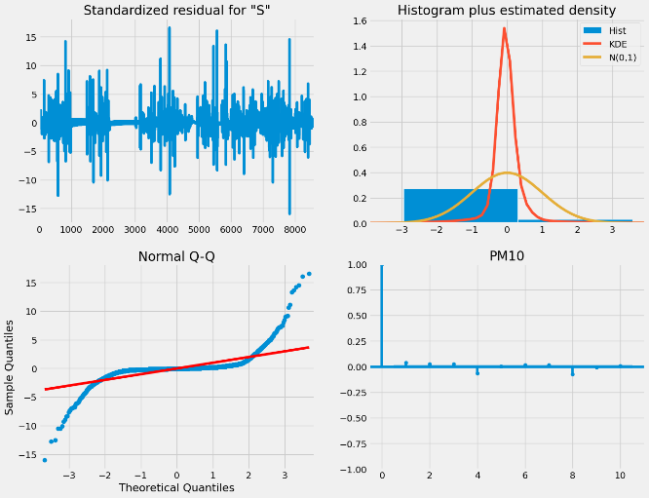

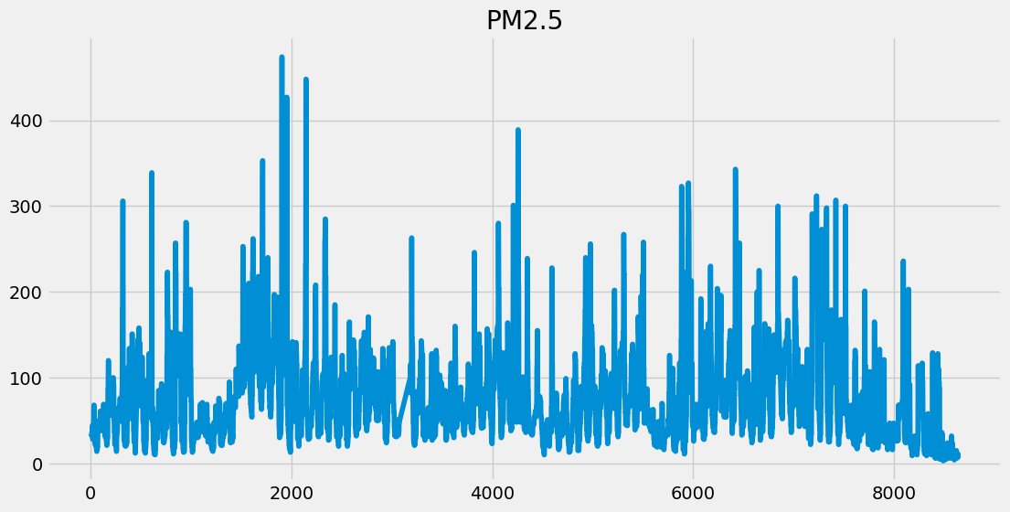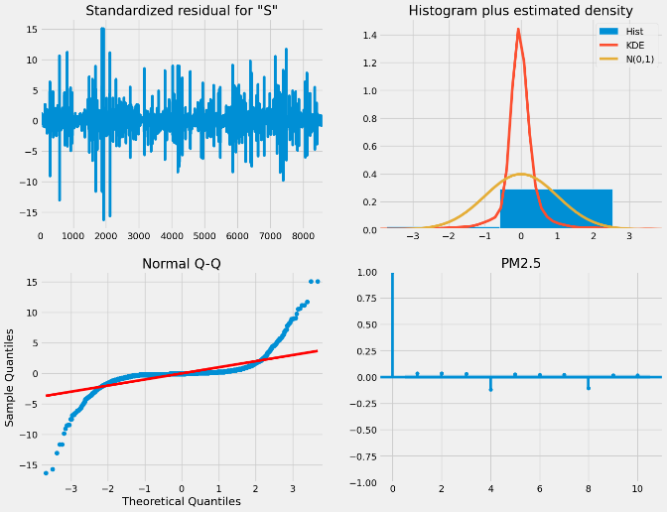

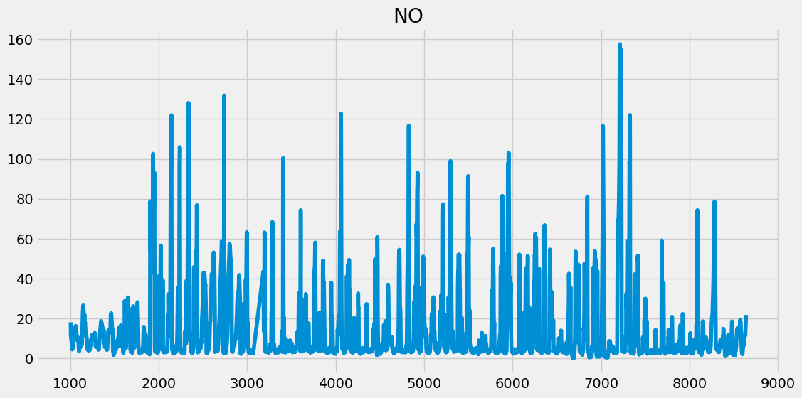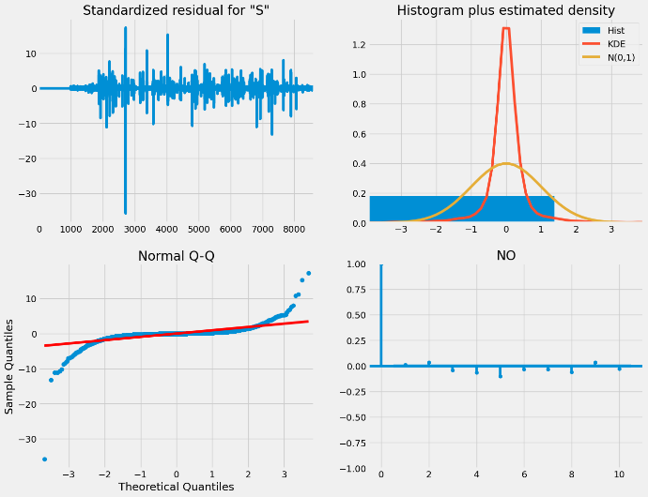

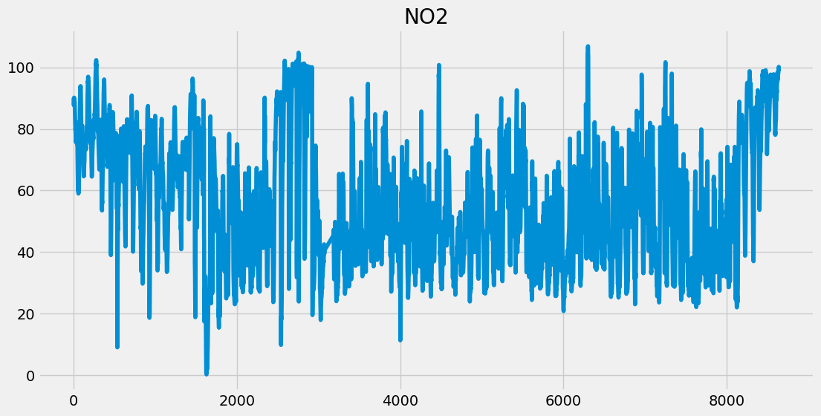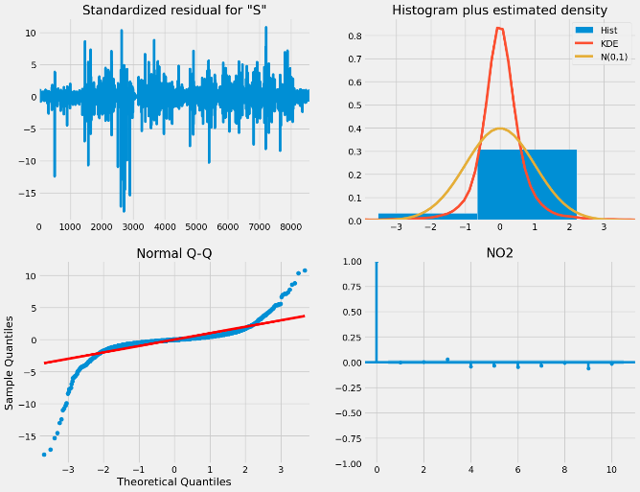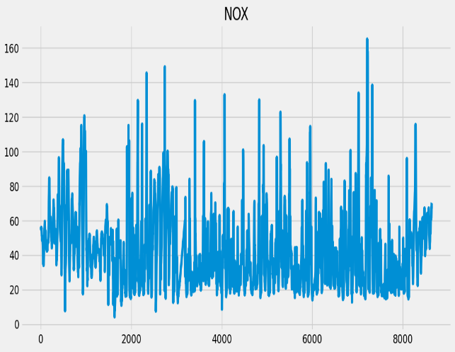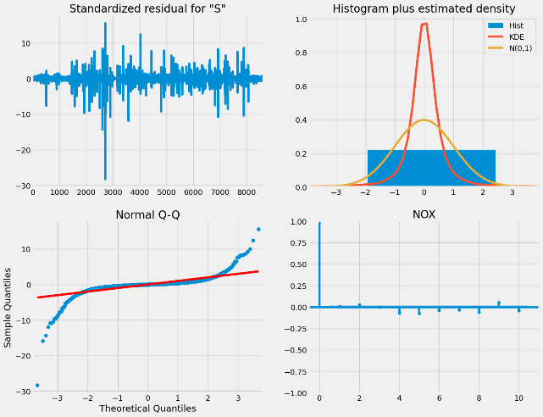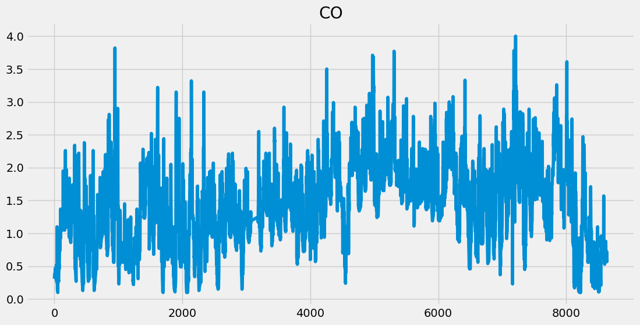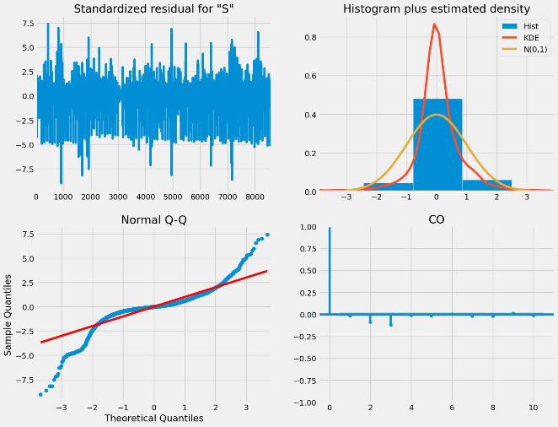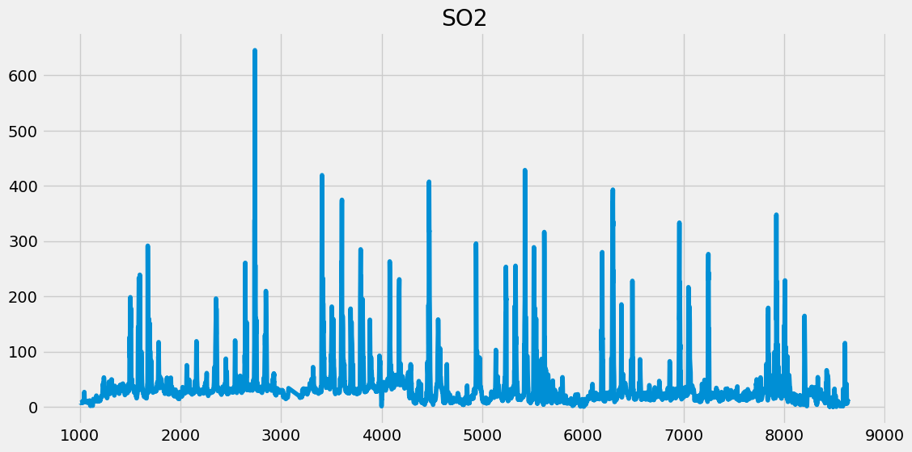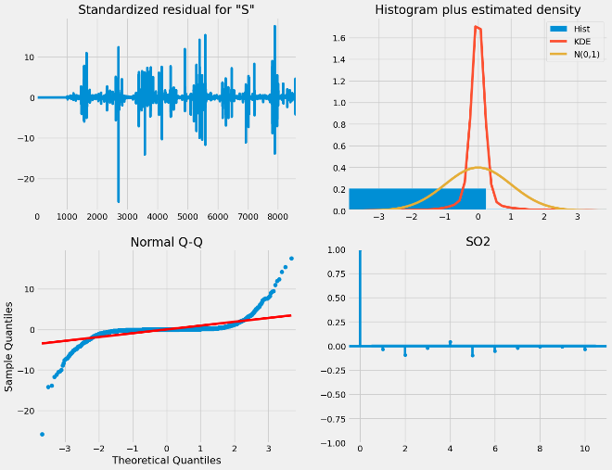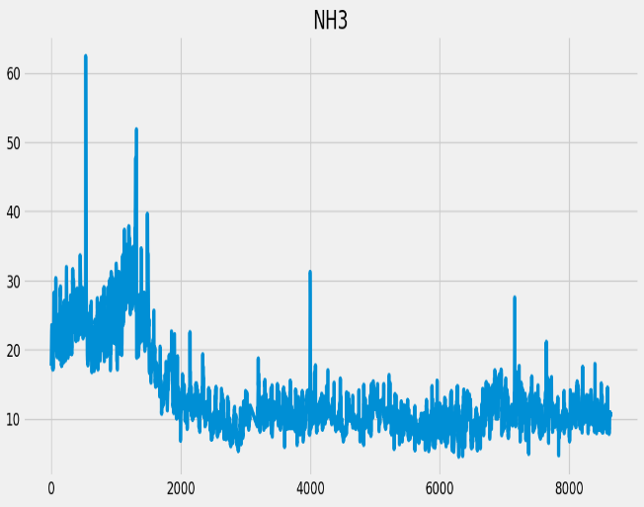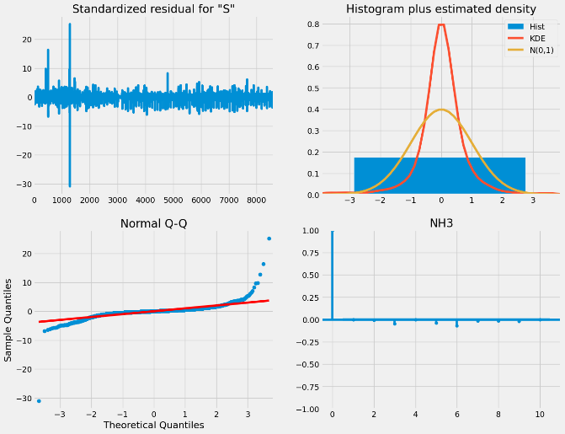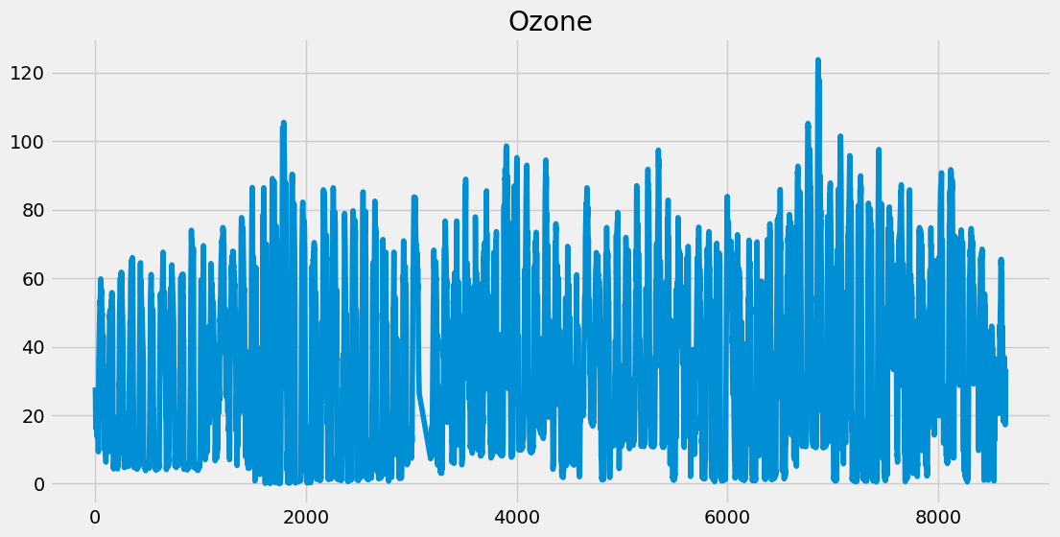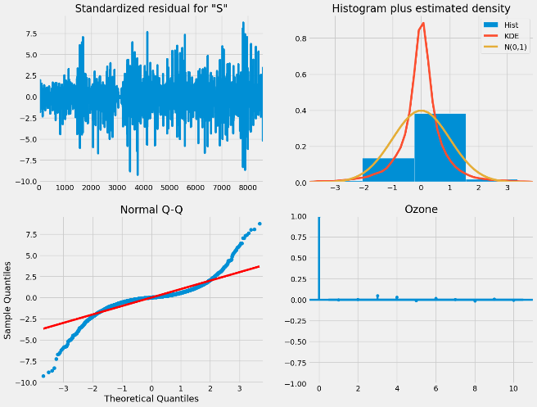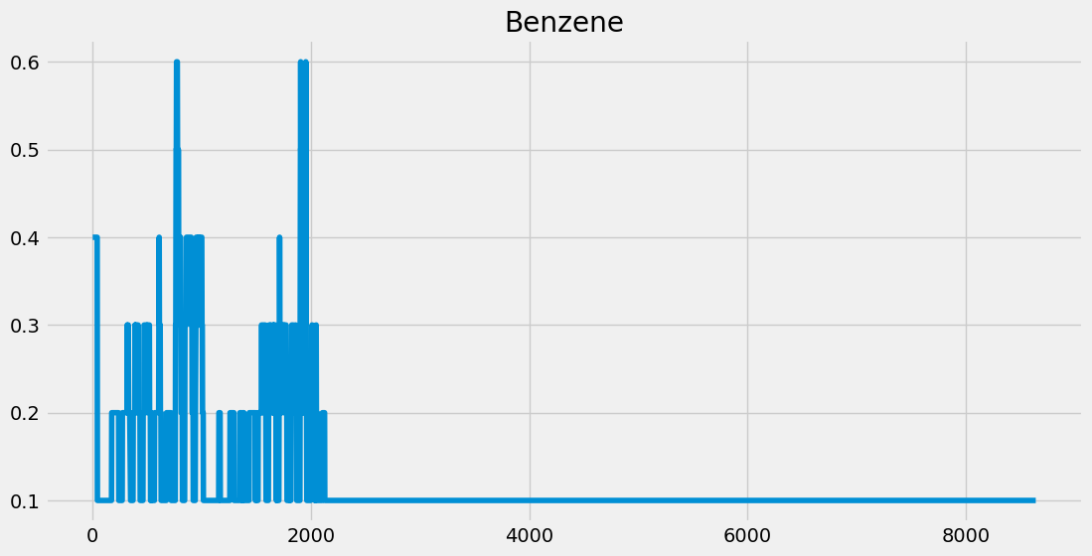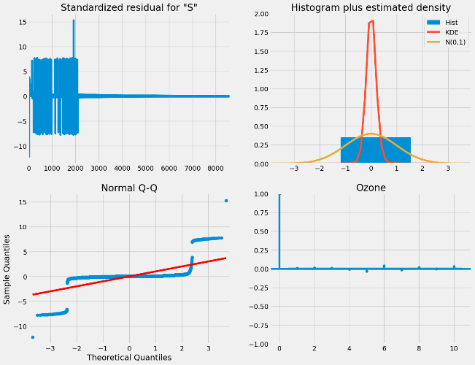

* Using Cubical Interpolation:

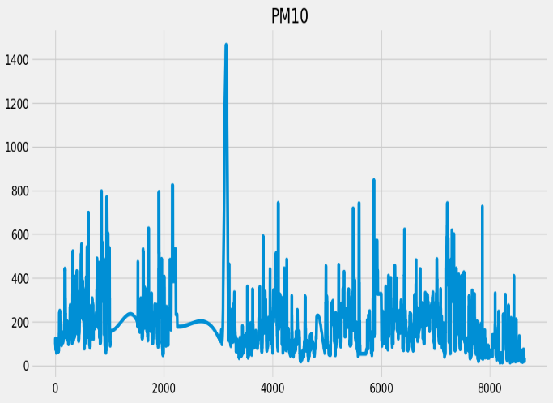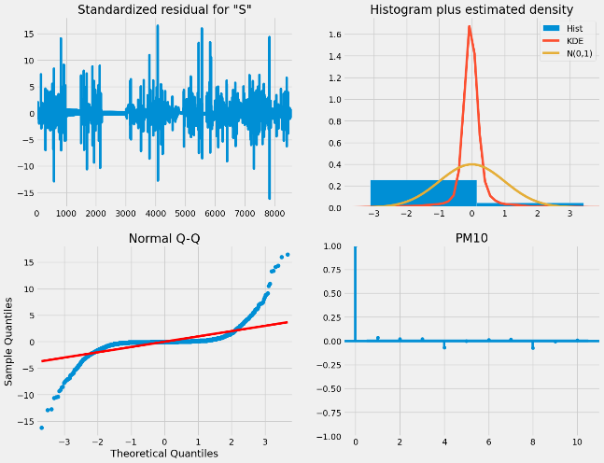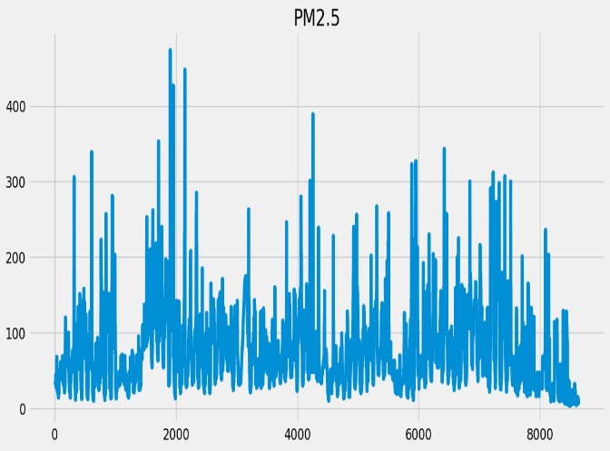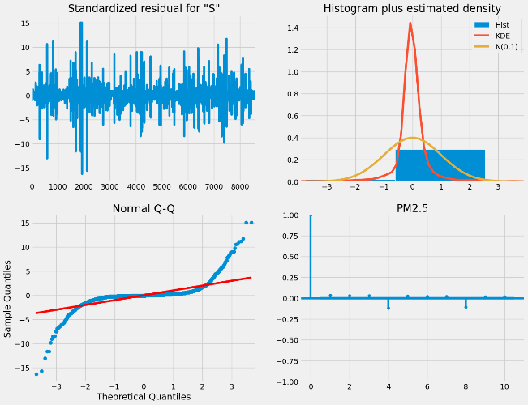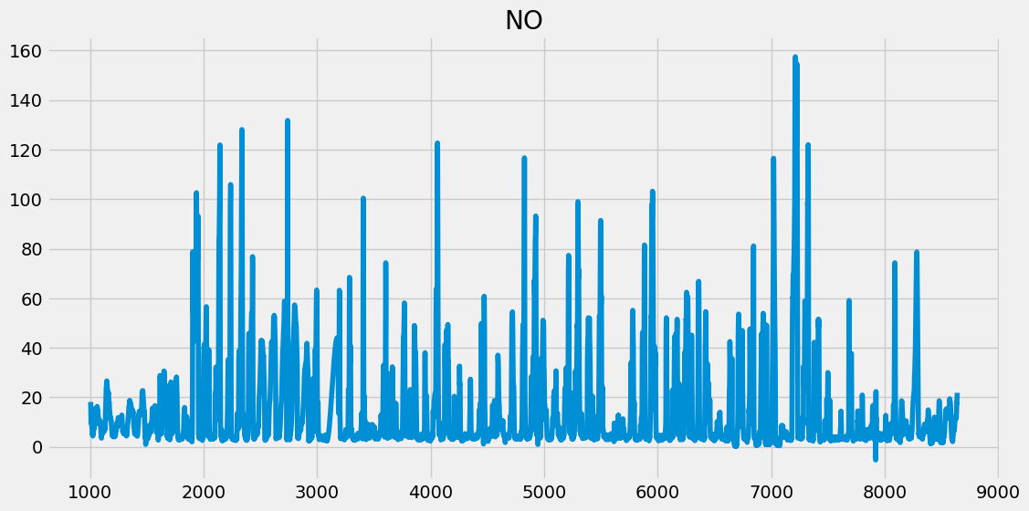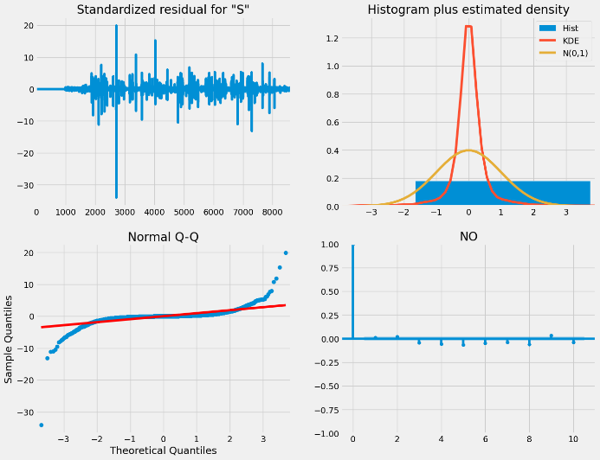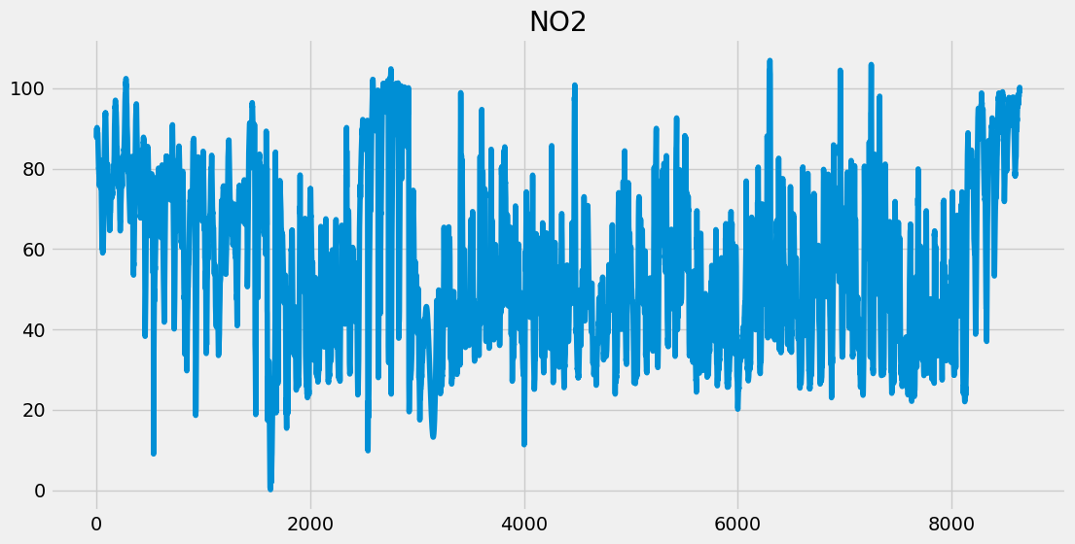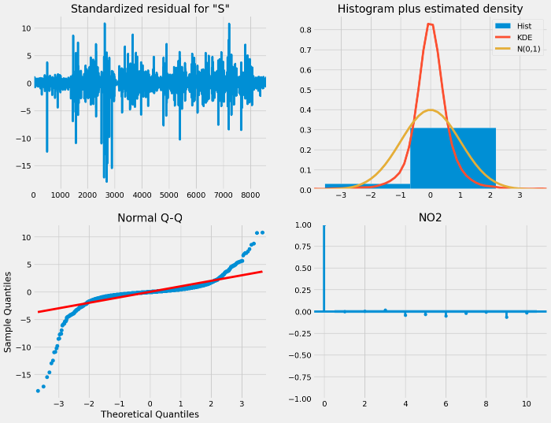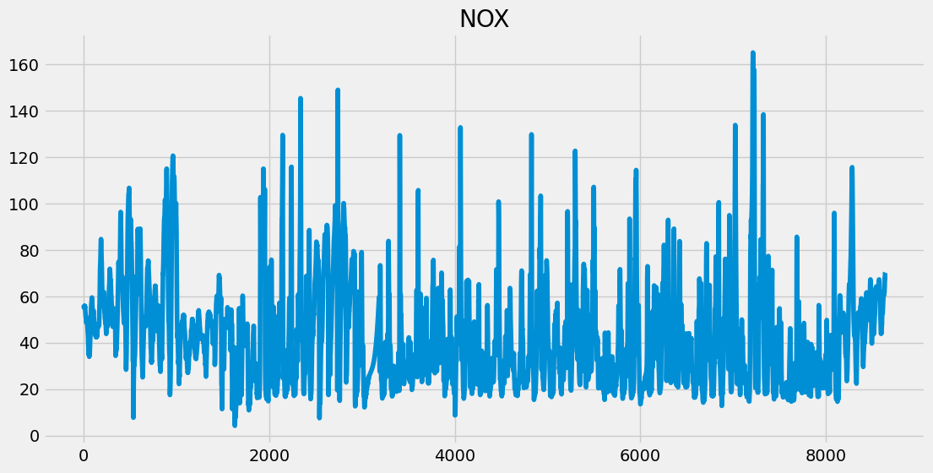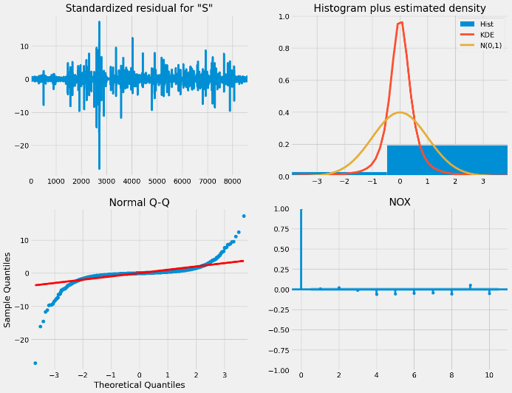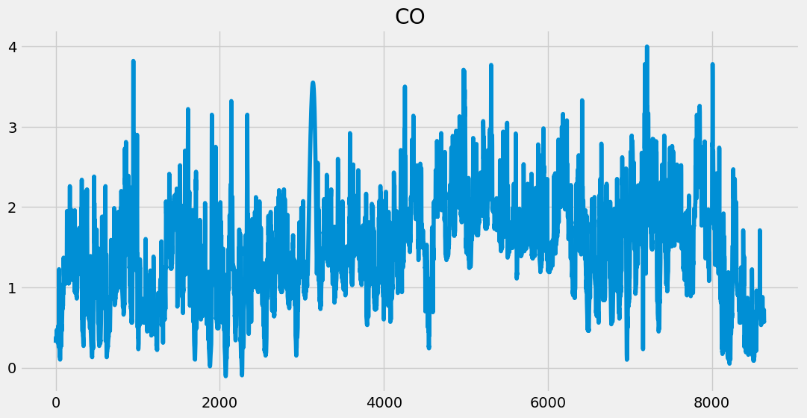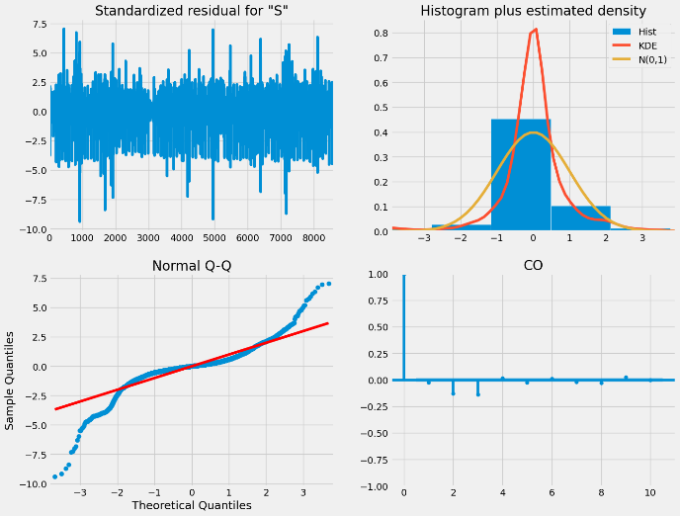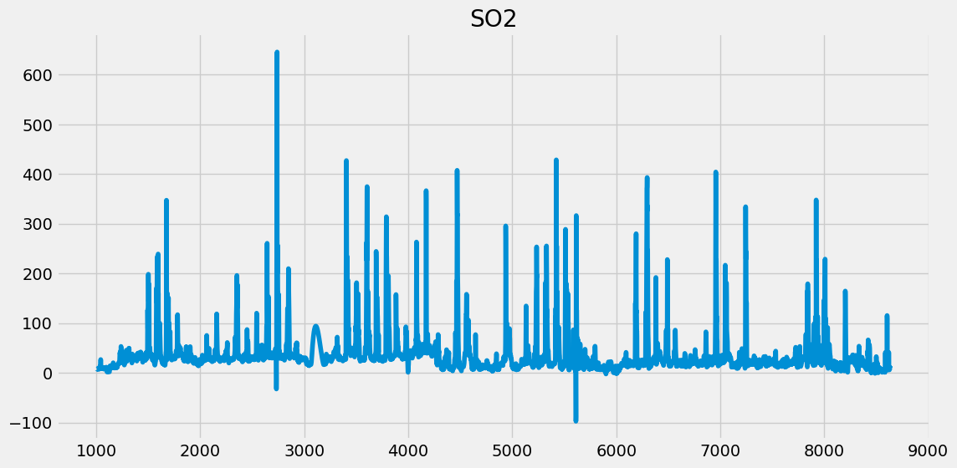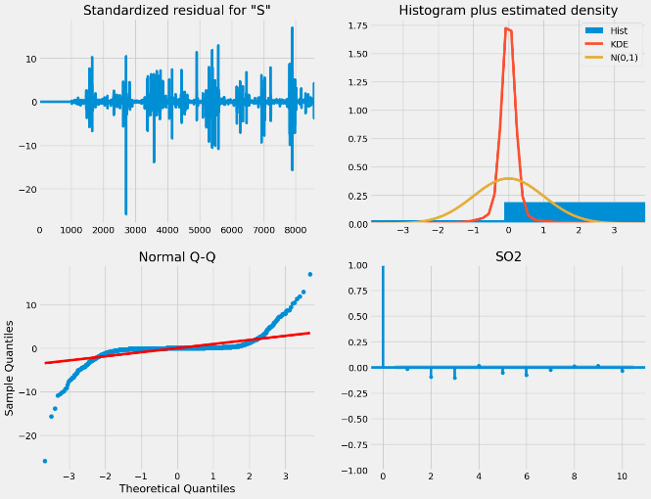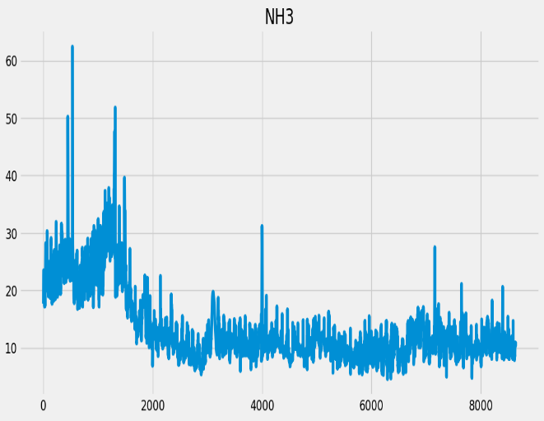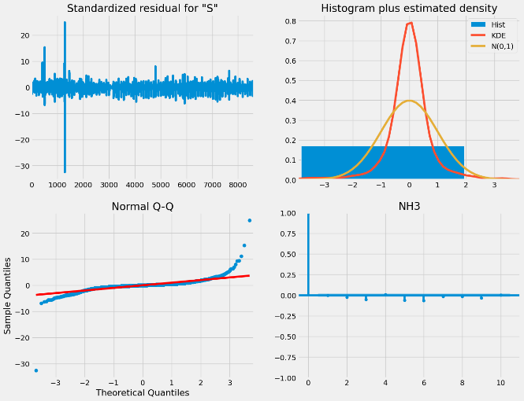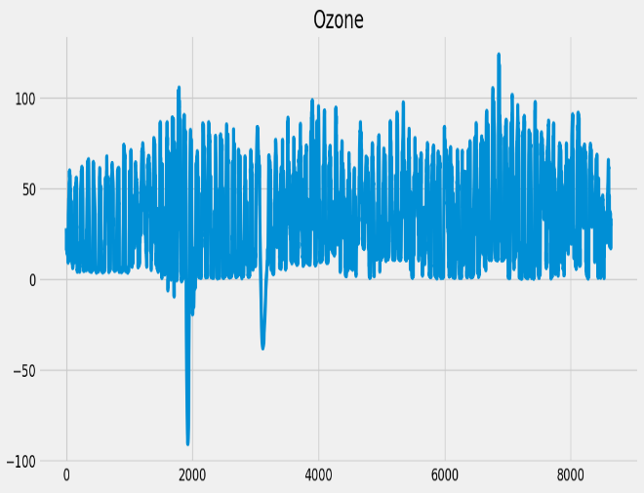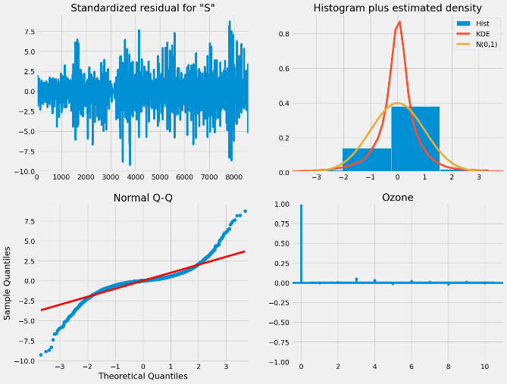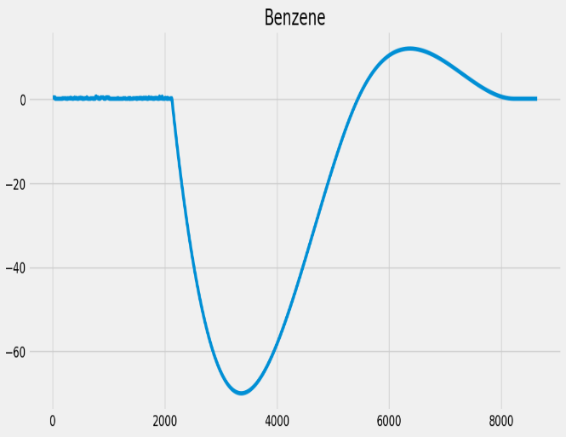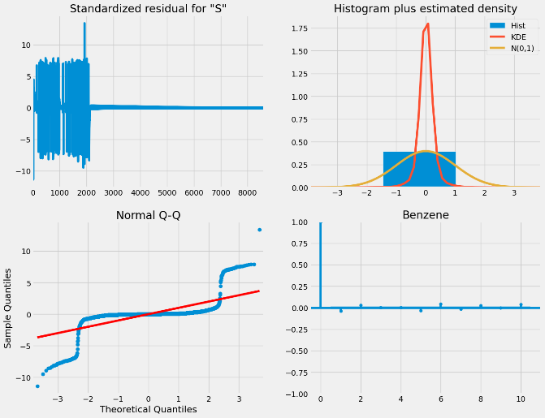

* Using Spline Interpolation:

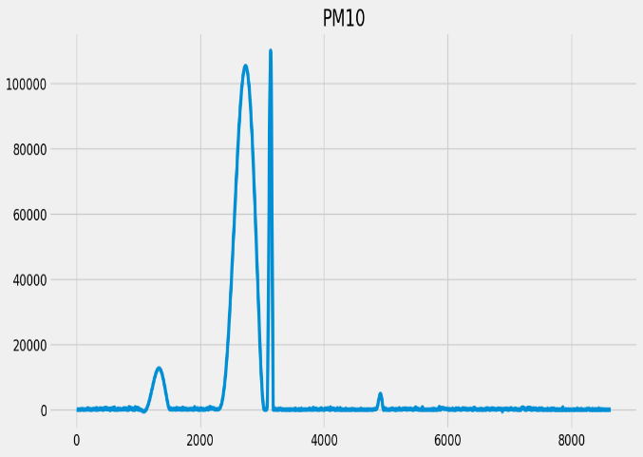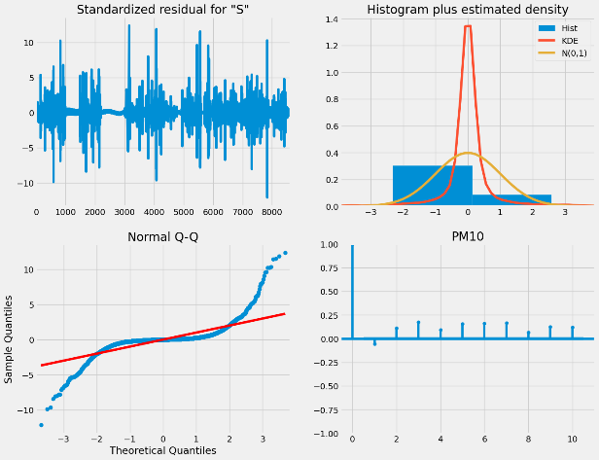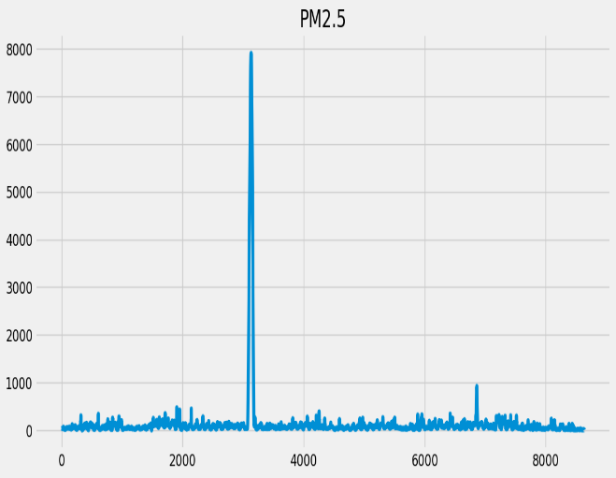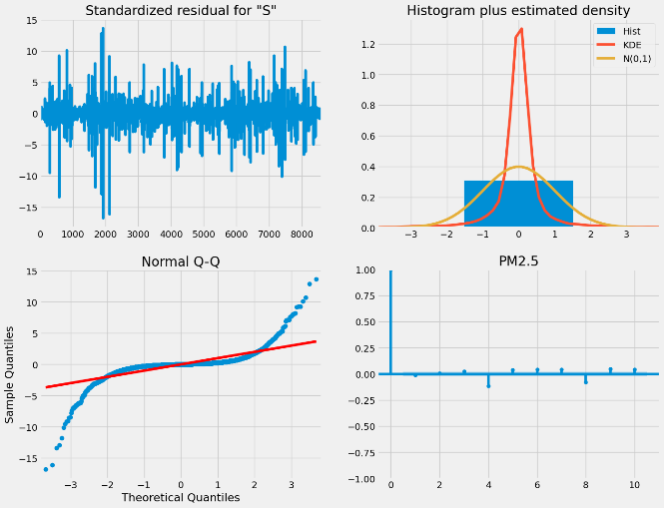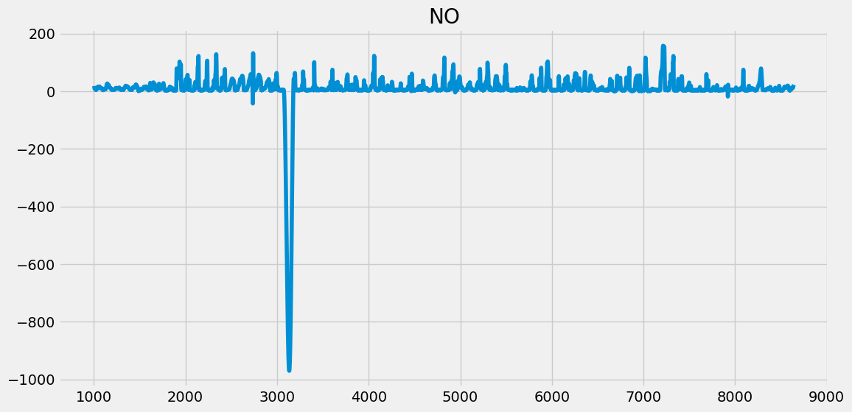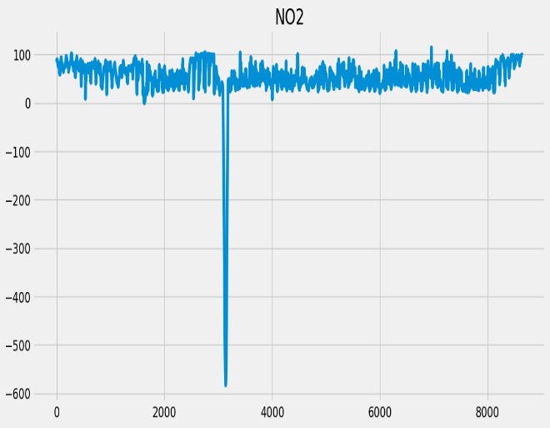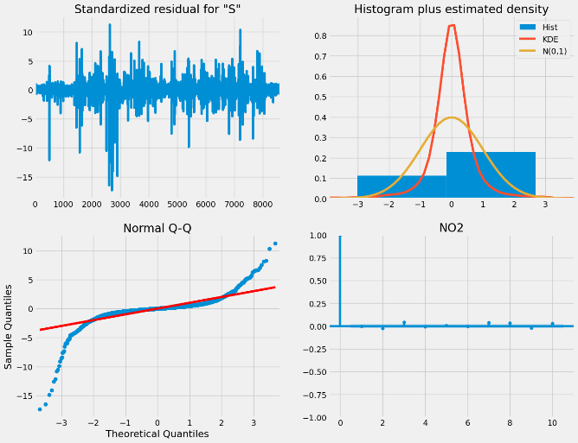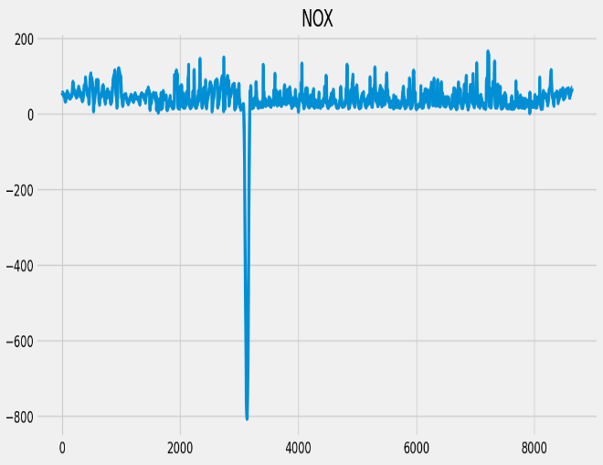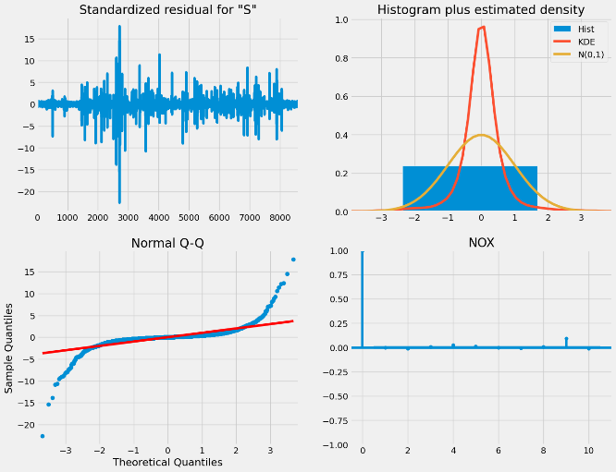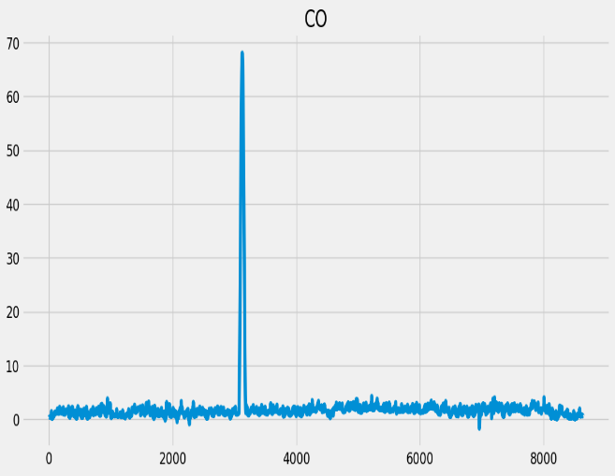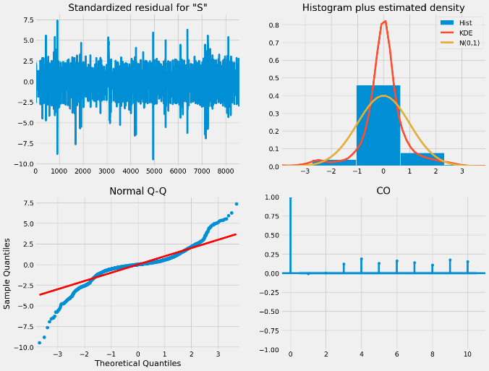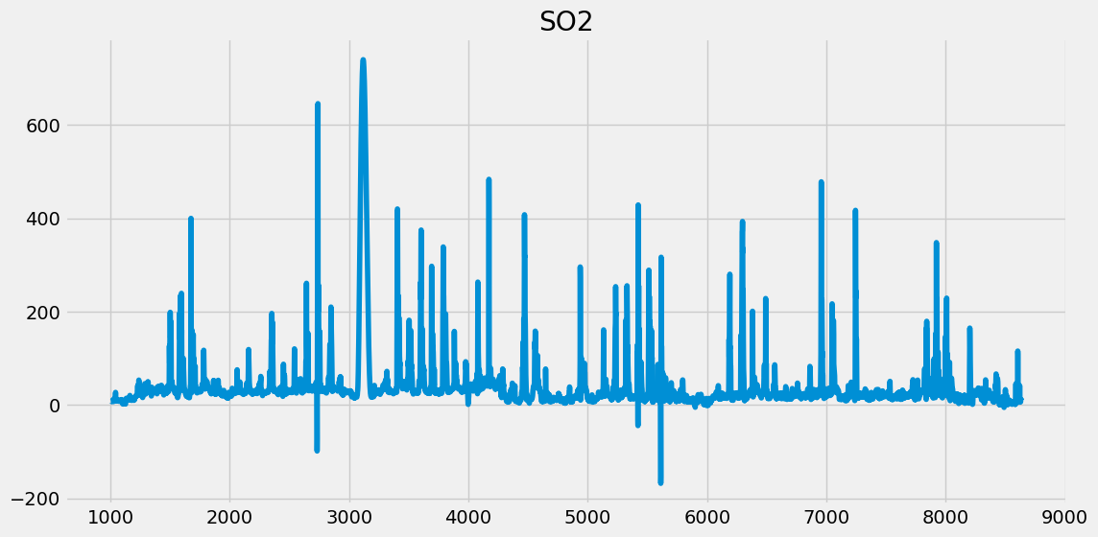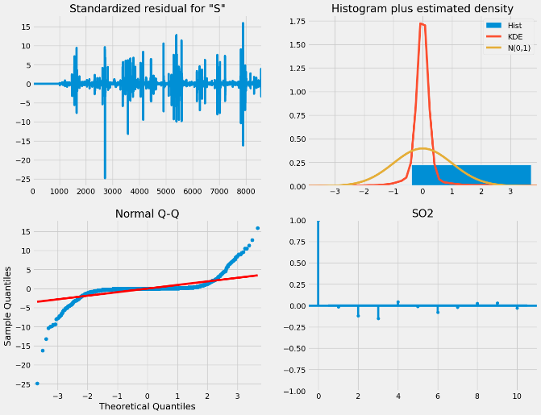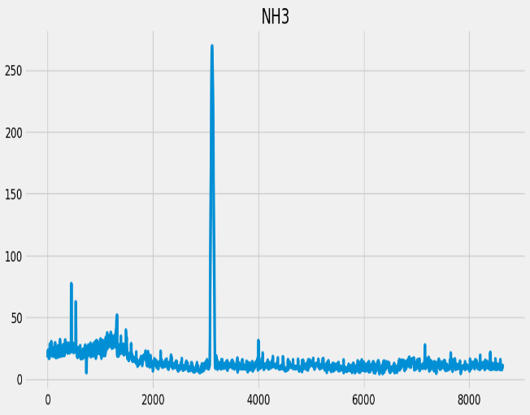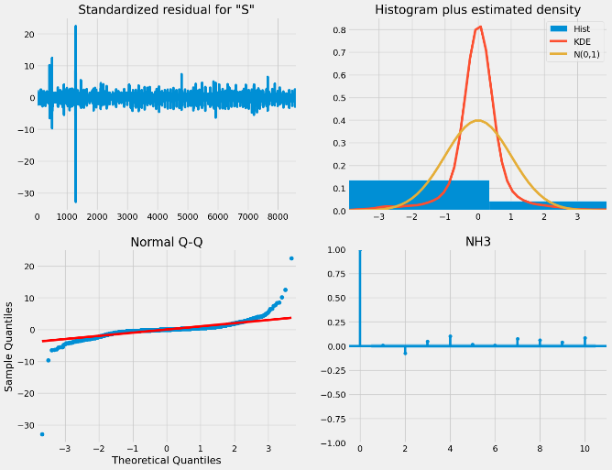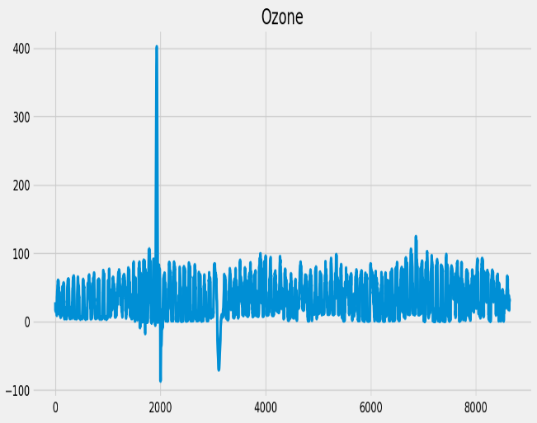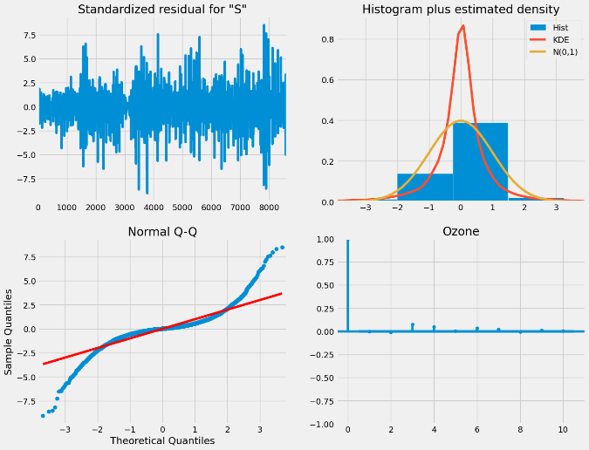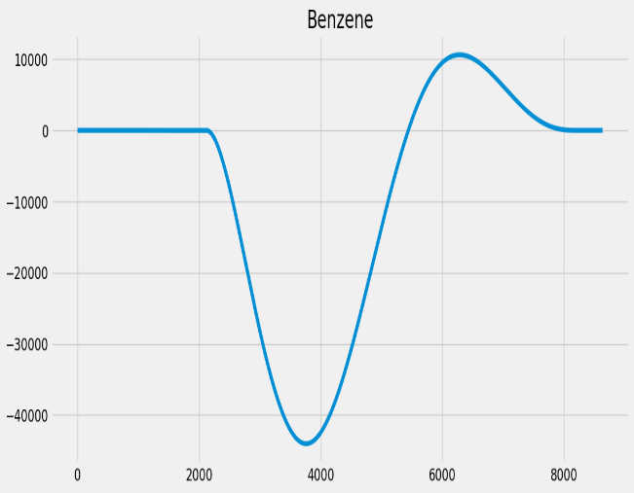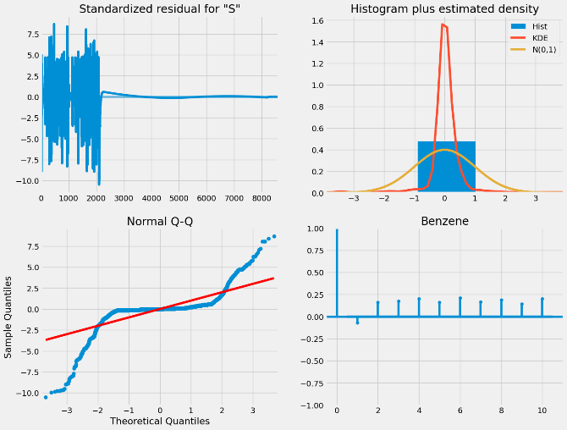

From the above graphs, we see that we don’t get much satisfactory results from ARIMA models. Now trying to get the raw autocorrelation, ACF and PACF graphs:

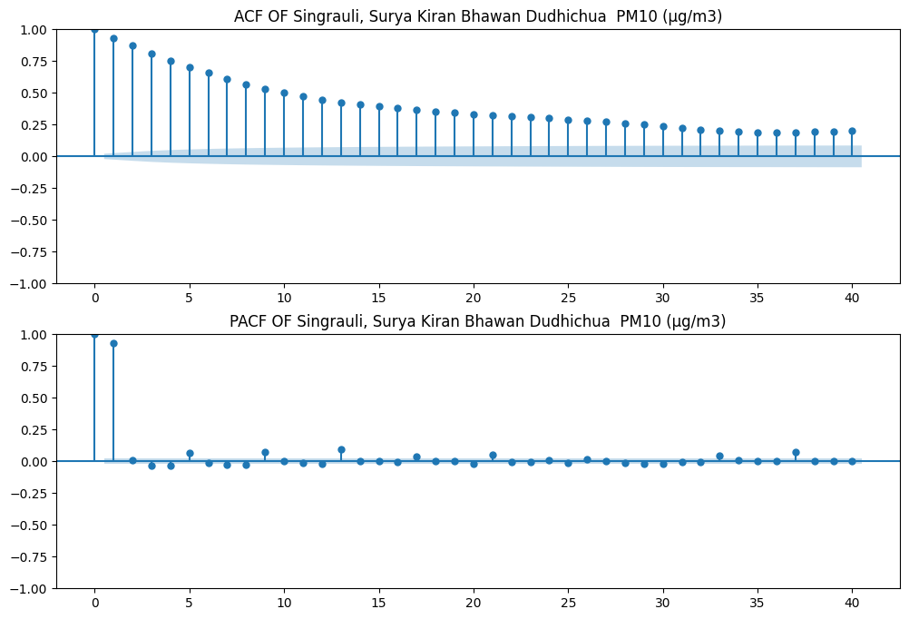

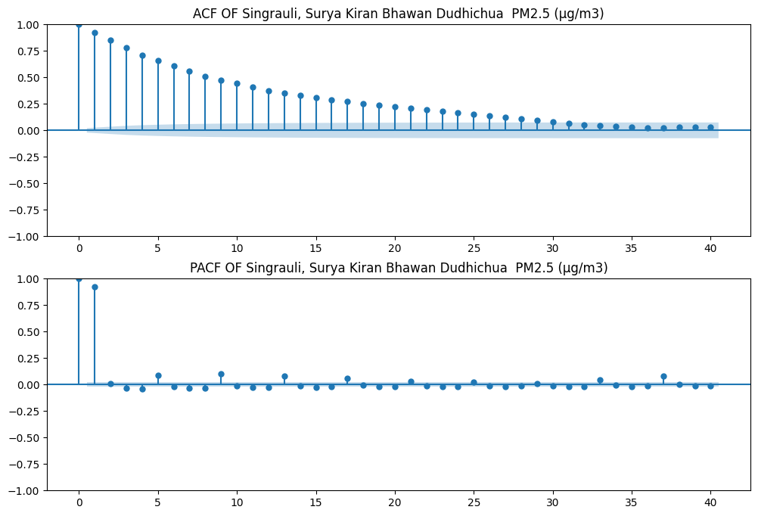

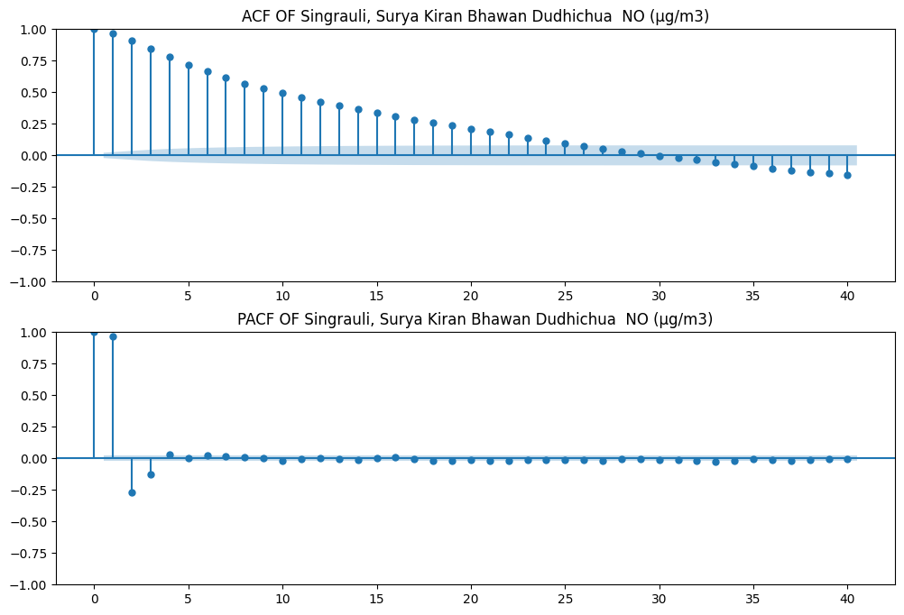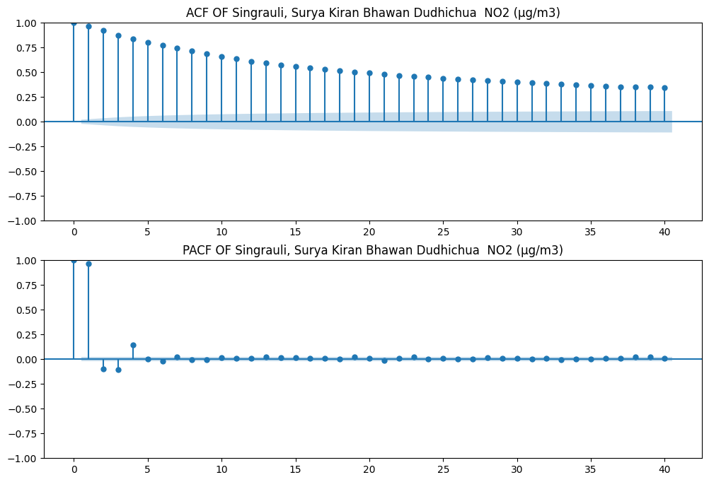

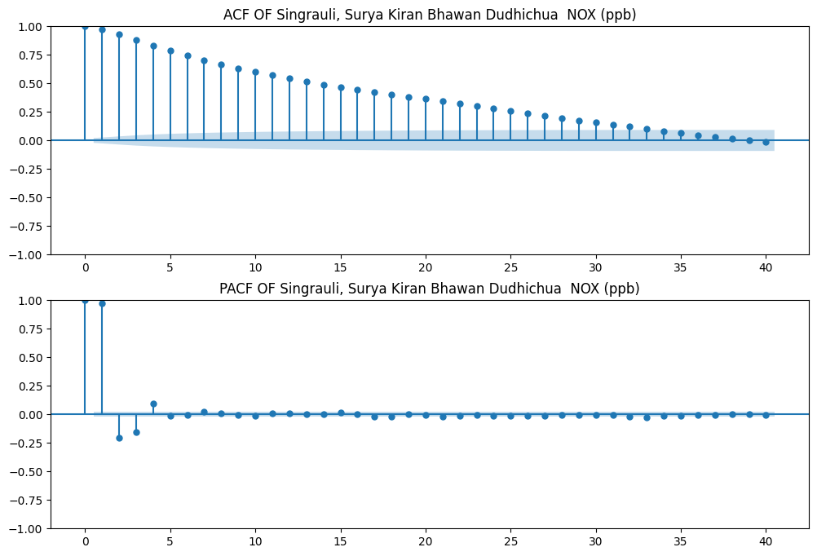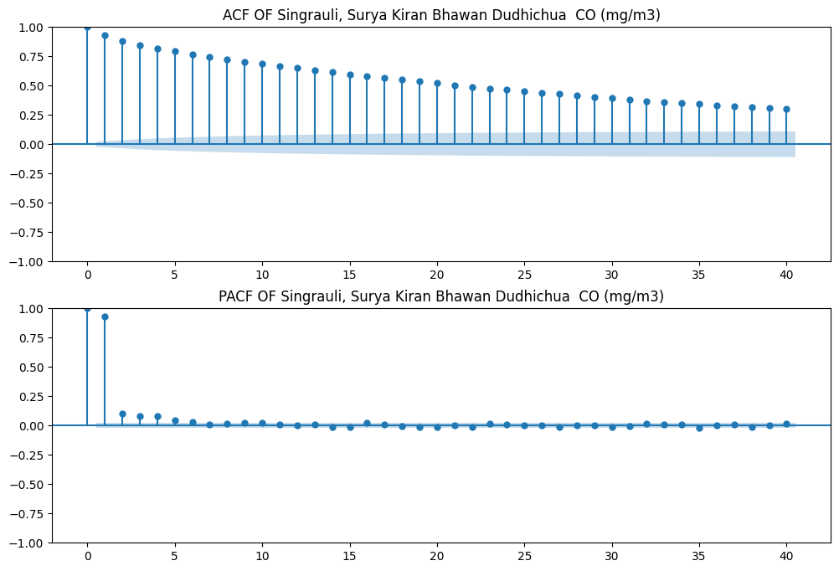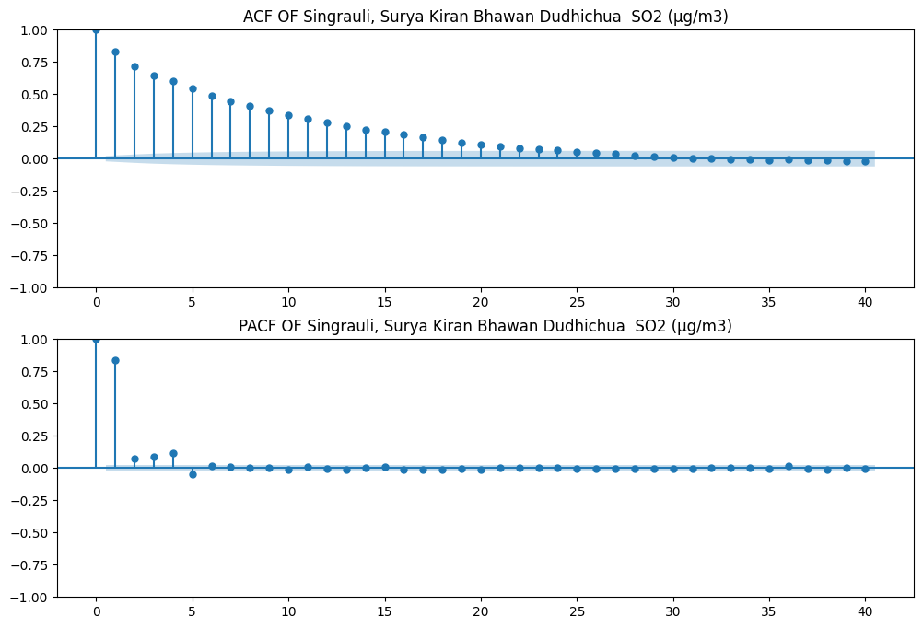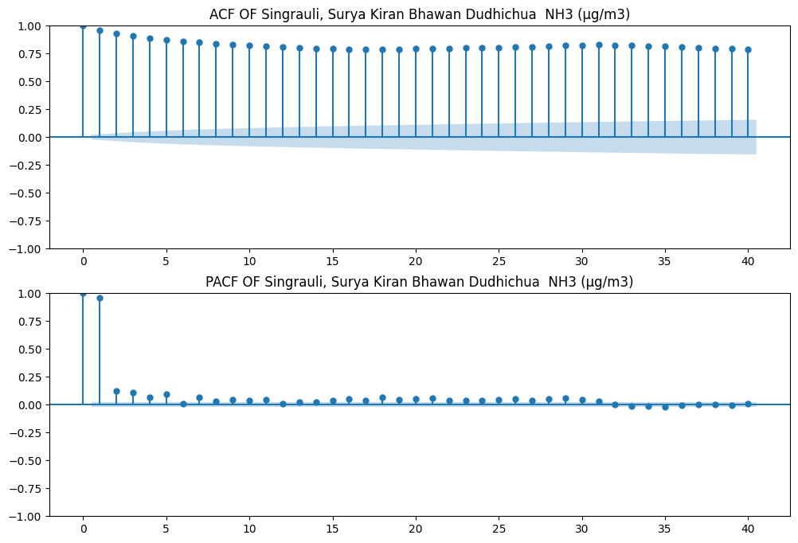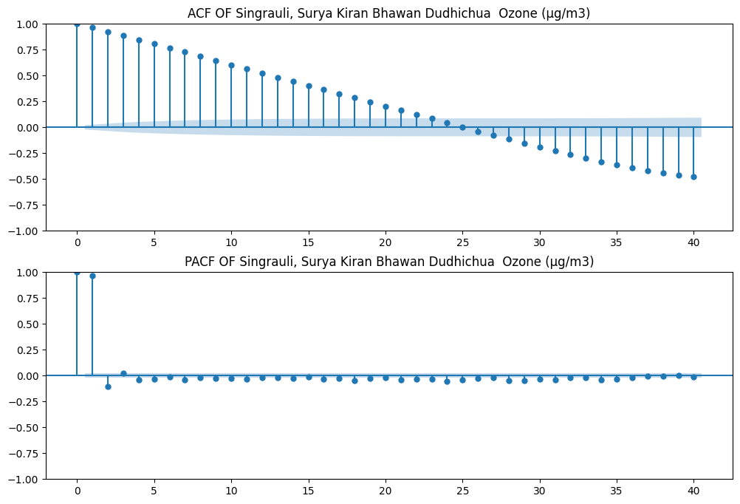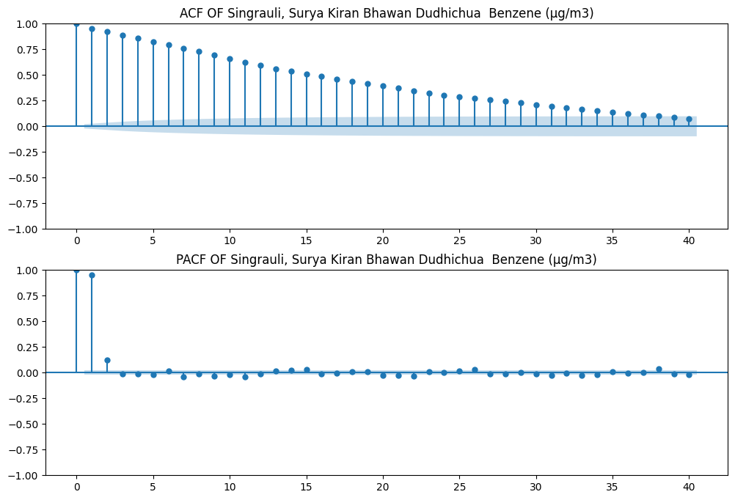

From the above graphs we observe ACF graphs to be consistently decreasing and first two bars to be dominating in PACF graphs. This indicates that the dataset must be following AR(2) model but in exact way p=[2,2,4,5,5,5,5,6,3,2] for columns in order but since dependency gets very low for further terms with respect to first two terms so we count p=2 for all columns. Fitting the model, we get original and forecasted graphs as following:

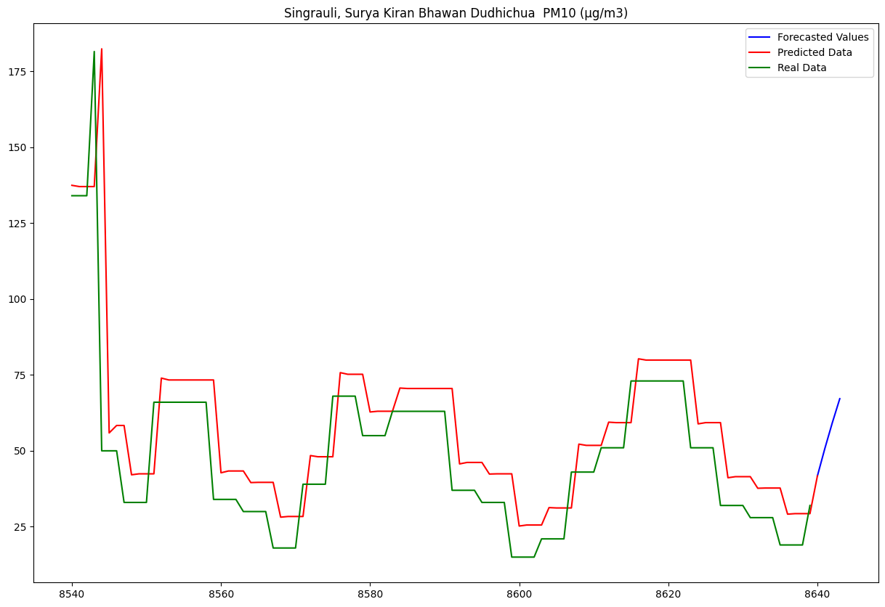

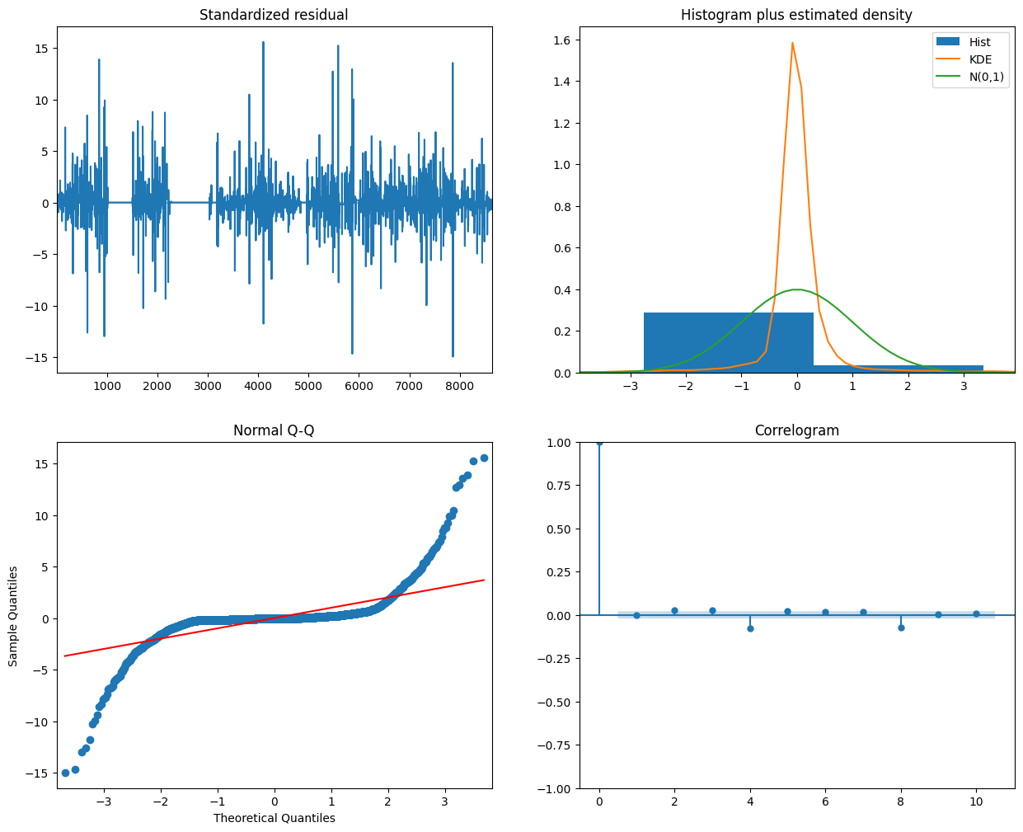

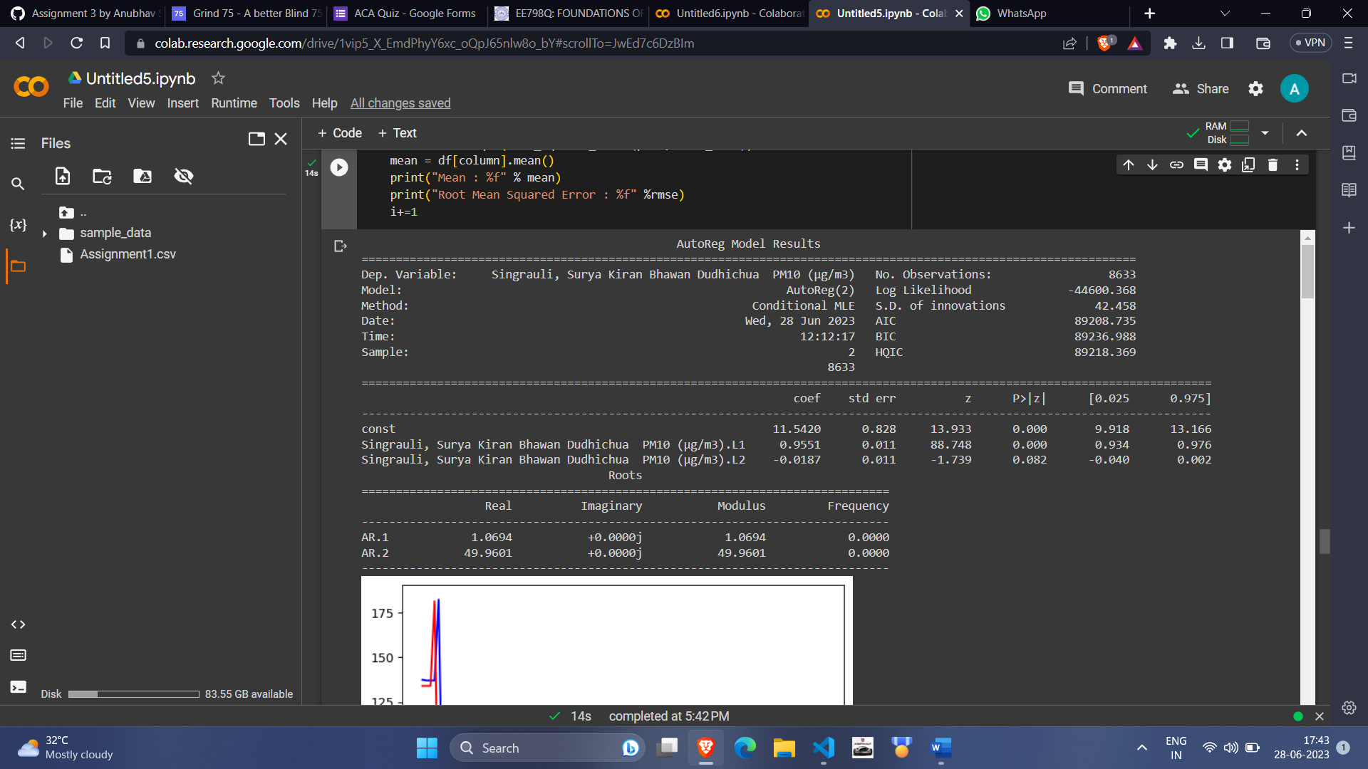

Mean Absolute Error: 339.48410172266847

Root Mean Squared Error: 18.425094347727732

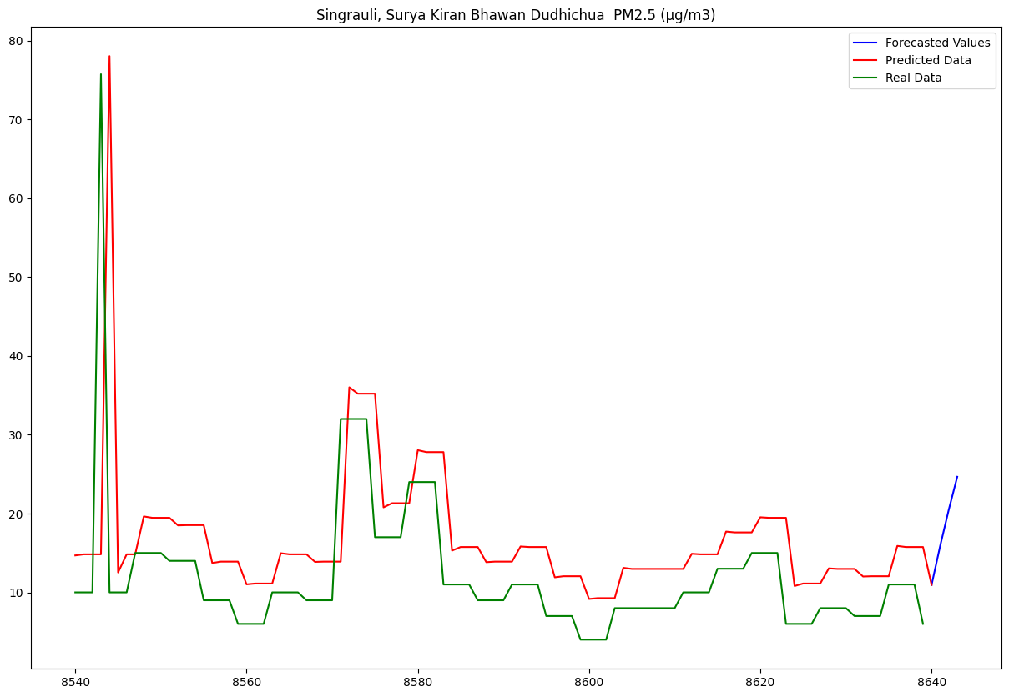

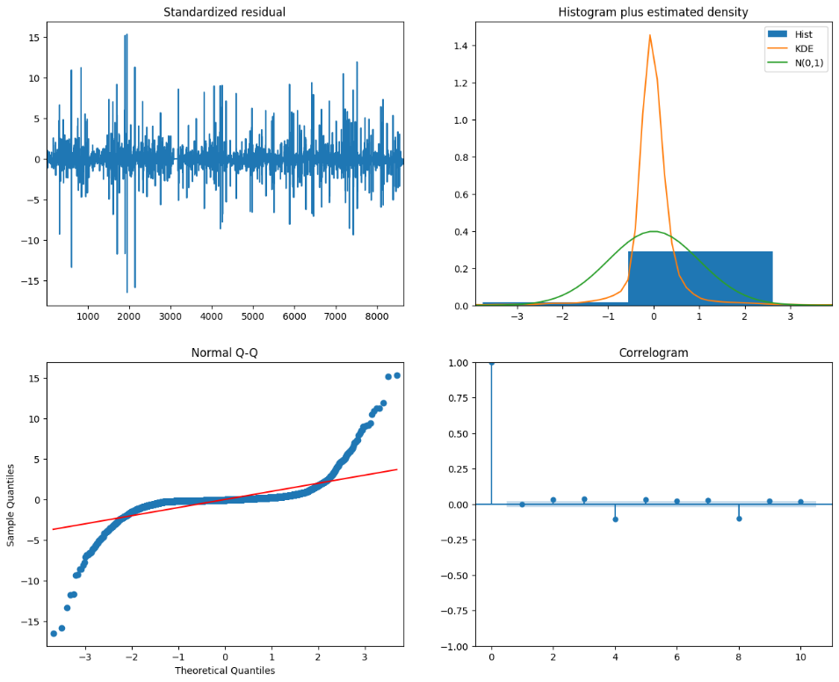

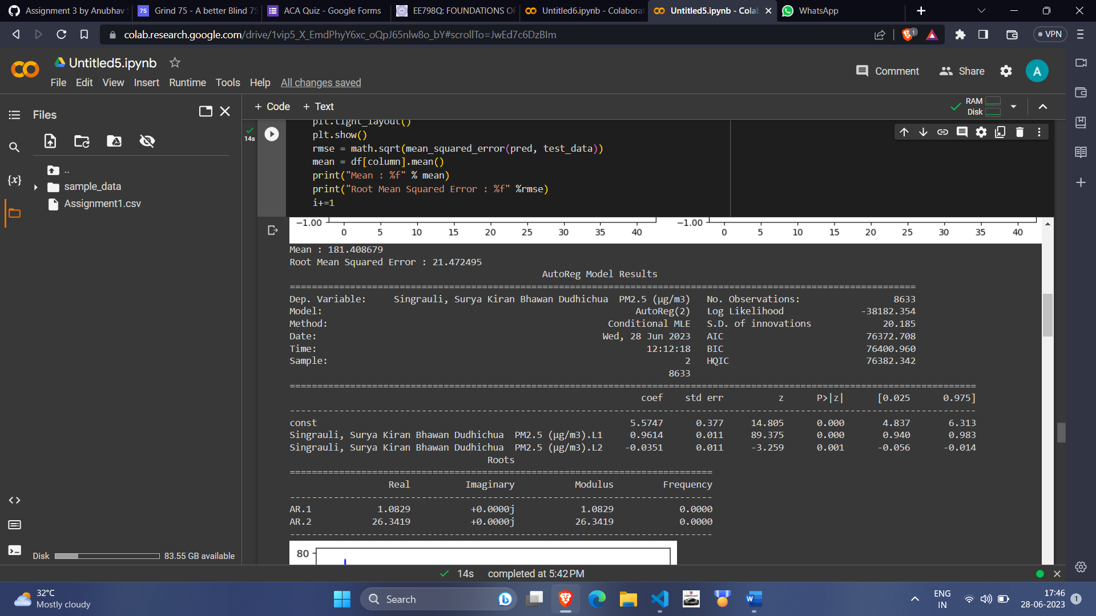

Mean Absolute Error: 117.14783976232256

Root Mean Squared Error: 10.82348556437909

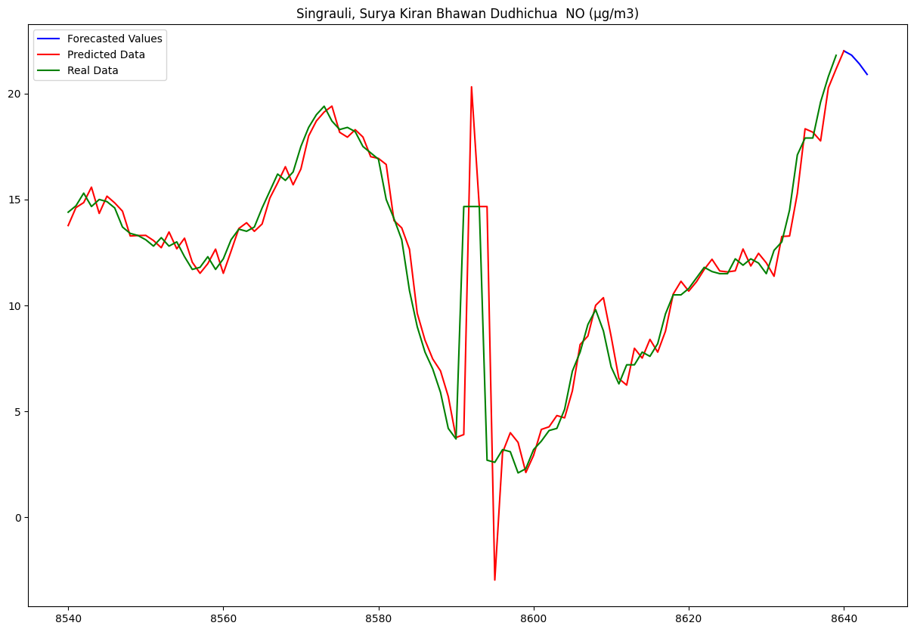

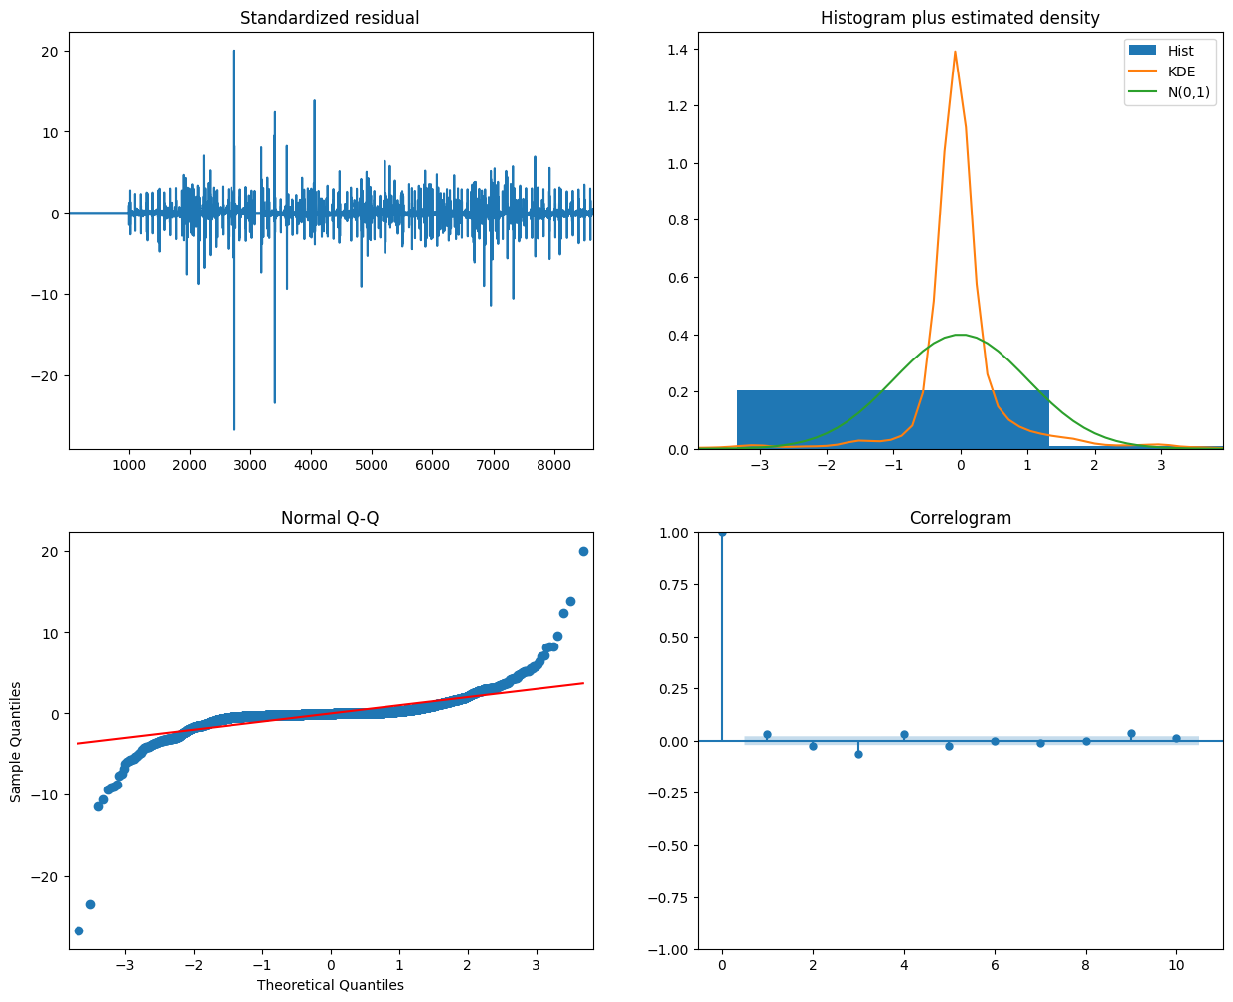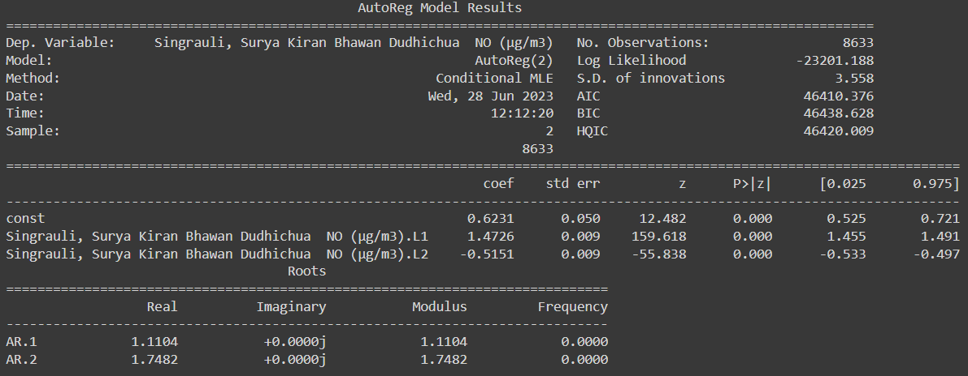

Mean Absolute Error: 3.6915458679425965

Root Mean Squared Error: 1.9213396024499667

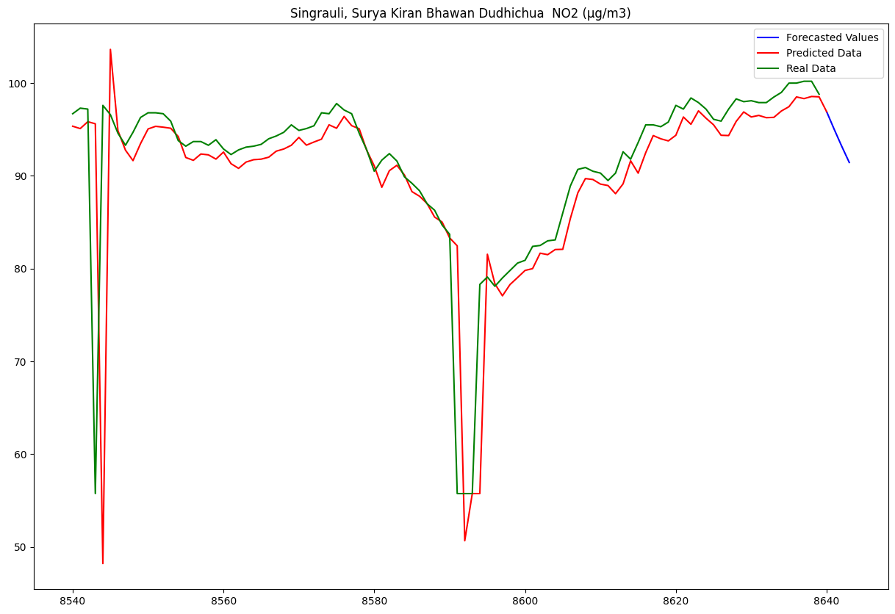

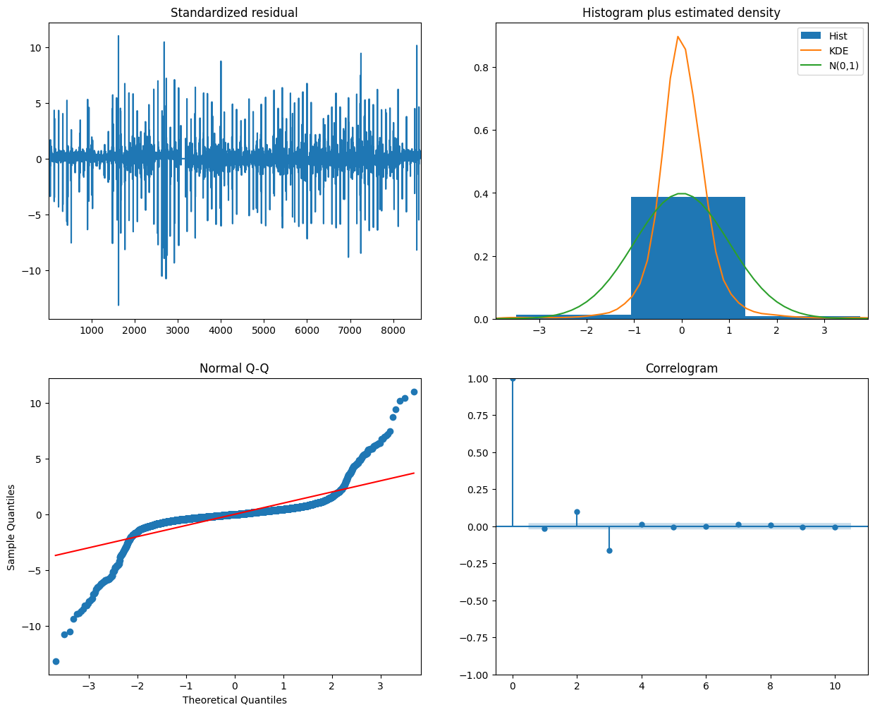

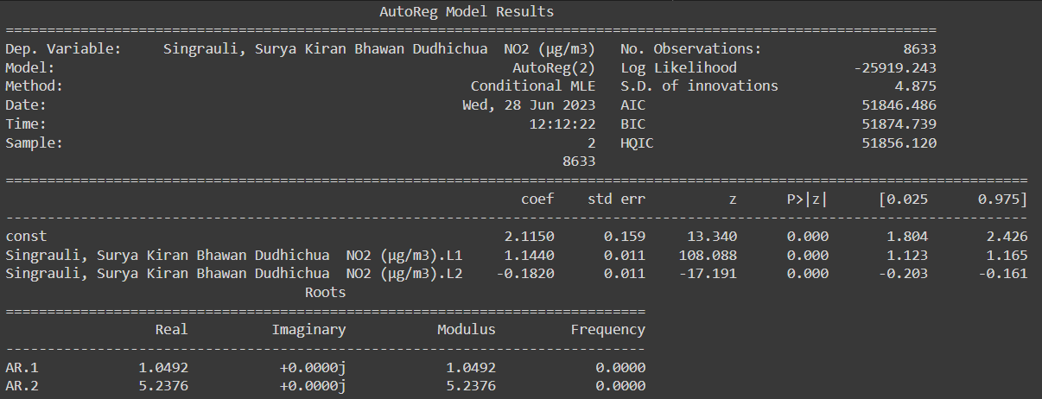

Mean Absolute Error: 56.16023924671195

Root Mean Squared Error: 7.494013560617031

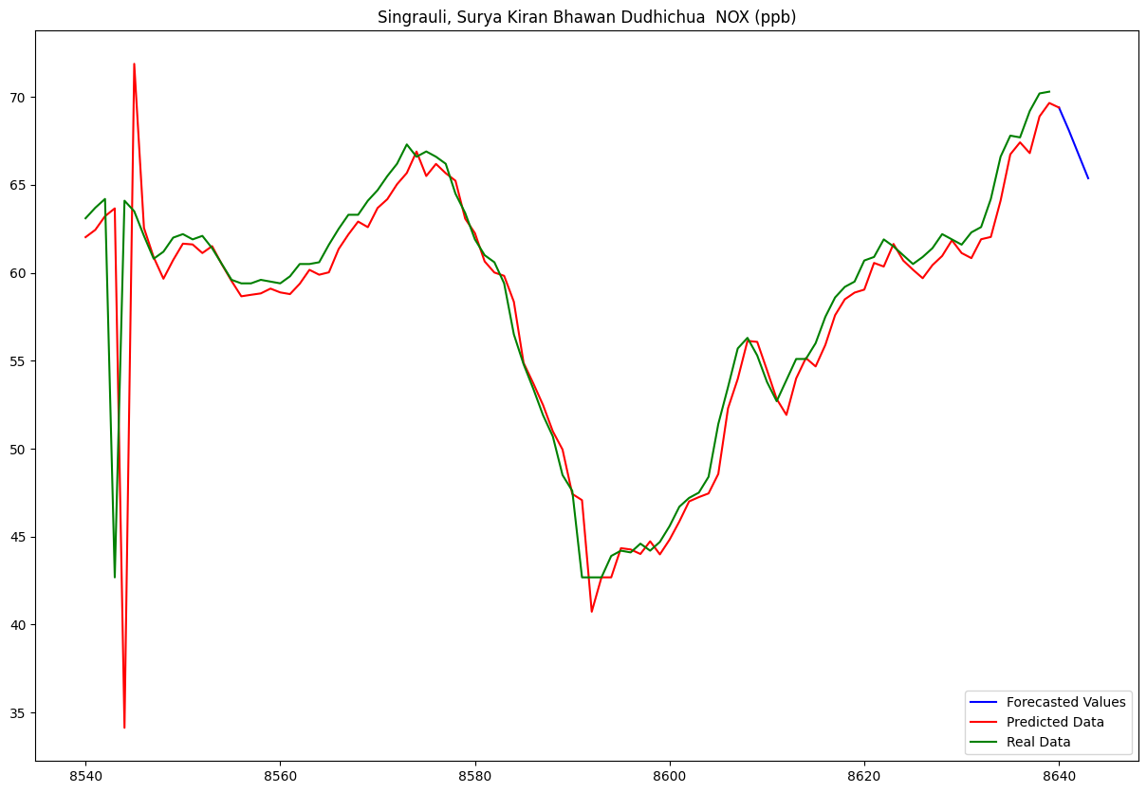

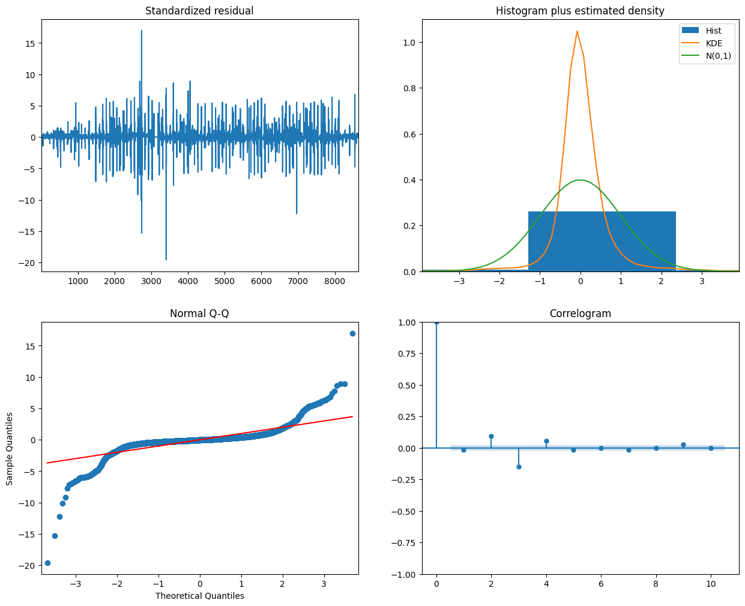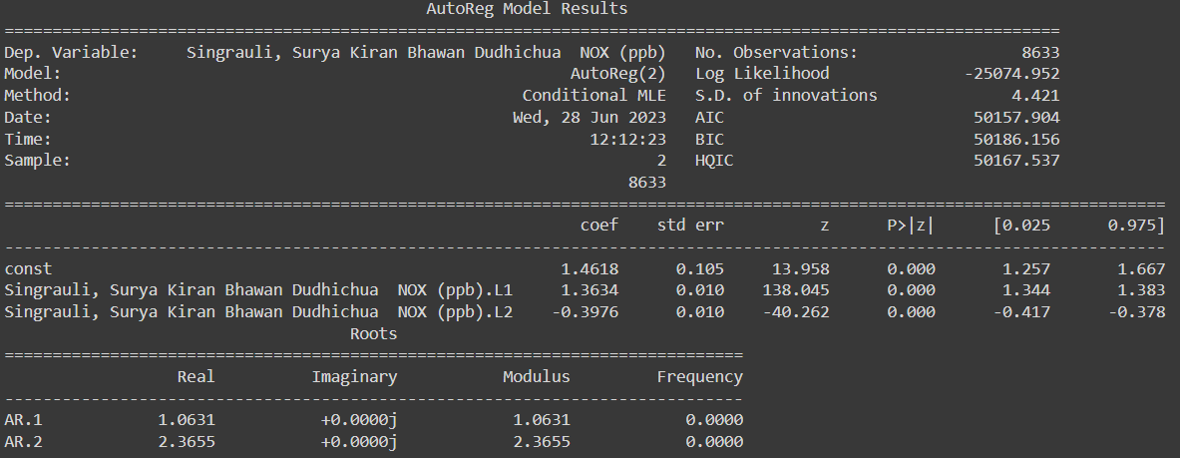

Mean Absolute Error: 15.323961376995022

Root Mean Squared Error: 3.9145831677197793

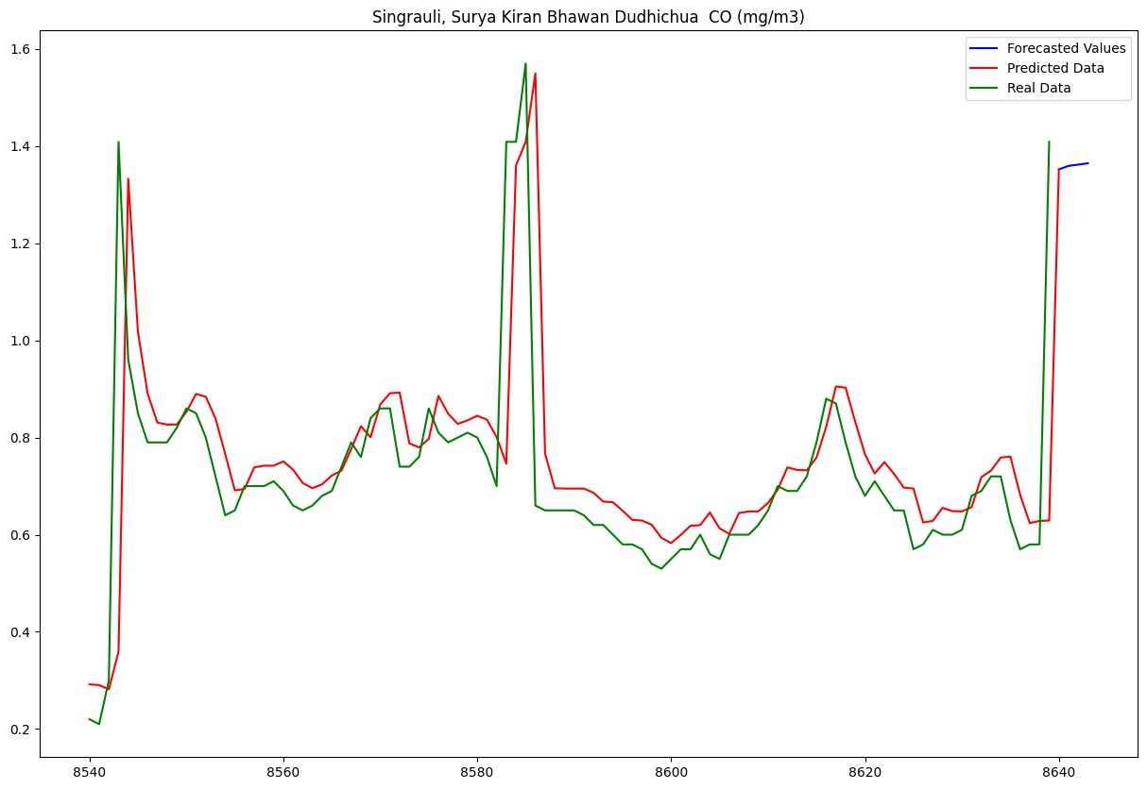

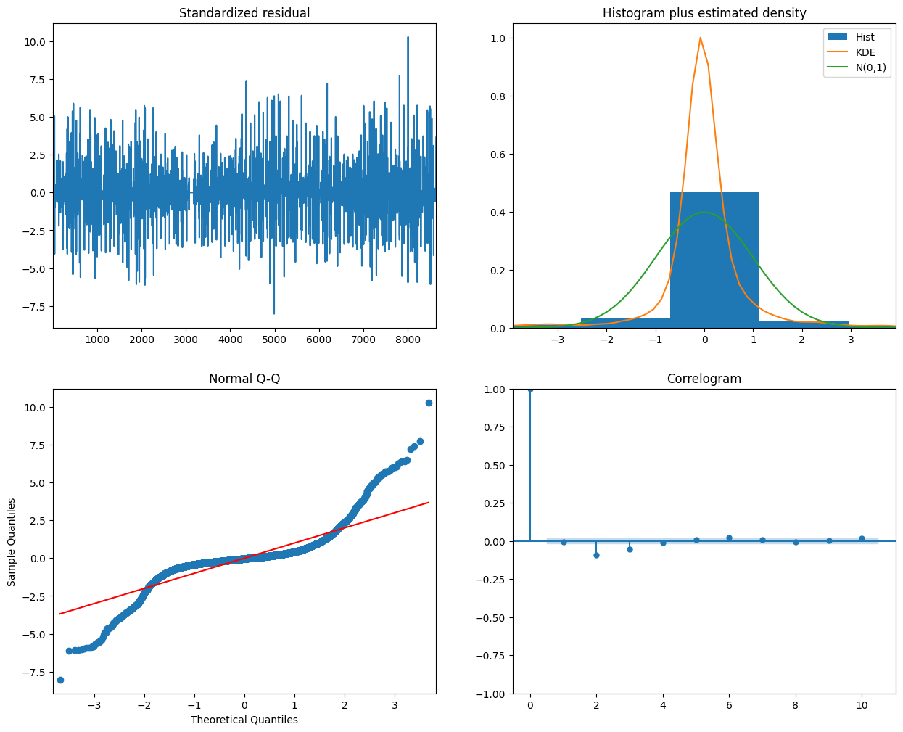

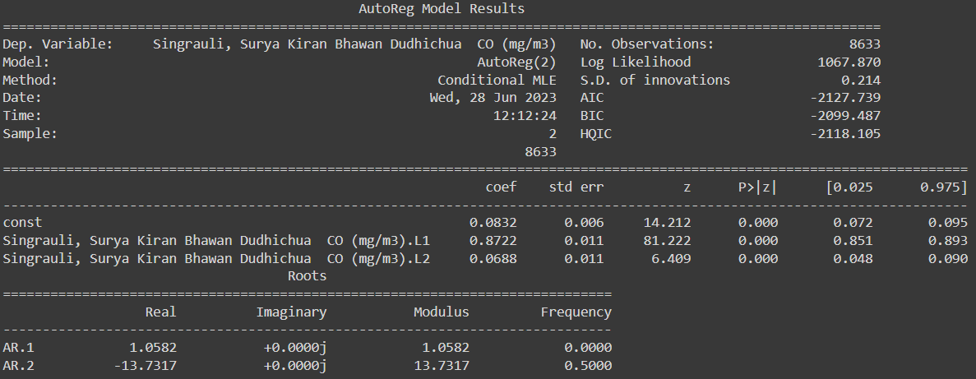

Mean Absolute Error: 0.0347895466301094

Root Mean Squared Error: 0.18651956098519373

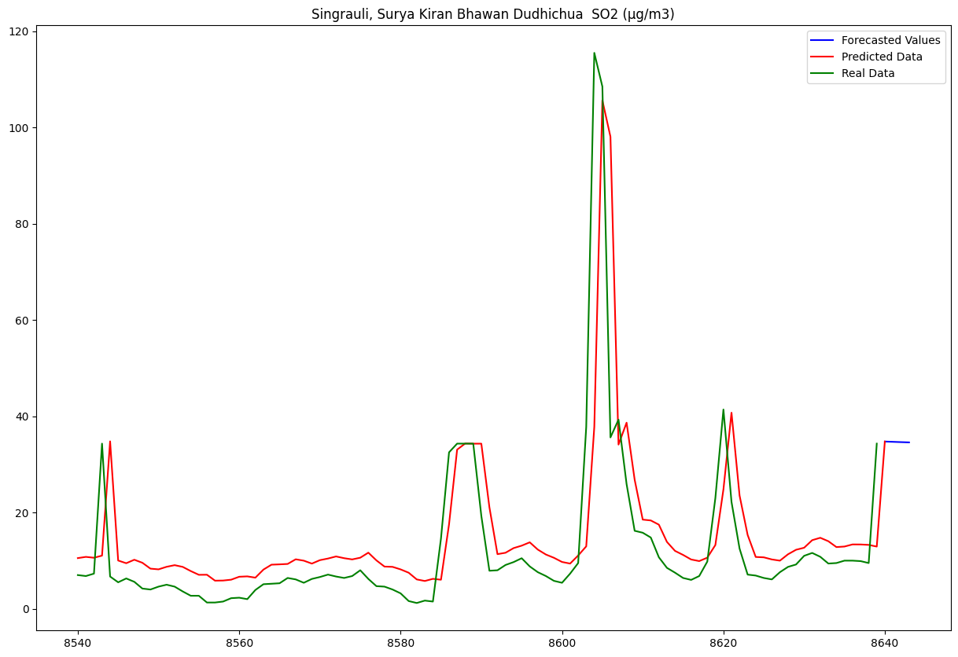

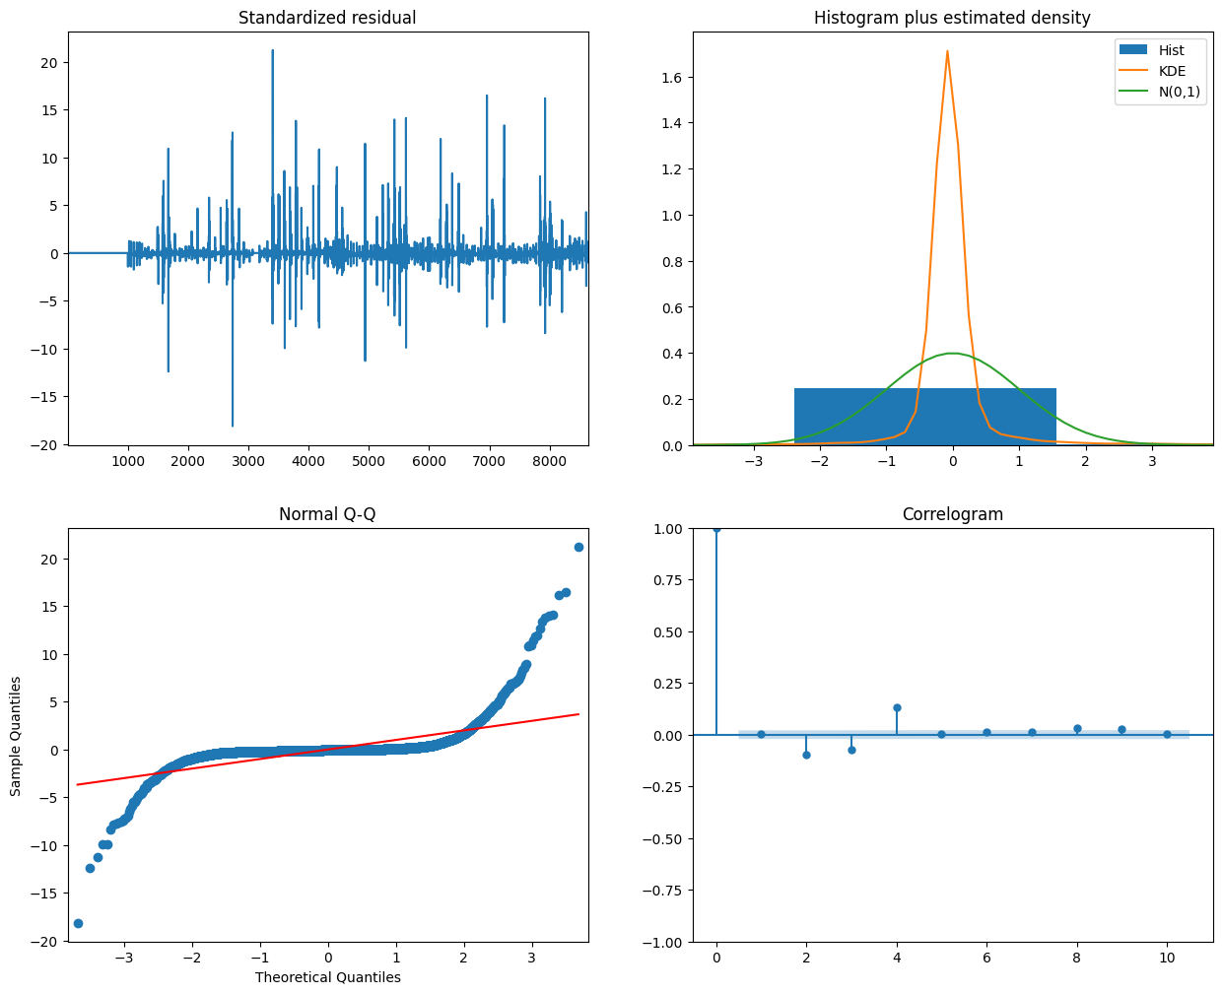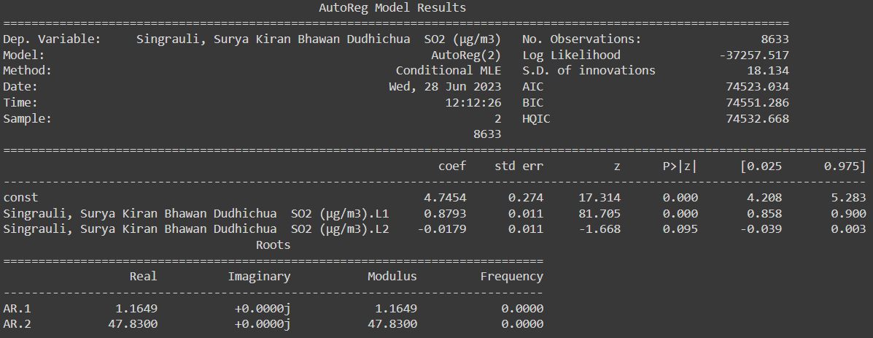

Mean Absolute Error: 155.34485802029565

Root Mean Squared Error: 12.463741734338676

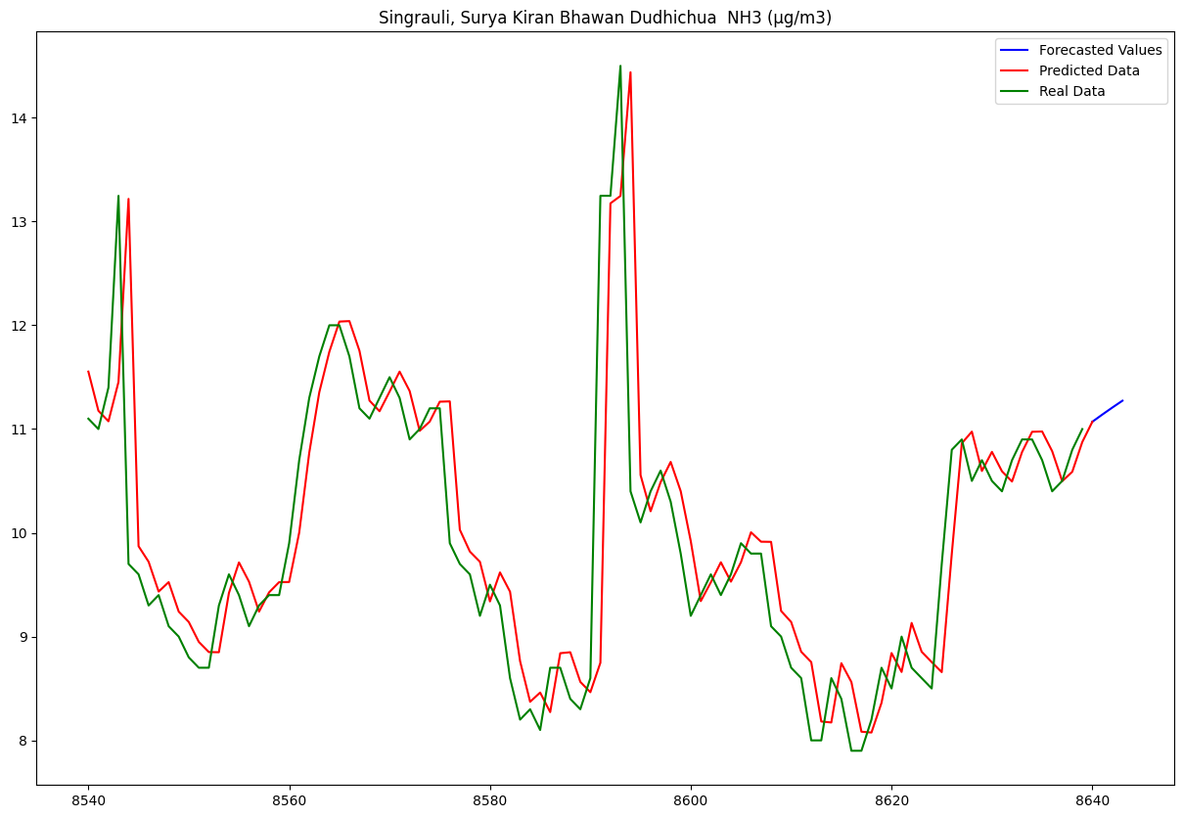

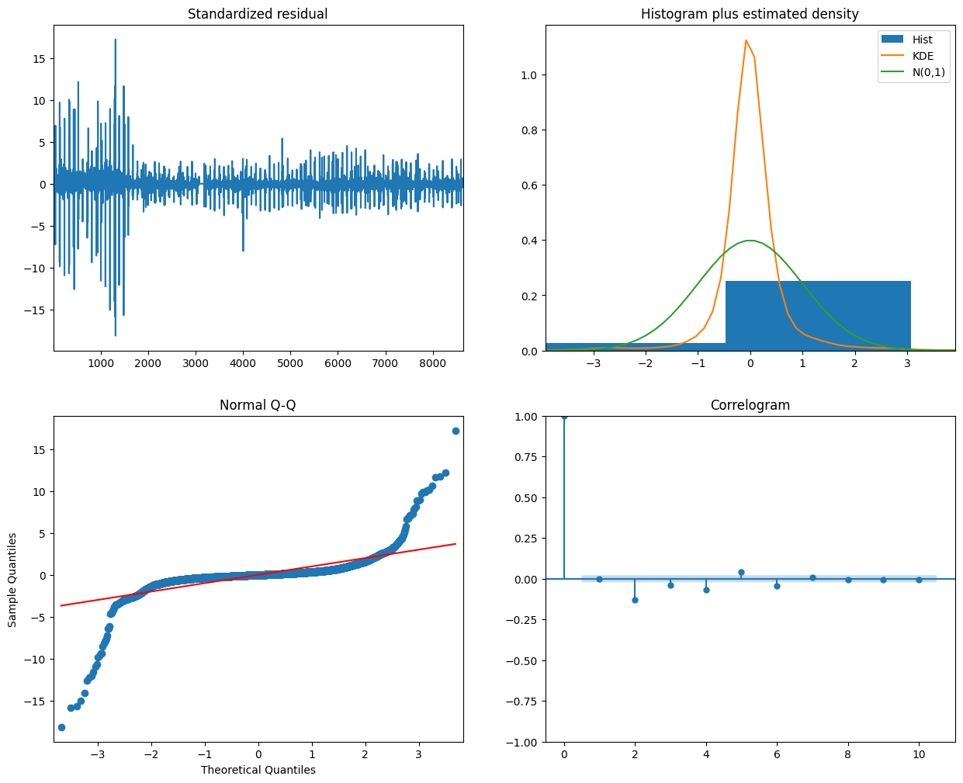

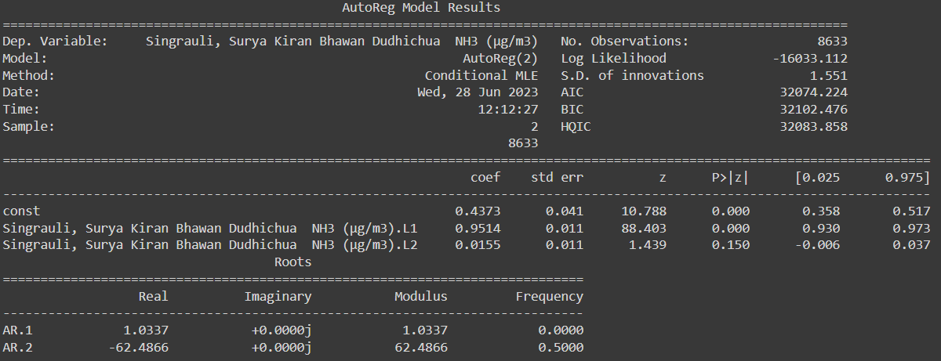

Mean Absolute Error: 0.6856057979658061

Root Mean Squared Error: 0.8280131629182027

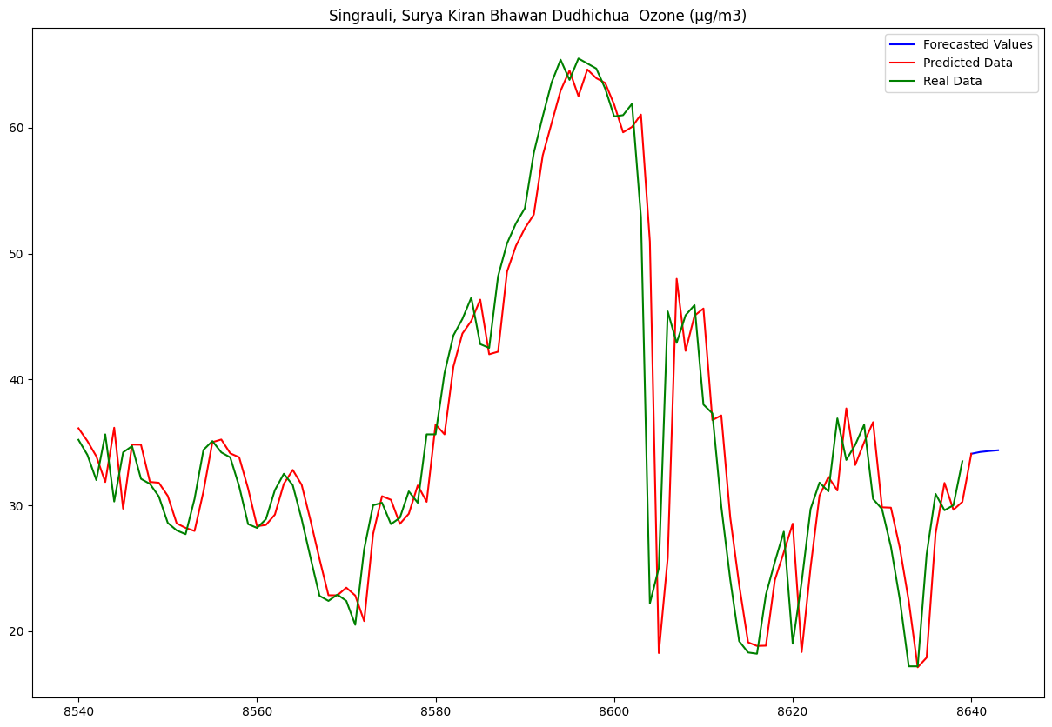

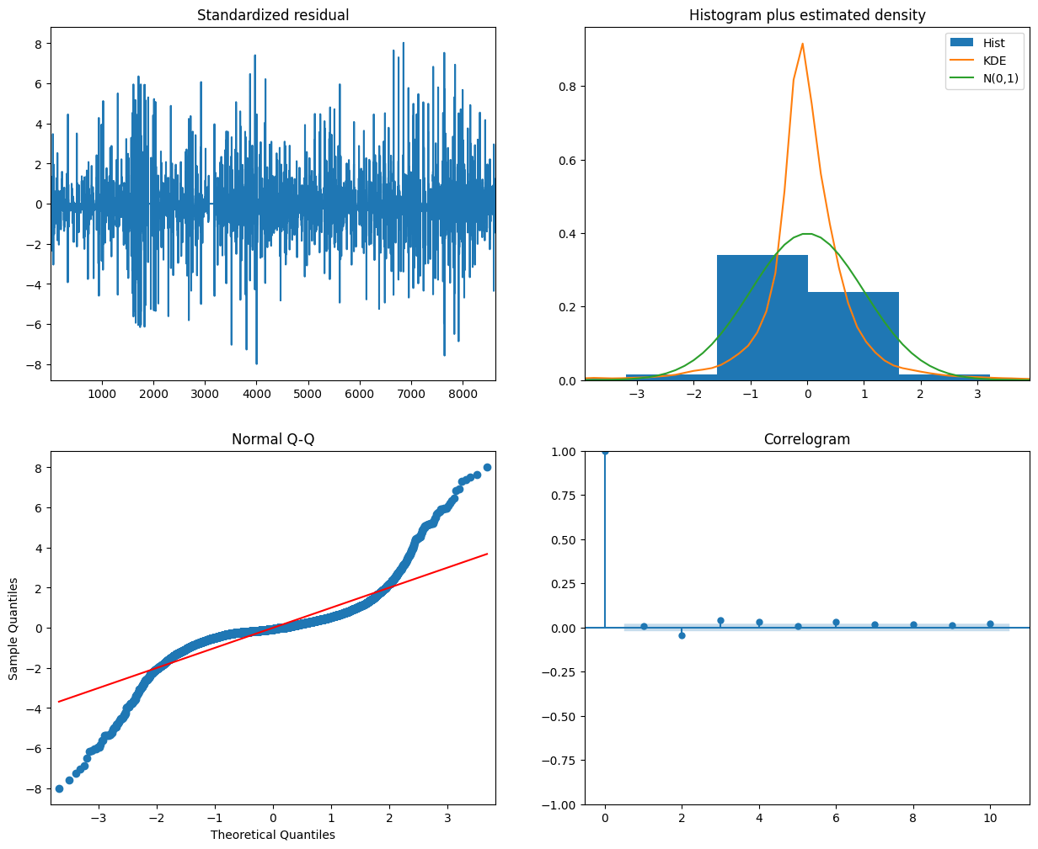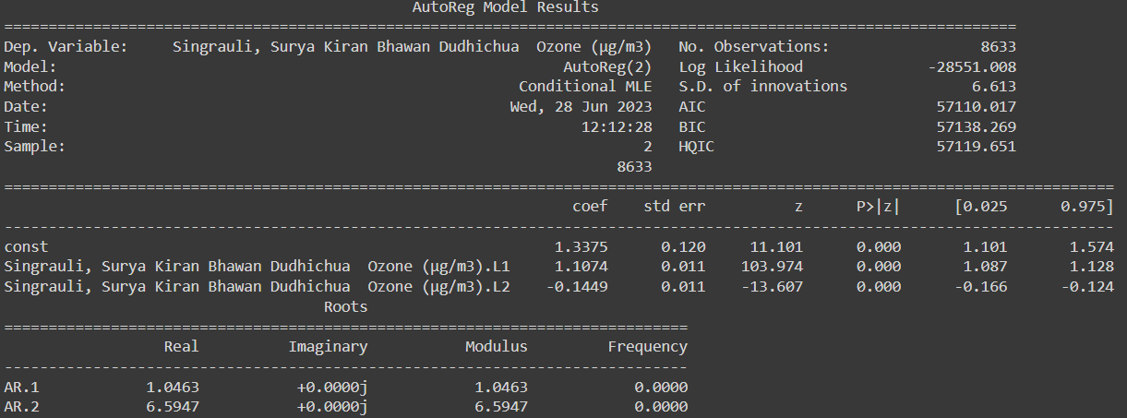

Mean Absolute Error: 23.125867778061497

Root Mean Squared Error: 4.808936241837845

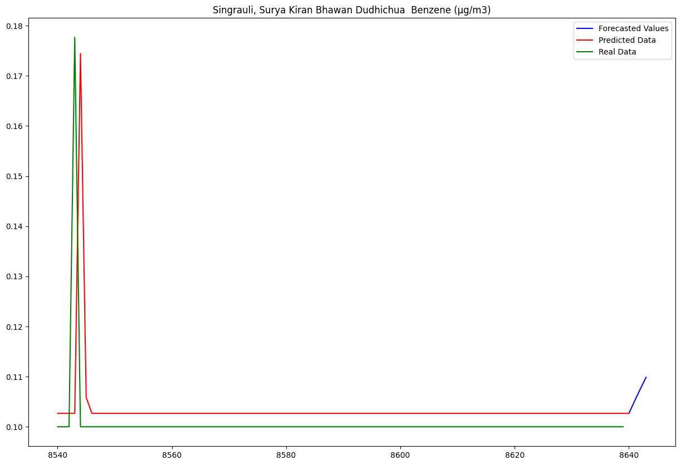

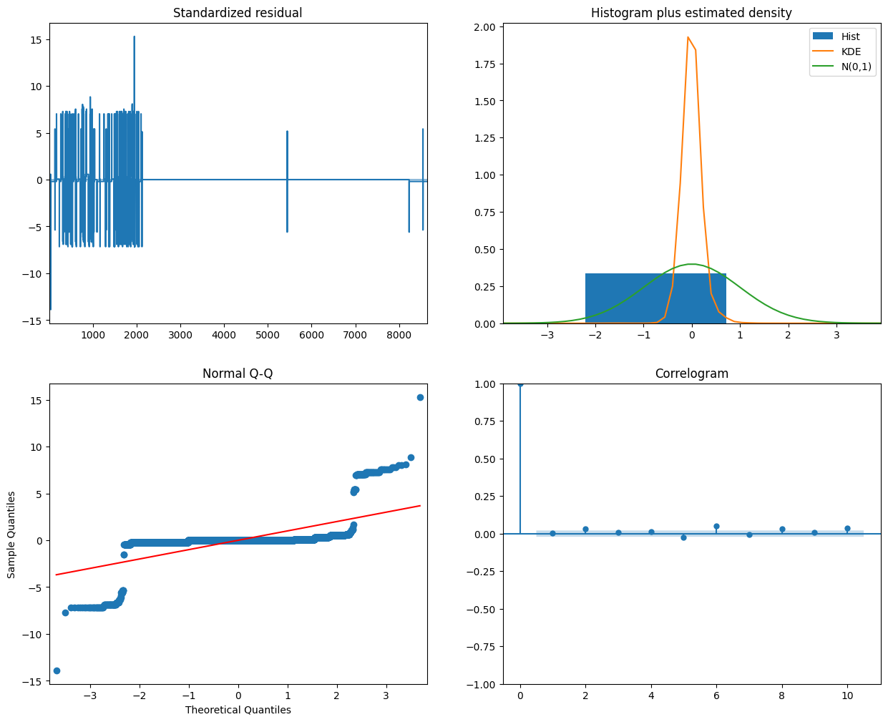

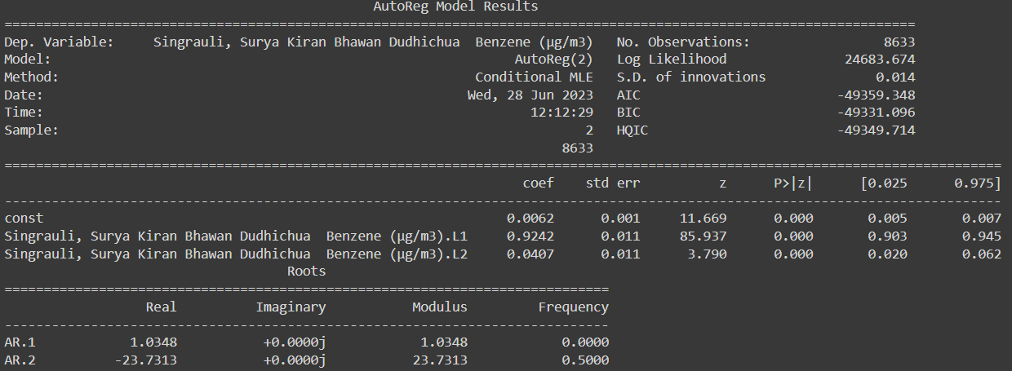

Mean Absolute Error: 0.00011891763220975853

Root Mean Squared Error: 0.010904936139646052

In the second part, it is given that blasting has high effect on air pollution stats between 13:45 and 14:45. This can be validated by the interpolated graphs averaged over every time stamp for all the days and then we can observe the peak measurements after 12:00 in the noon which certify that level of pollutants increases around that that time. But for some pollutants like NO2 and NOX the levels decrease at those time stamps, this may be due highly absent data around that time and interpolation not being a good and workable practice for it. Also, for a number of columns we need to do a high order interpolation i.e., up to order of 7.

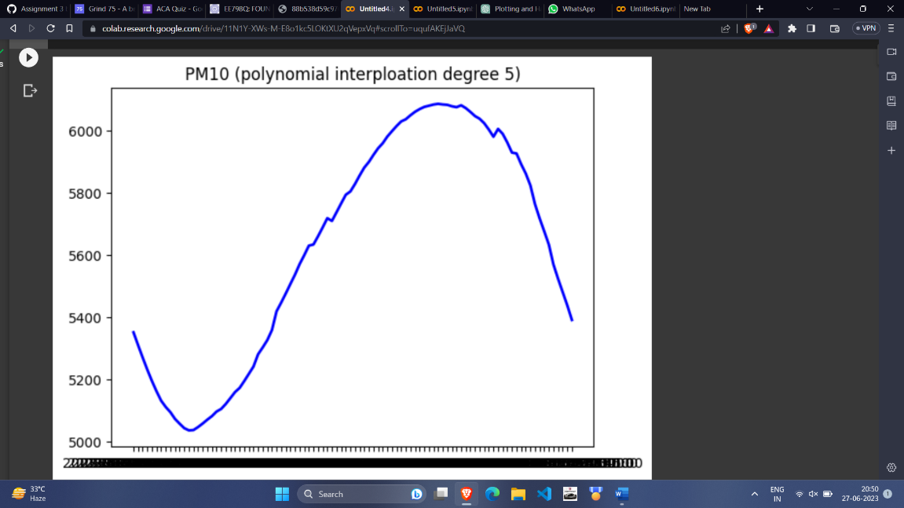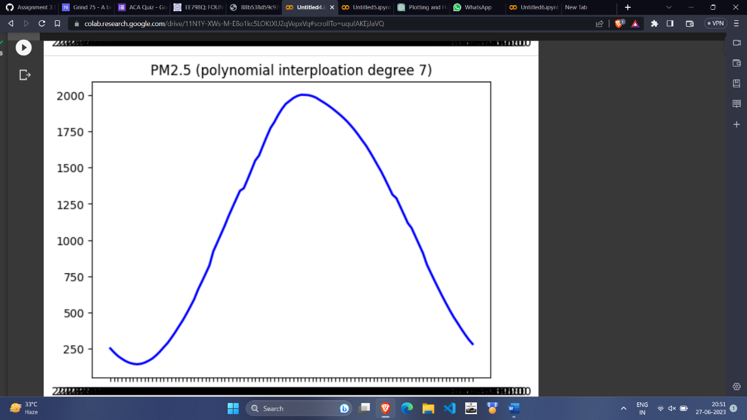

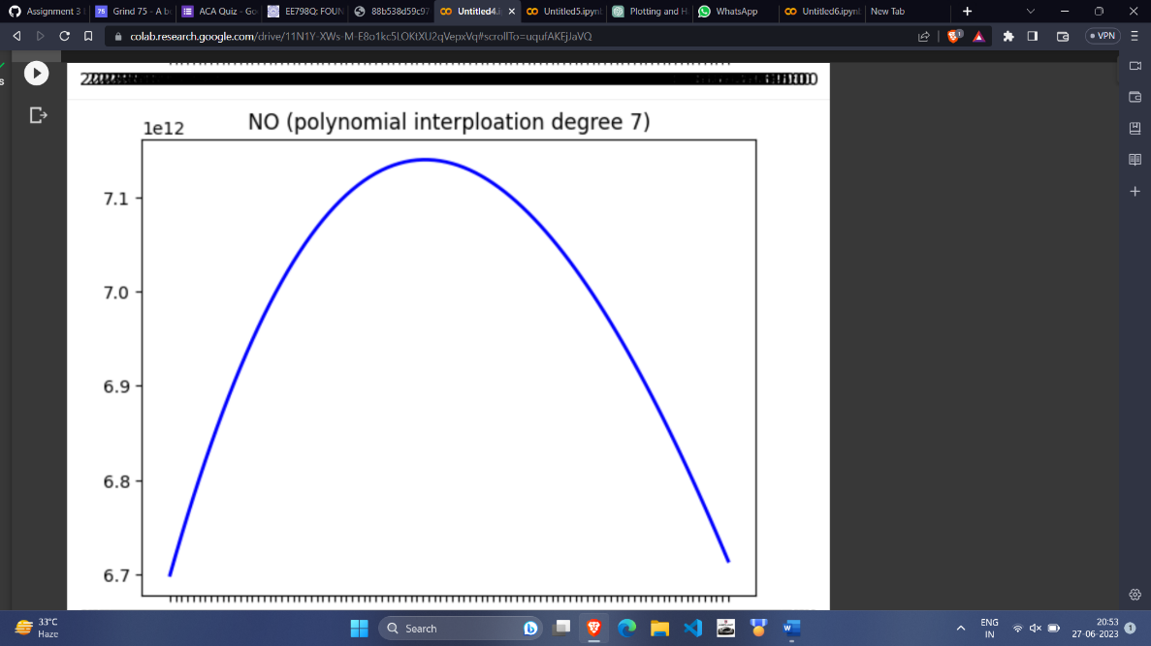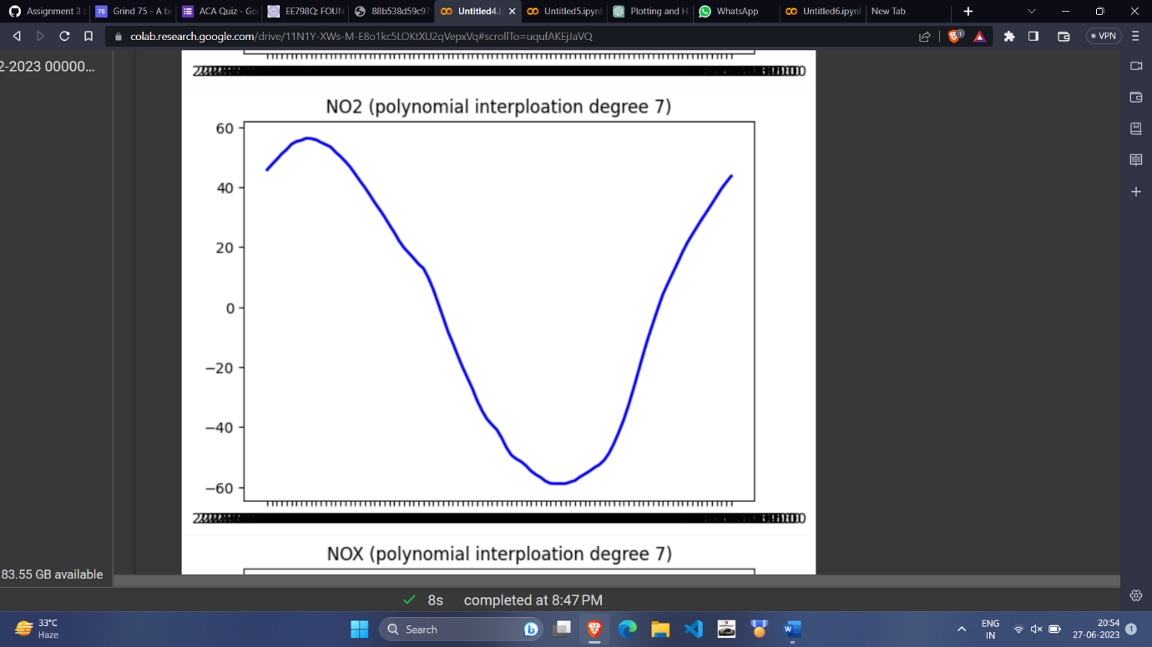

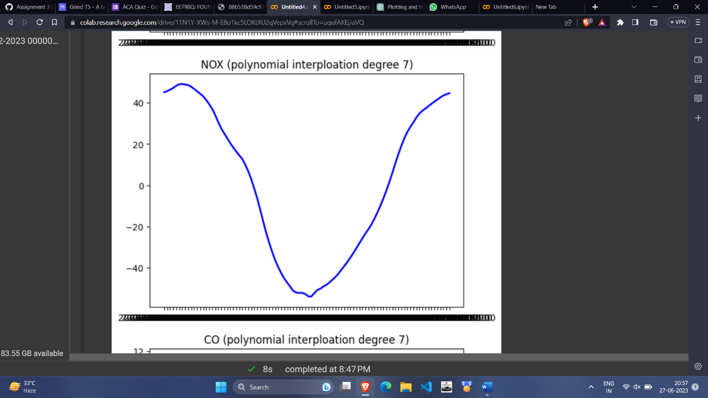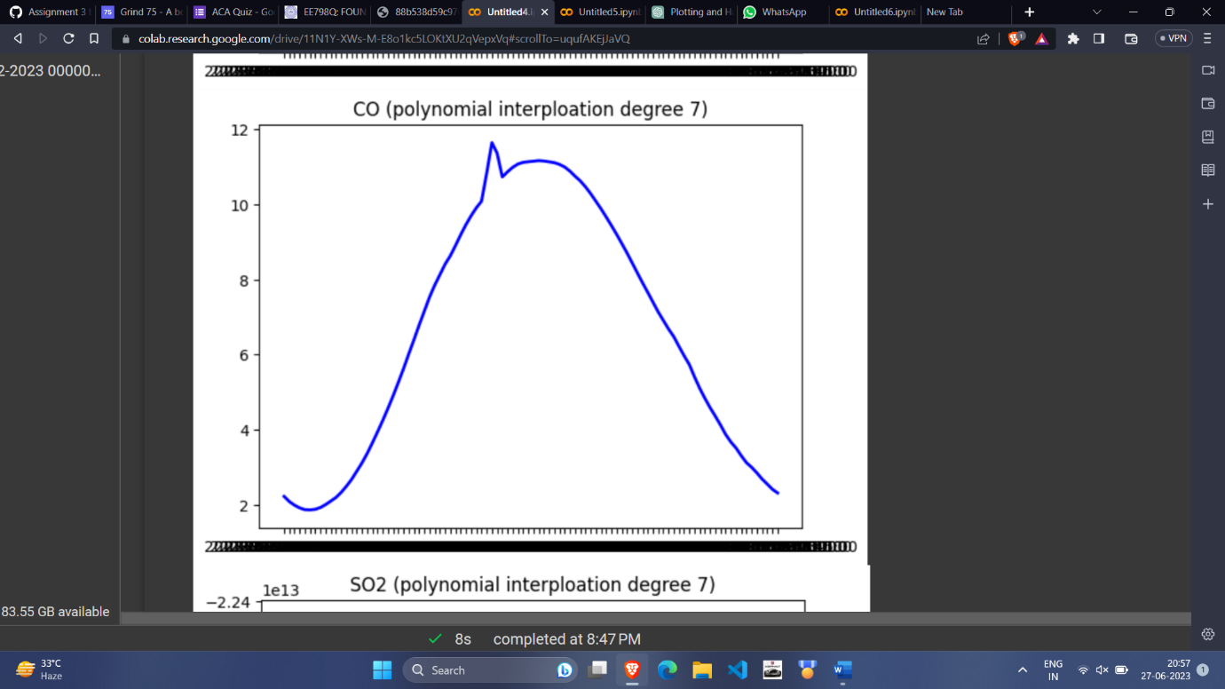

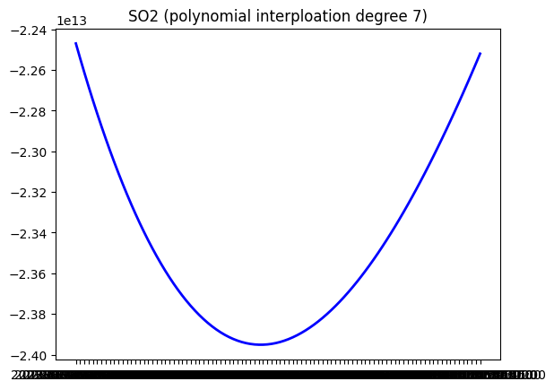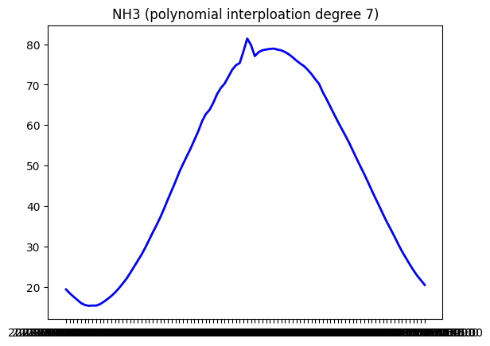

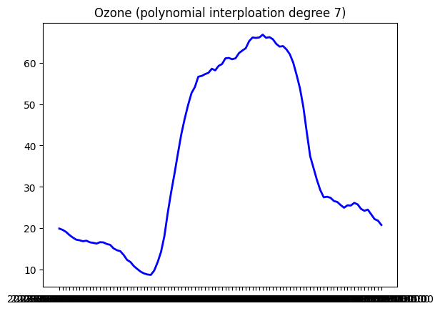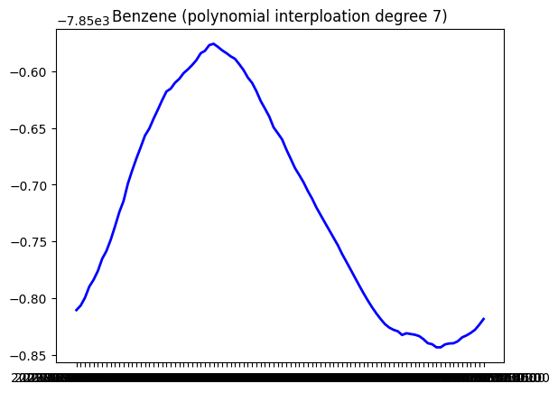

For the combined times series, we combined individual readings over a time stamp, normalised them and adjusted the weights to closely follow normal distribution. So, the graph for the combined time series is as follows:

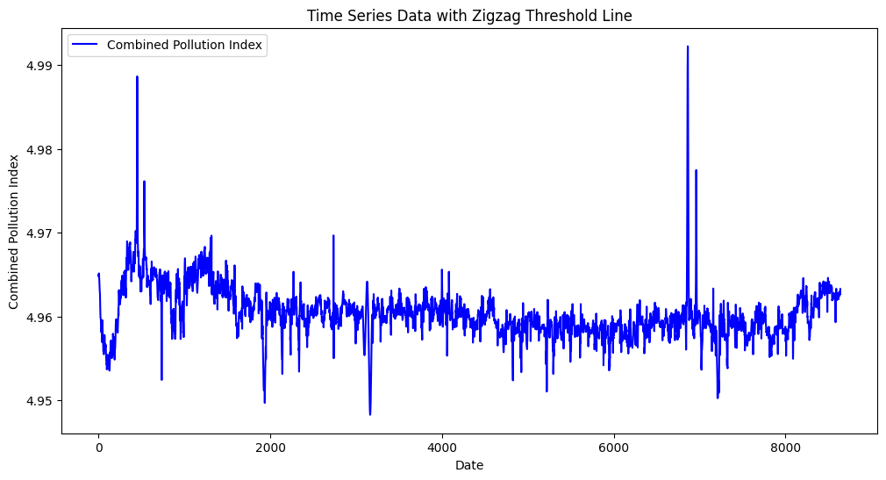

And the QQ Plot: From this QQ plot we observe that combined pollution index follows normal distribution quite closely, although not at the boundaries.

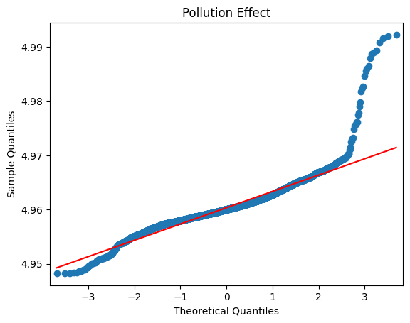

After this in order to find blast trigger times across all months, we averaged the values of combined pollution index and averaged them over various time intervals and checked where we get the highest value of pollution index and the histogram we observed is:

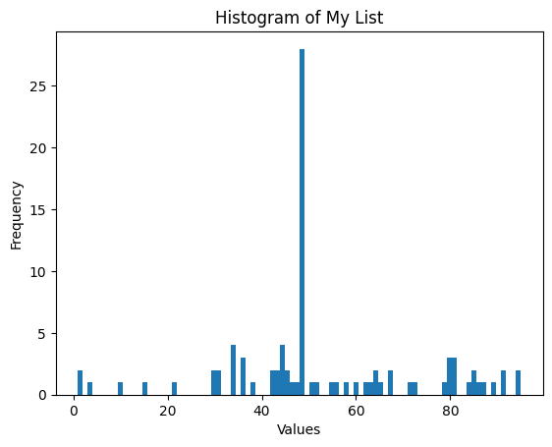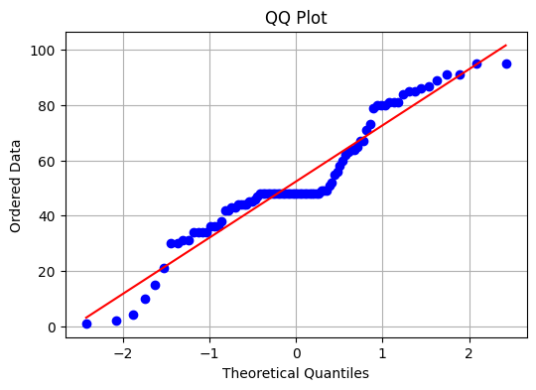

In the x-axis, the number we see are the indexes of time stamps. For example: 0 for 00:00, 48 for 12:00 etc. And the code used to get above graph is:

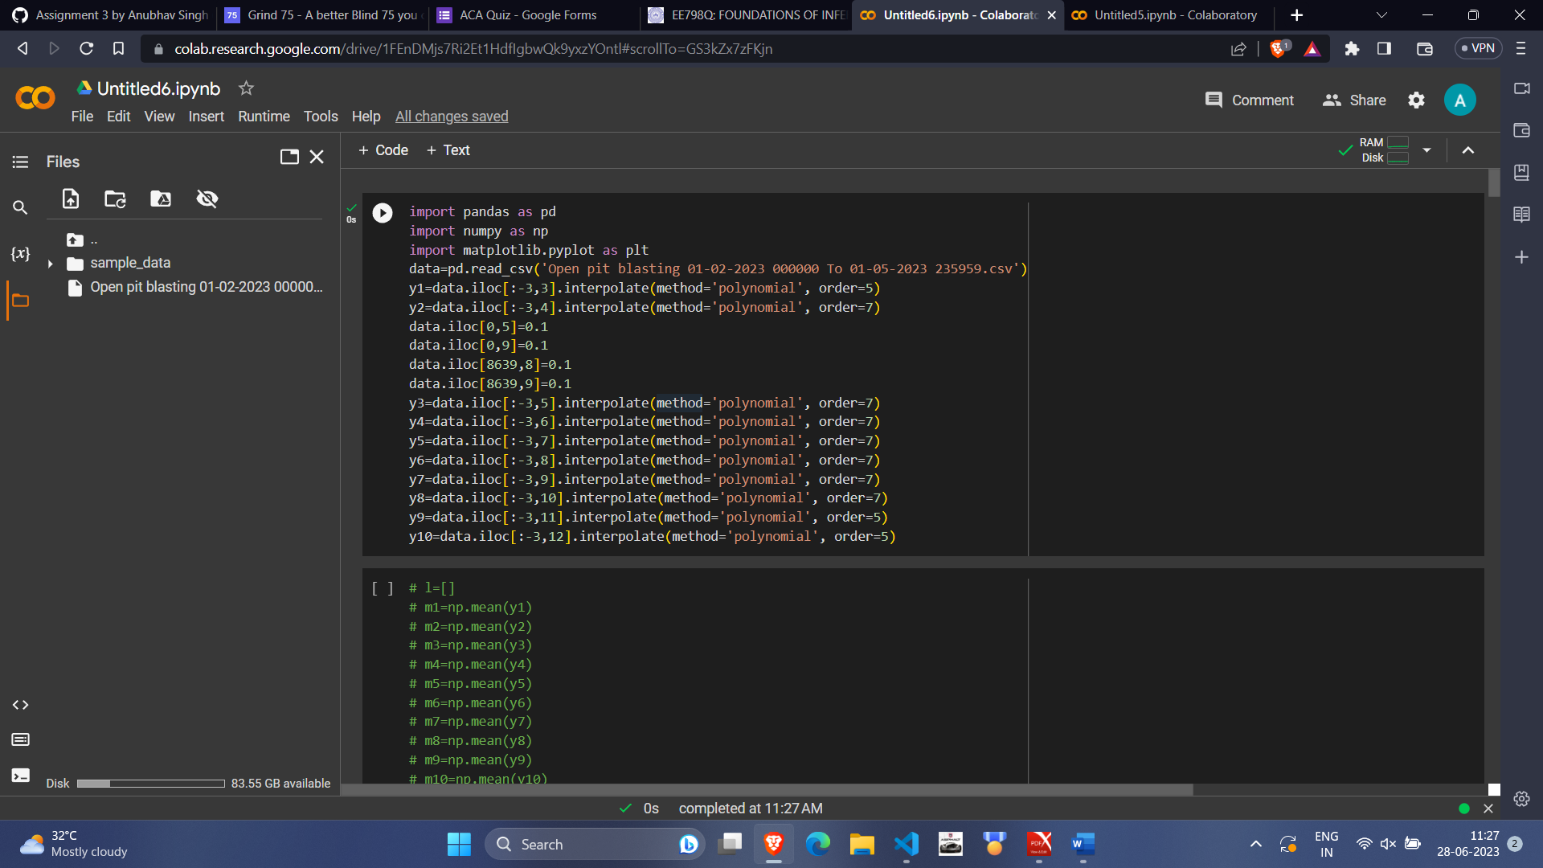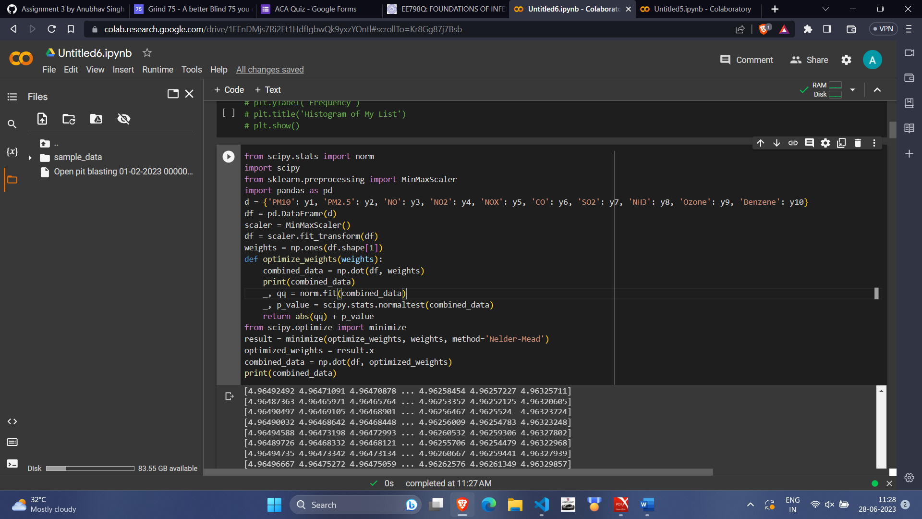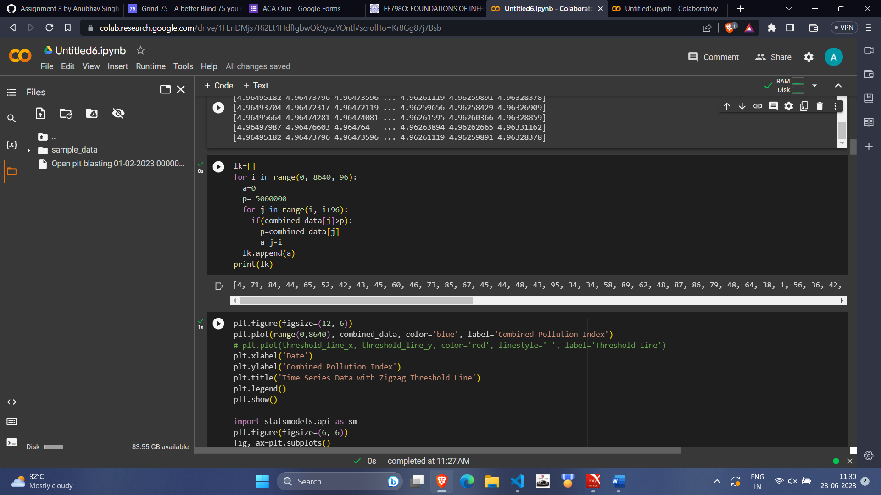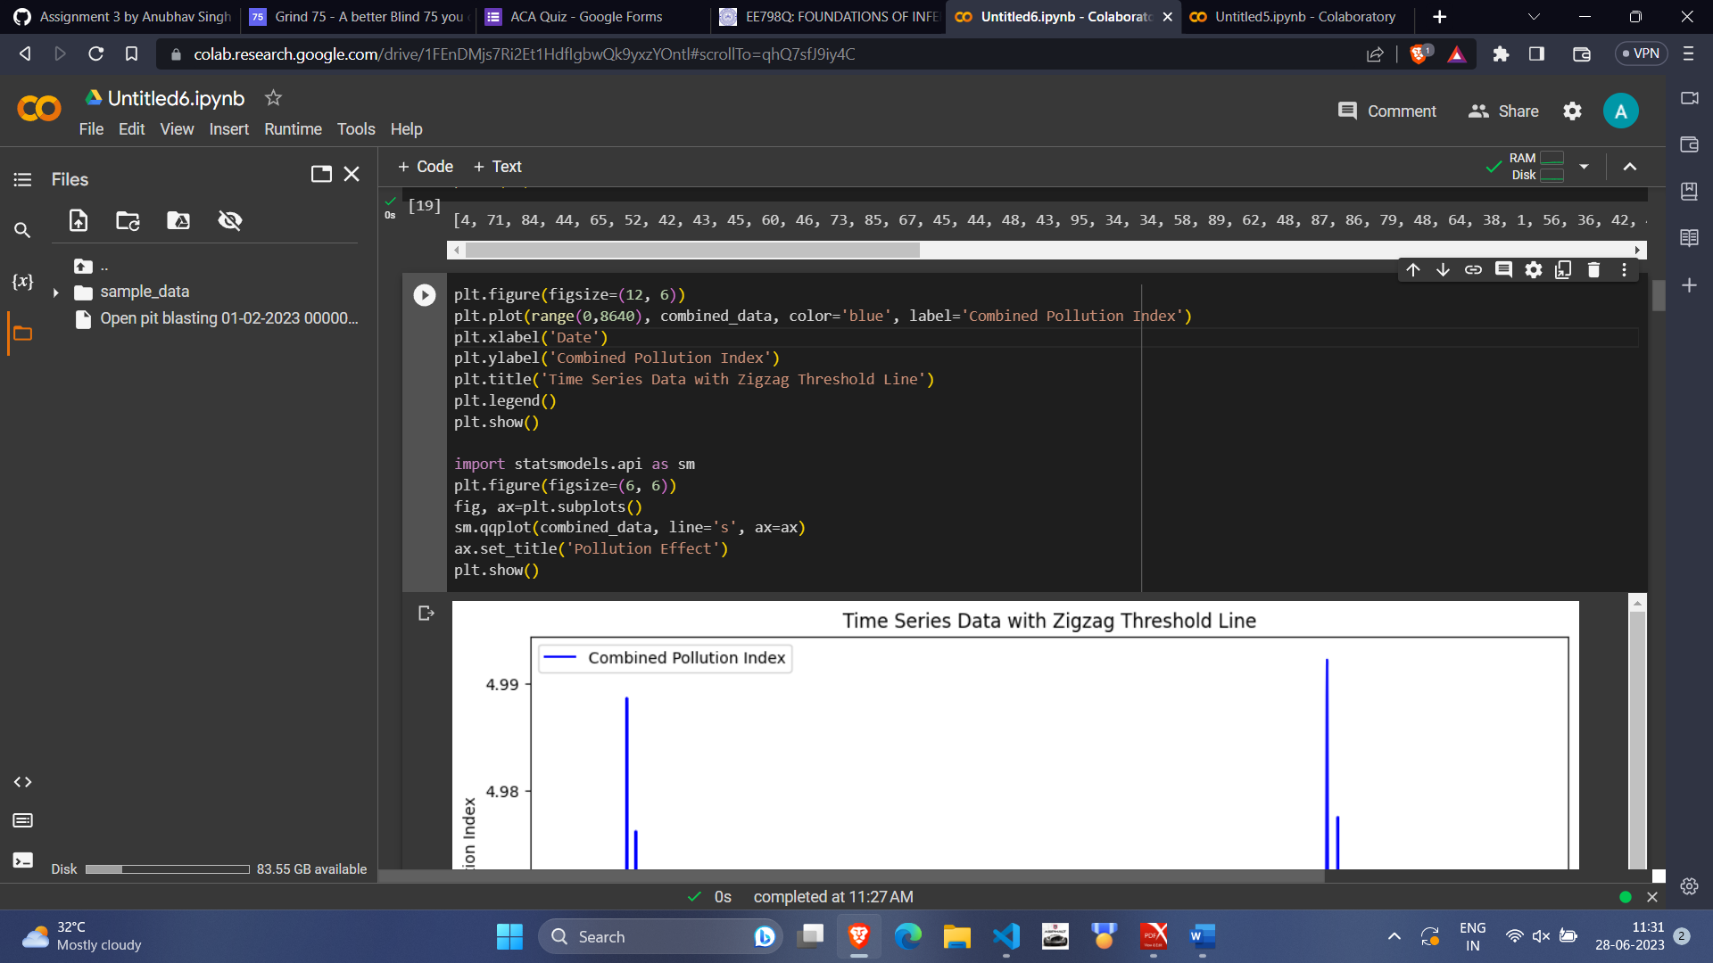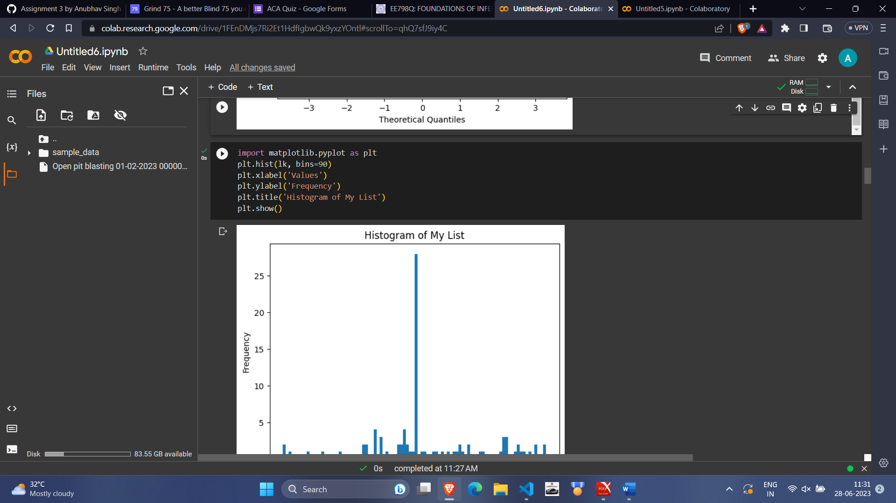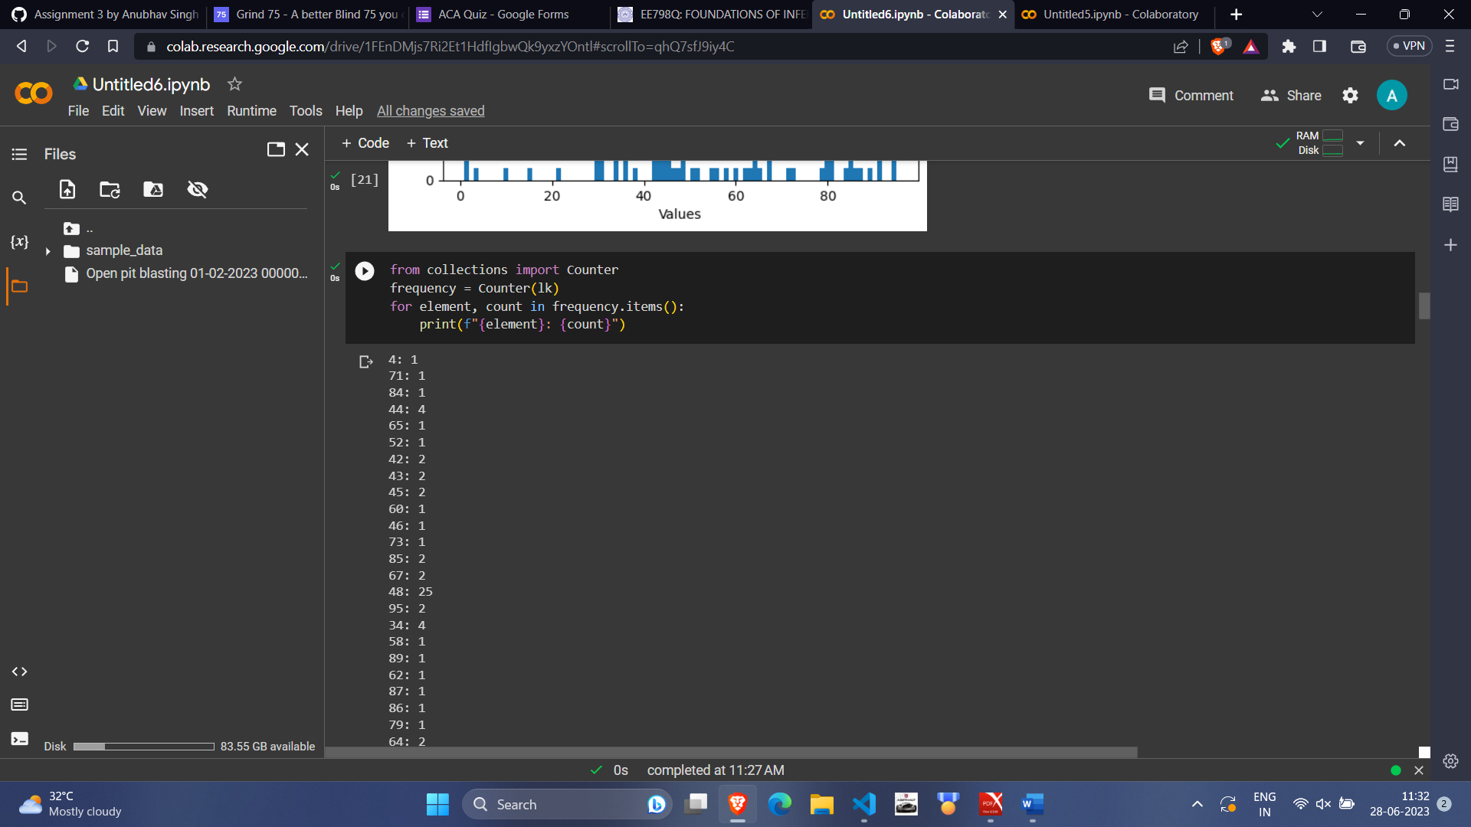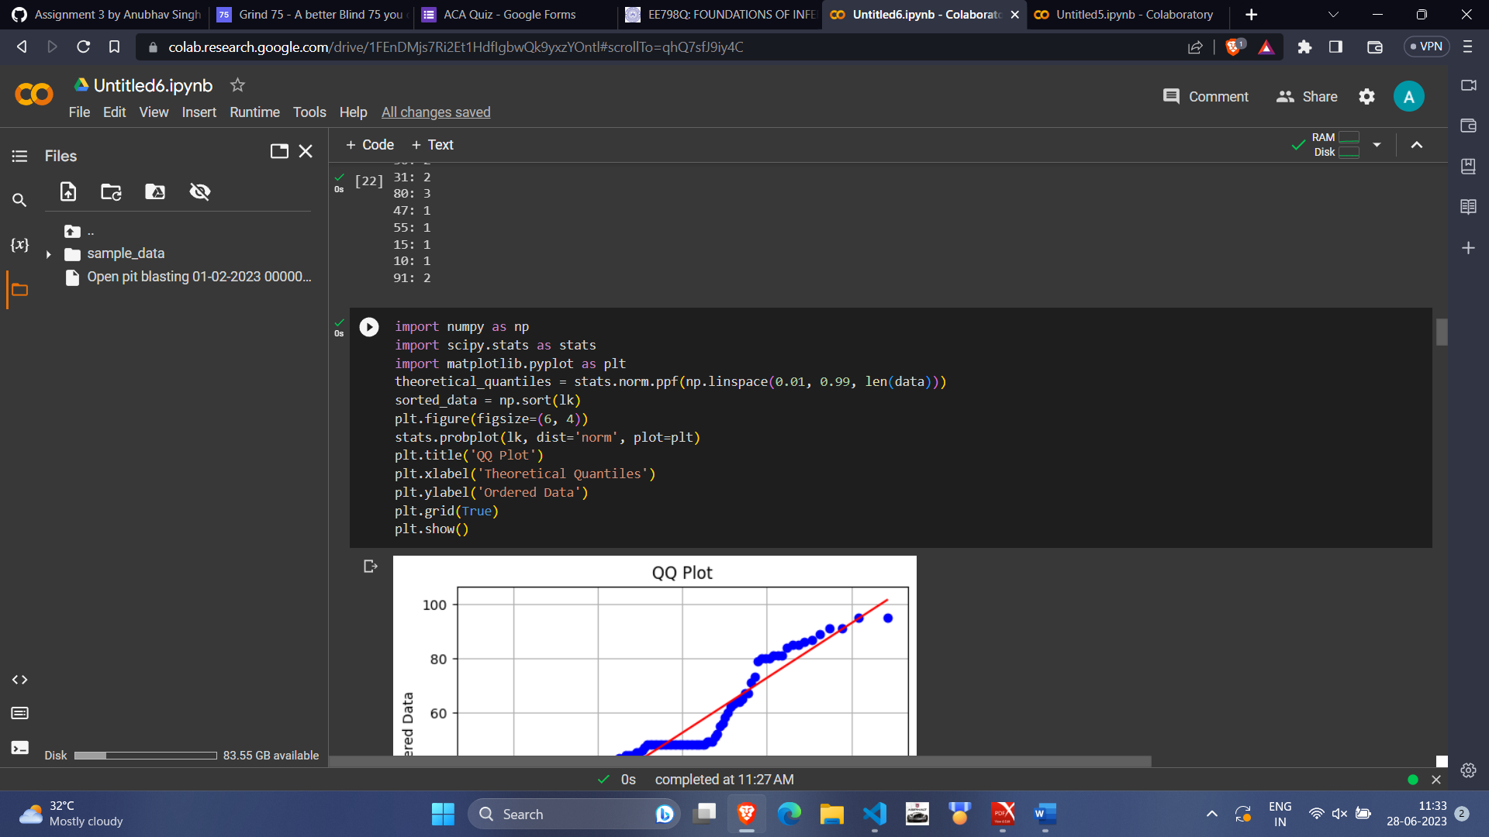

Thus, from the above graph we observe that the highest times a max pollution value is observed is around 12:00 in noon on an average day. This is due to adjusting the weights in such a way that it follows a standard normal distribution. Therefore, we can get true values by adjusting and shifting the mean from 12:00 to 14:00. Also, from the graph we observe number of max values at different times as follows:

12:00-25, 12:15-3, 12:45-1, 13:00-1, 13:45-1, 14:00-1, 14:30-1, 15:00-1

Now, taking into account the errors due to interpolation and missing values, we take blasting frequencies between 13:45-14:45 to be the sum of above values, which is 34.

Now, accounting for the probability of blasting at 14:15-14:30, we take value in this range to be between 12 and 15, then probability for 90 days comes out to be between 12/90 to 15/90.

For February: we observe that blasting time is around 12:30-1:30 and the graphs for this:

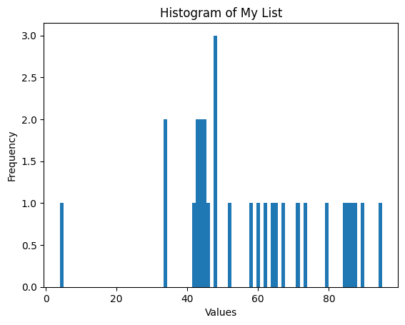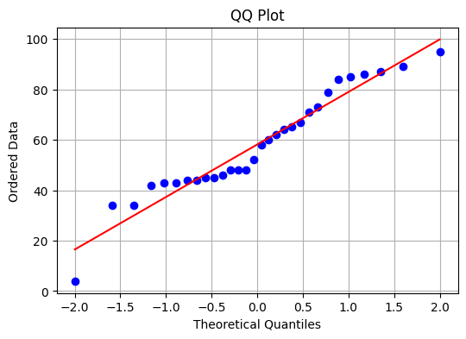

For March: we observe that blasting time is around 13:30-14:30 and the graphs for this:

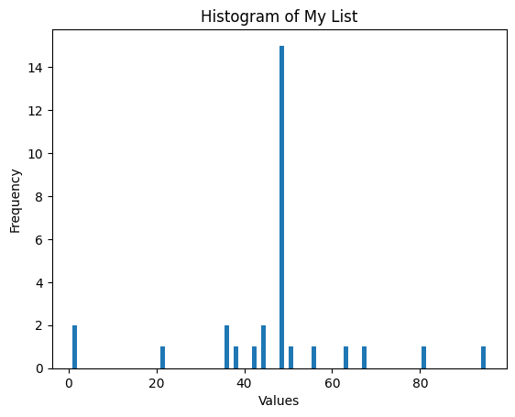 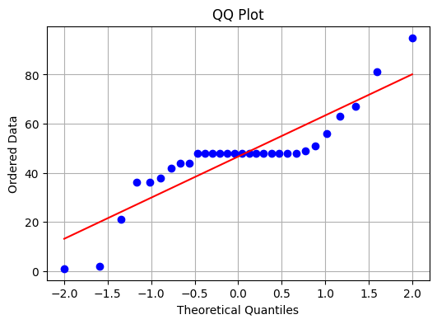

For April: we observe that blasting time is around 13:30-14:30 and the graphs for this:

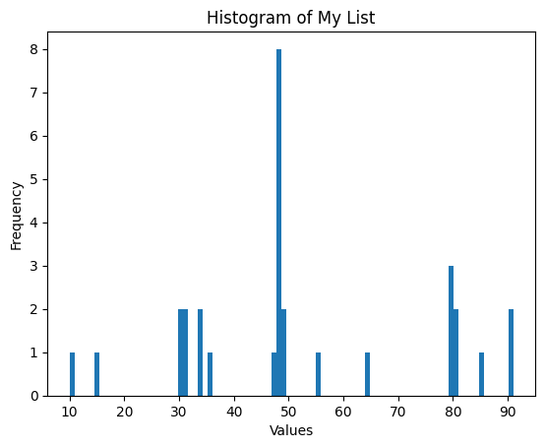 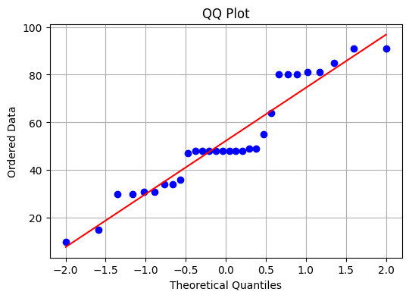

**Curve Fitting:**

**Parametric:** It consists of three types of curves: Linear, Exponential and Logistic functions. Combined graph for them:

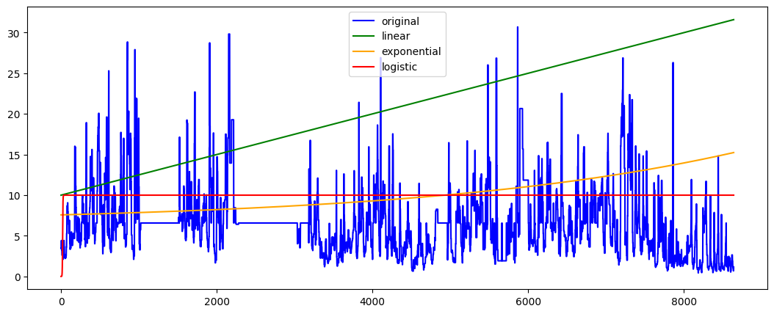

**Non-Parametric:**

1. **Decision Tree Regressor:**

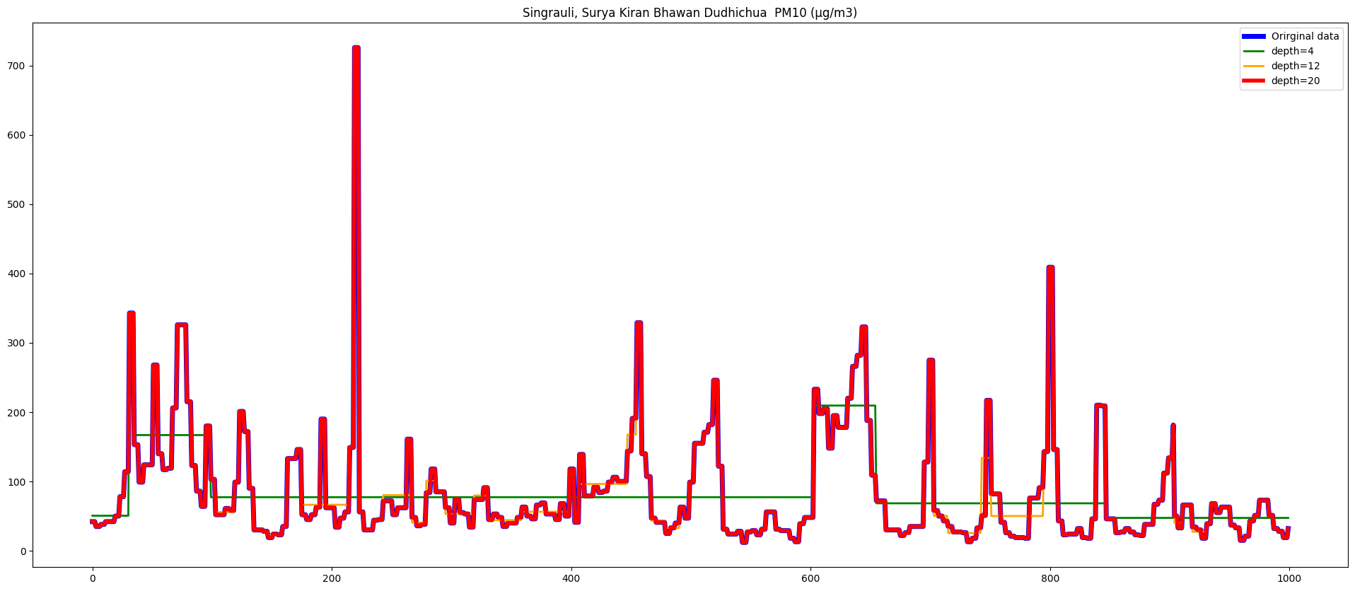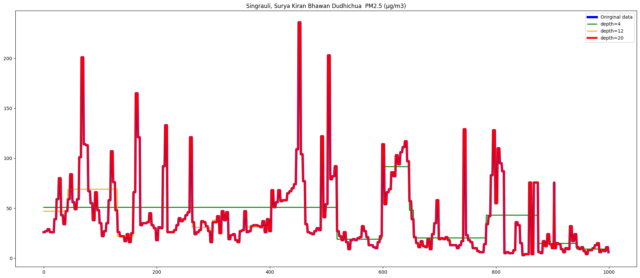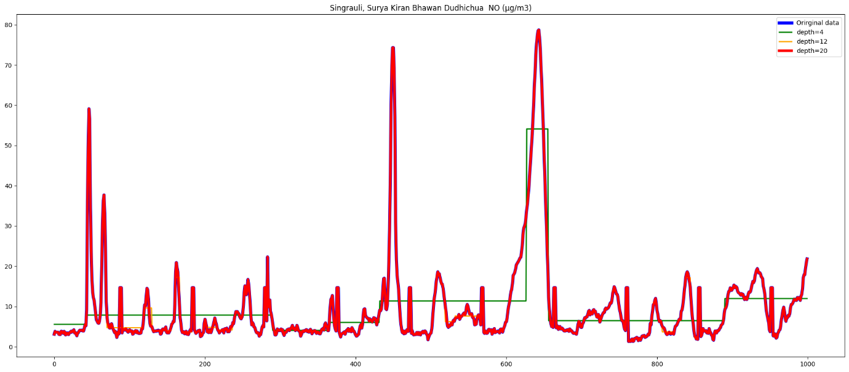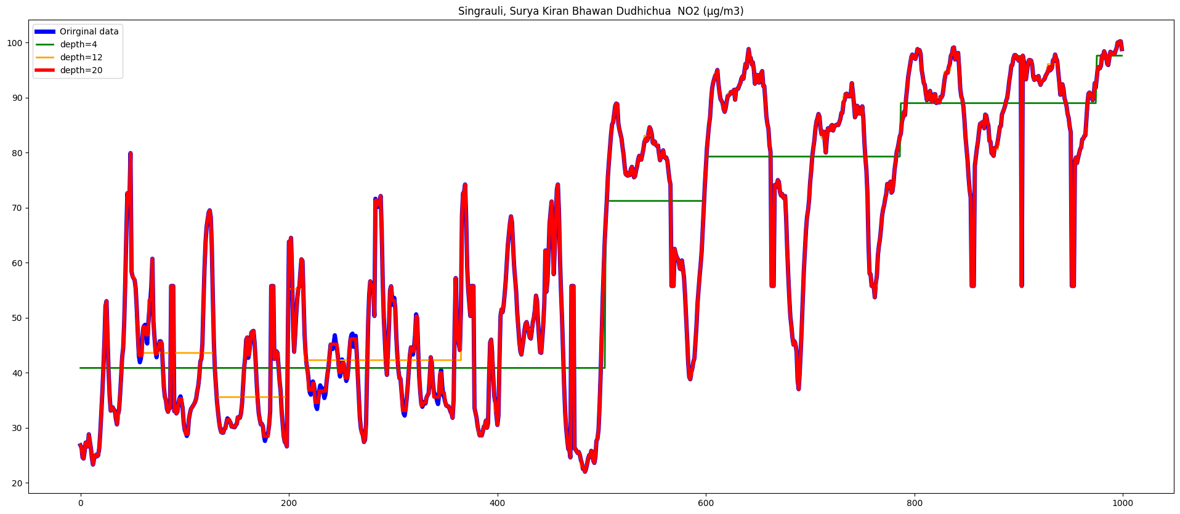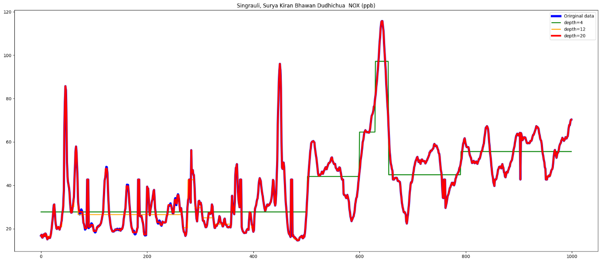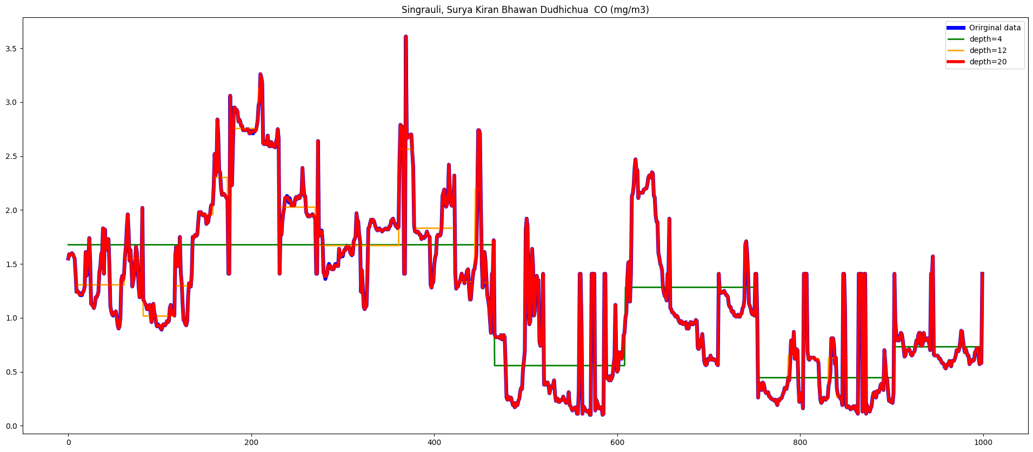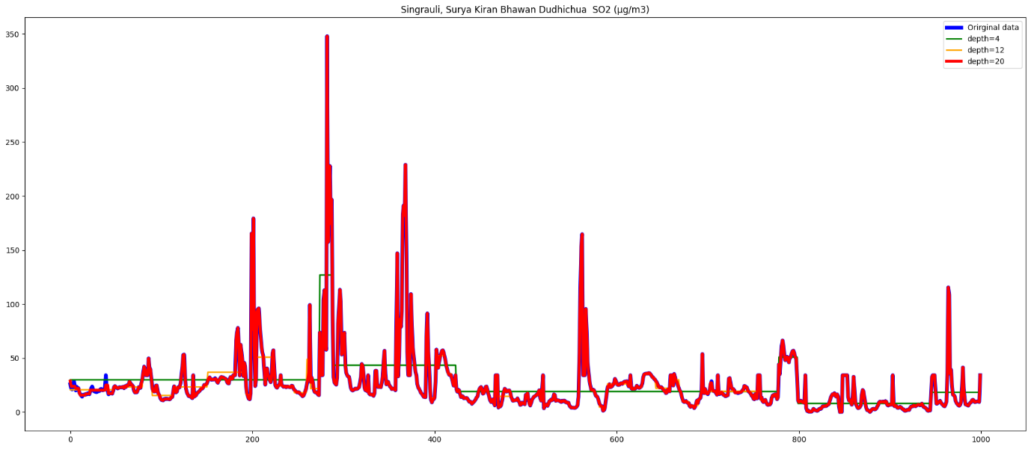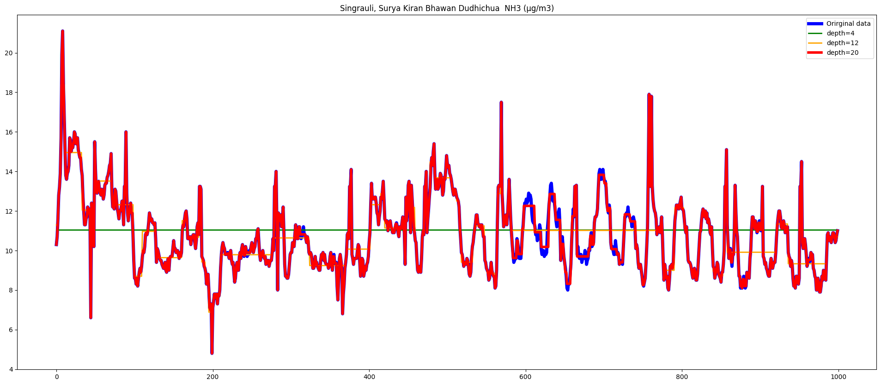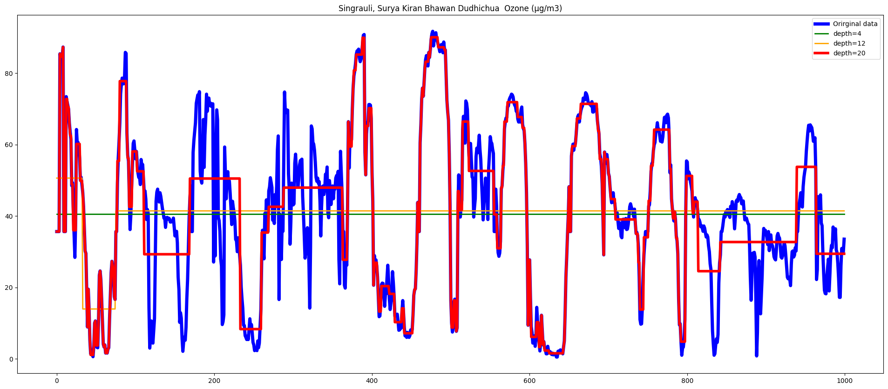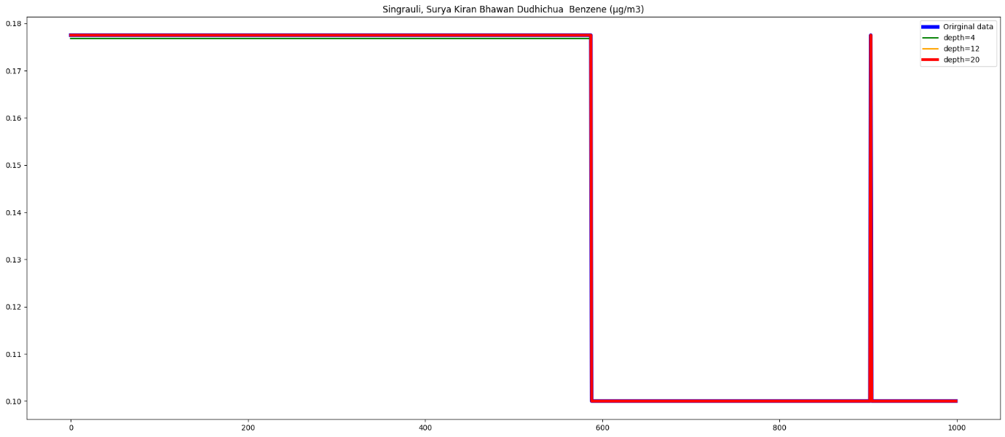

1. **K Nearest Neighbor Regressor:**

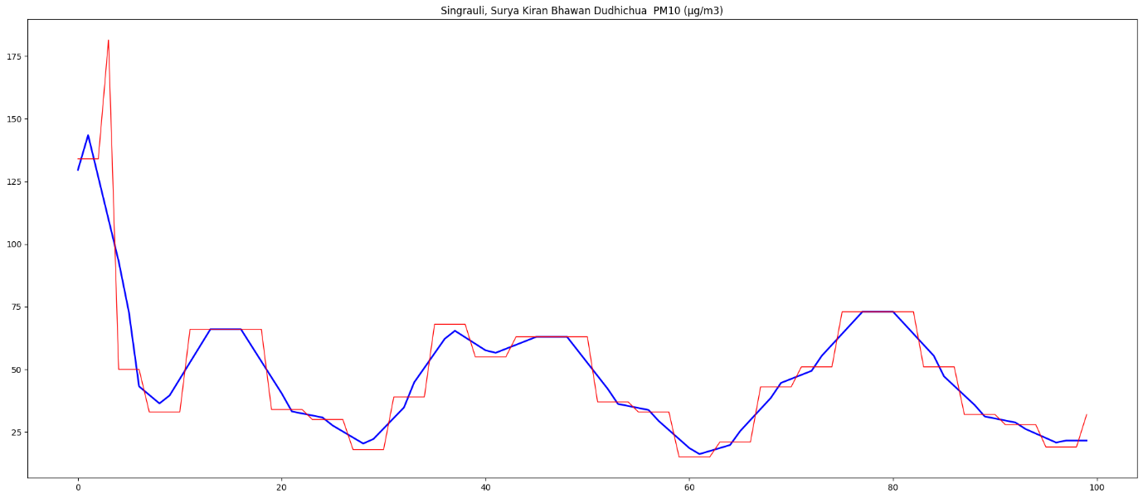

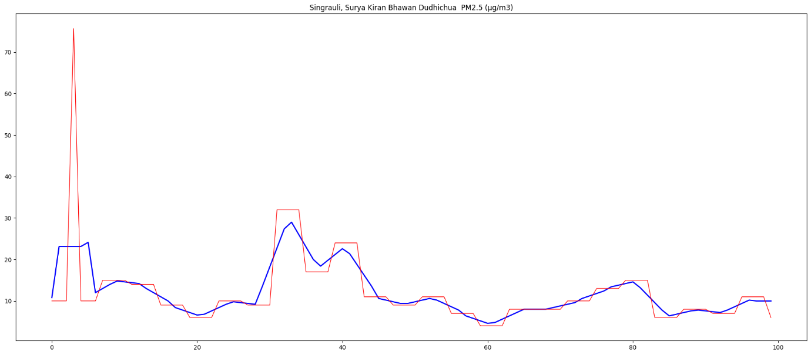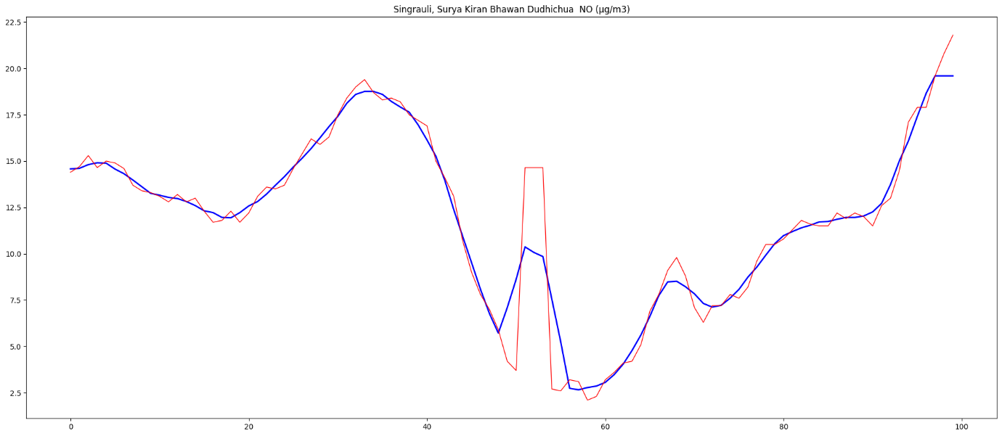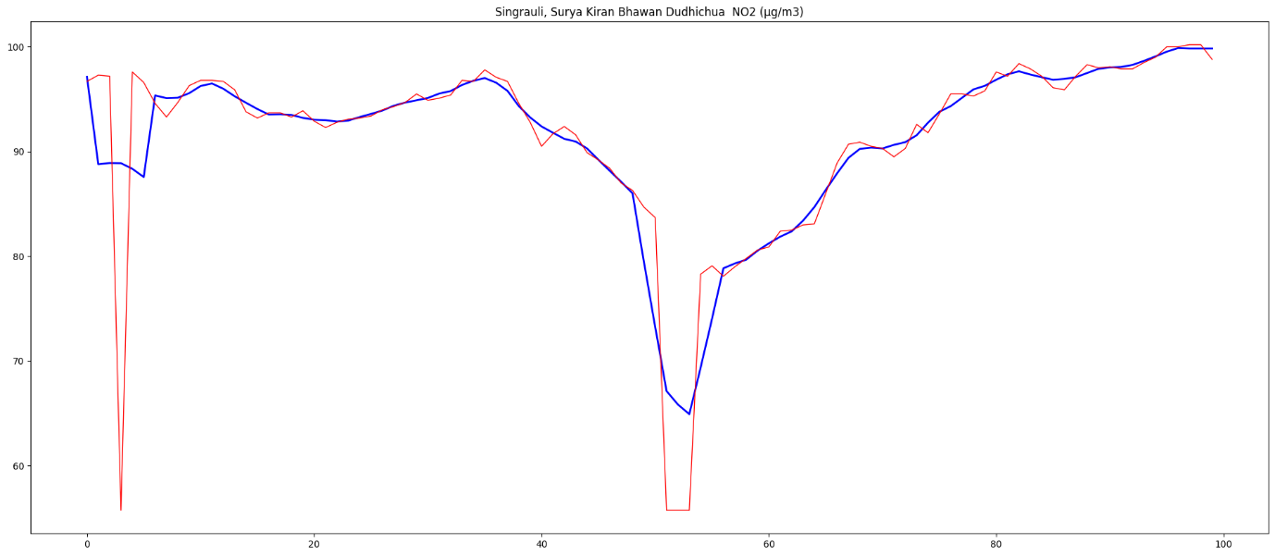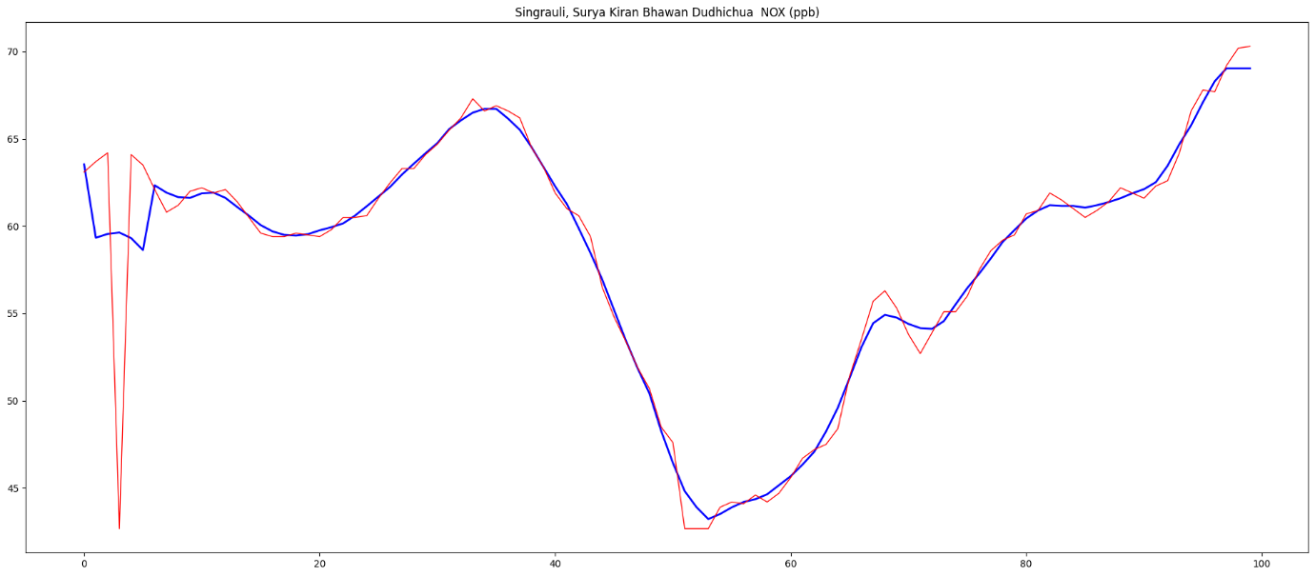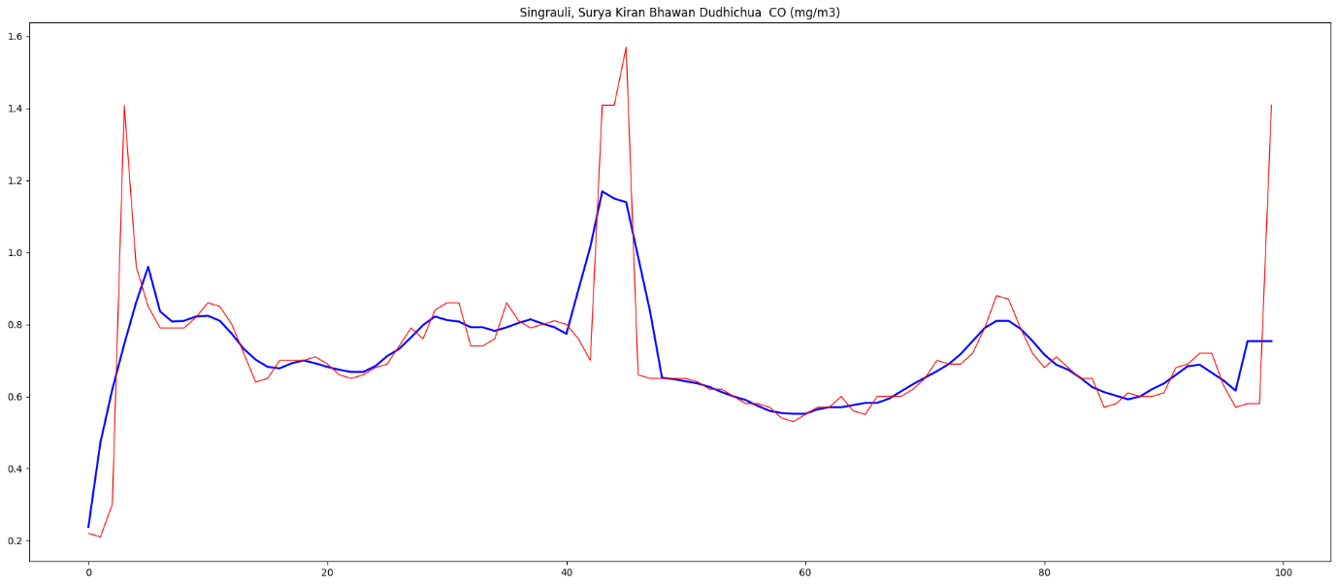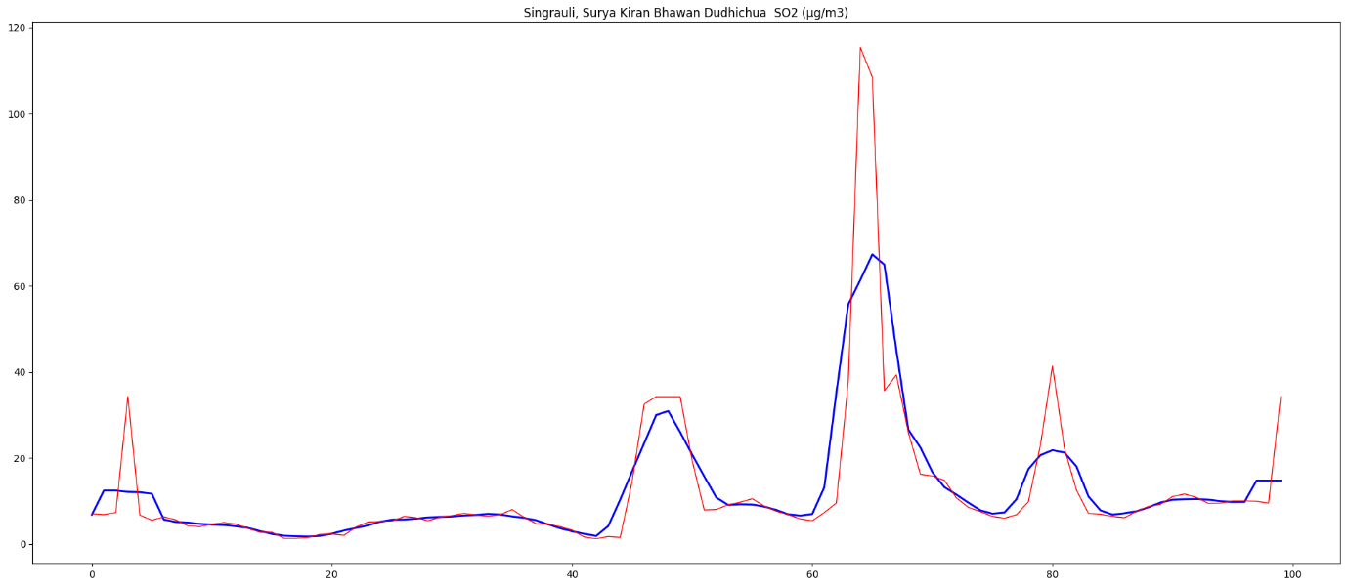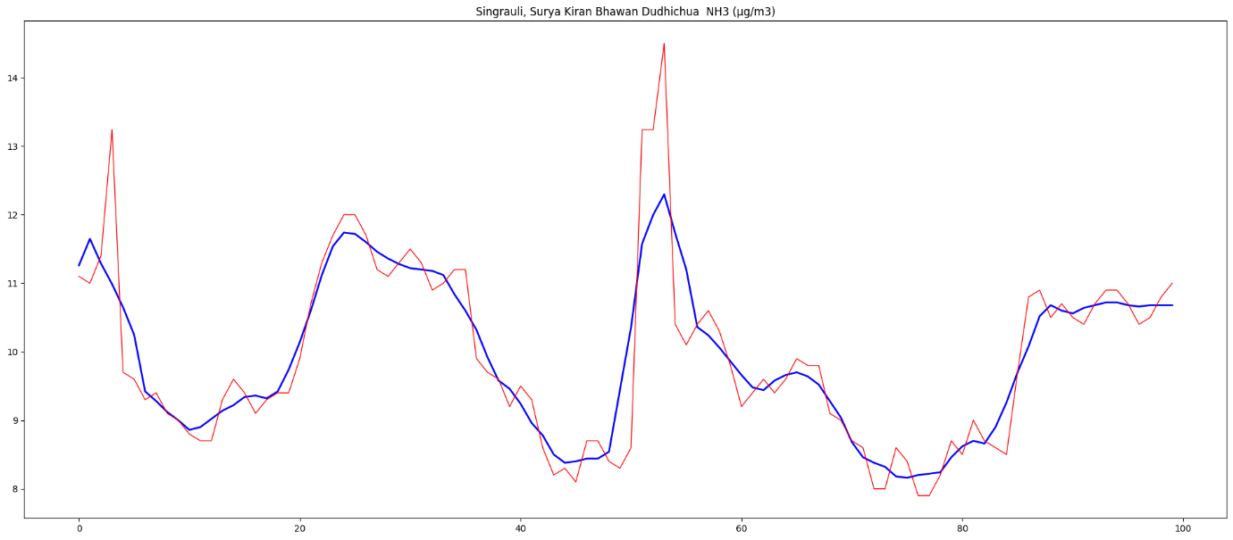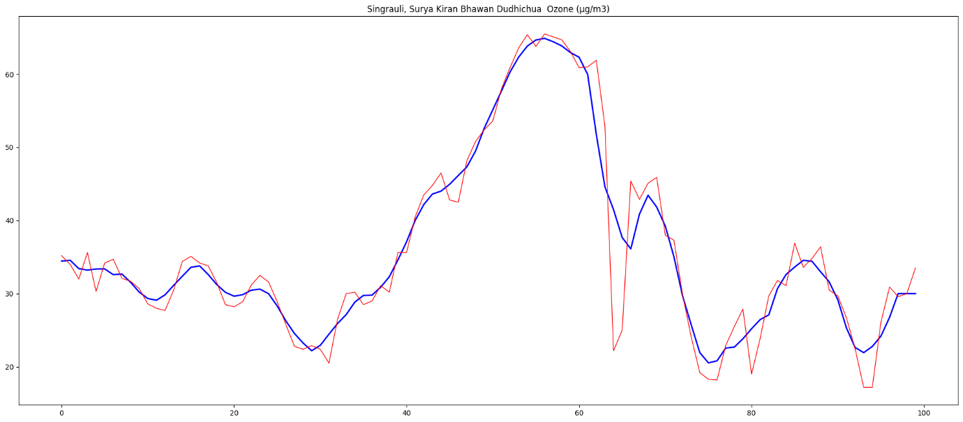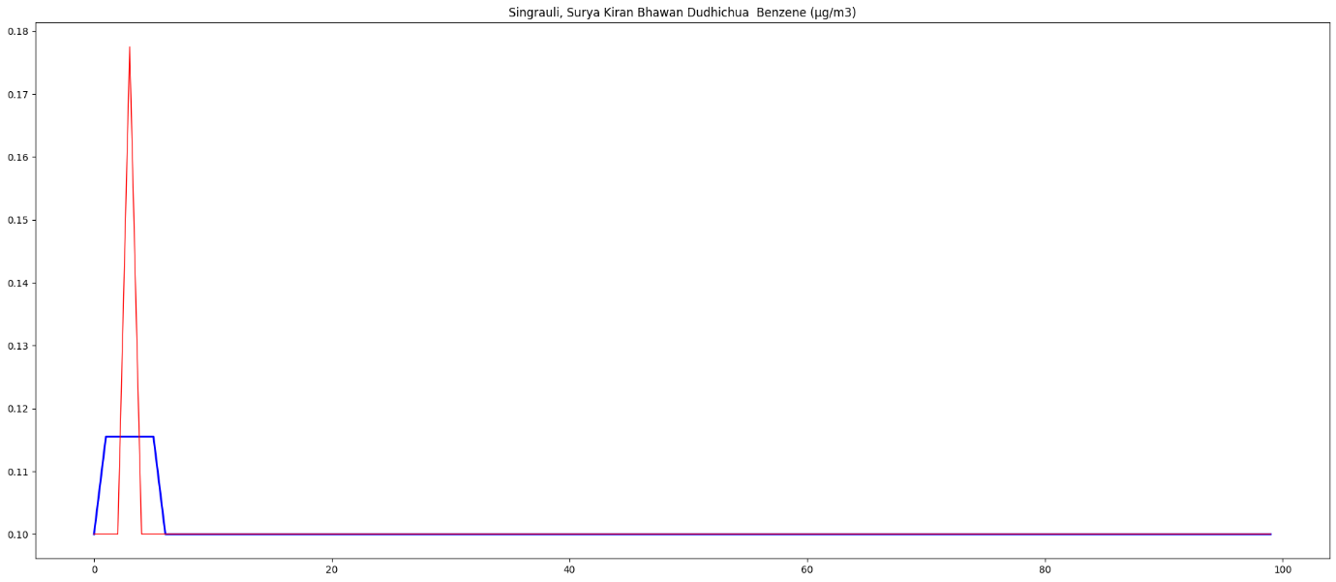

**Forecasting:** Predicting future values, here we have taken last 100 values:

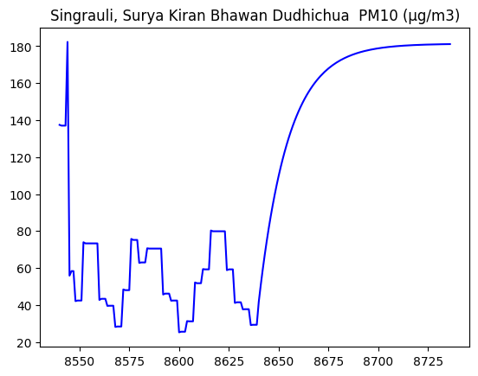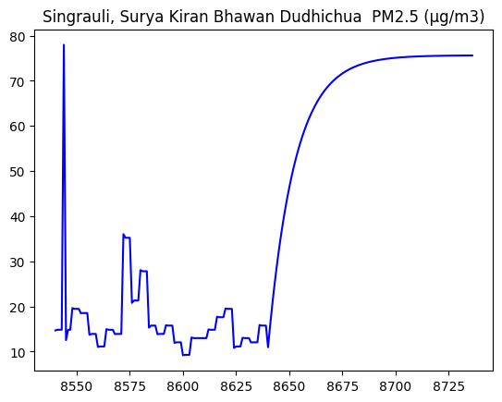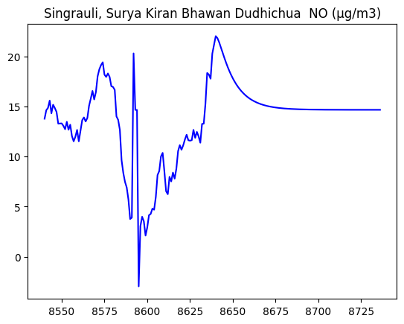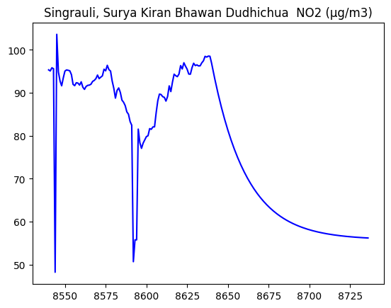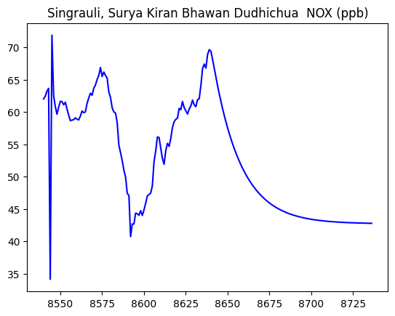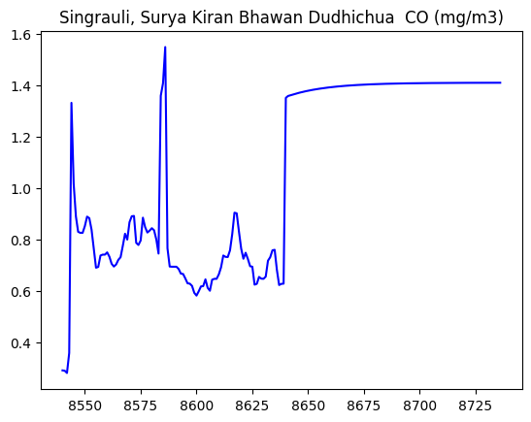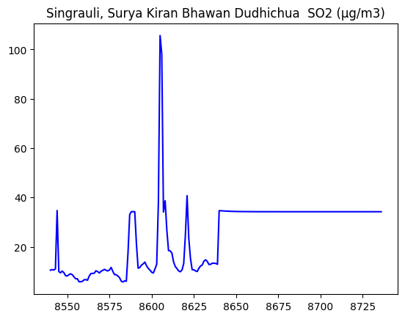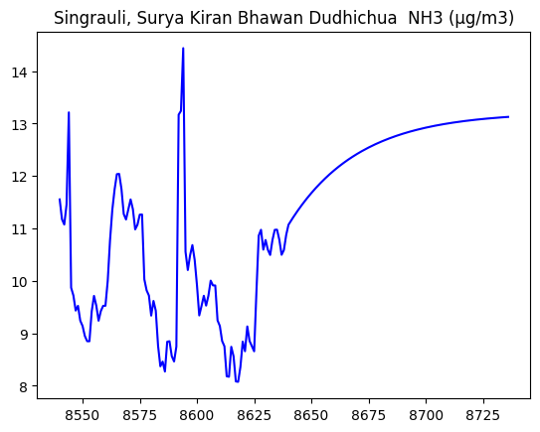

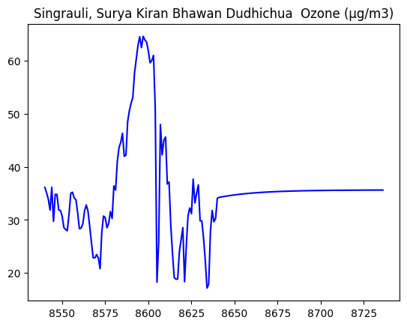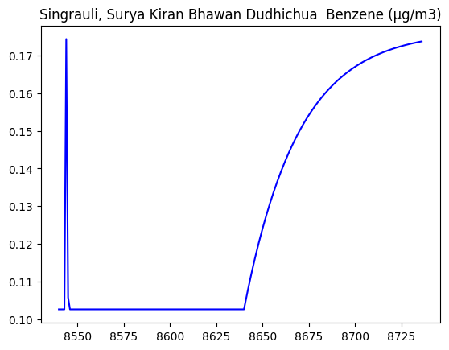

**Descriptive Analysis:**

|  |  |  |  |  |  |  |  |  |  |  |  |
| --- | --- | --- | --- | --- | --- | --- | --- | --- | --- | --- | --- |
|  | # | PM10 | PM2.5 | NO | NO2 | NOX | CO | SO2 | NH3 | Ozone | `Benzene |
| count | 8643 | 6962 | 8417 | 7274 | 8227 | 8228 | 8147 | 7192 | 8317 | 8190 | 2448 |
| mean | 4322 | 181.47995 | 75.729083 | 14.667274 | 55.756492 | 42.682434 | 1.408695 | 34.312991 | 13.247534 | 35.632958 | 0.177647 |
| std | 2495.163522 | 136.235742 | 55.41145 | 19.291029 | 20.244845 | 22.475811 | 0.631759 | 40.099306 | 6.17423 | 27.03416 | 0.099215 |
| min | 1 | 12 | 3 | 0.1 | 0.2 | 4.2 | 0.1 | 0.1 | 4.6 | 0.1 | 0.1 |
| 25% | 2161.5 | 84 | 36 | 3.9 | 39.4 | 25 | 0.95 | 16.1 | 9.4 | 10.5 | 0.1 |
| 50% | 4322 | 145 | 61 | 6.1 | 53.2 | 37.7 | 1.42 | 25.3 | 11 | 32.4 | 0.1 |
| 75% | 6482.5 | 238 | 101 | 16.5 | 71.05 | 53.8 | 1.85 | 35.2 | 14 | 58.8 | 0.2 |
| max | 8643 | 847 | 474 | 157.5 | 106.9 | 165.2 | 4 | 645.6 | 62.4 | 123.8 | 0.6 |

**Explanatory Analysis:** We were provided a dataset of several air contaminants, all of which are known to interact and relate to one another in different ways. Understanding these connections would make it easier to understand the causes and consequences of air pollution caused by India's coal blasting.

The small solid or liquid particles suspended in the air are referred to as particulate matter (PM10 and PM2.5). These particles may come from a number of sources, including the burning of coal. Particulate matter is released during coal blasting as a result of the mechanical action of breaking and crushing coal.

When coal is burned, gaseous pollutants such NO, NO2, NOX, CO, SO2, NH3, and Benzene are created. When nitrogen in the air combines with oxygen at a high temperature, nitrogen oxides (NOx), also known as NO and NO2, are created. The result of incomplete combustion is CO. When the Sulphur in the coal combines with the oxygen, SO2 is produced. In addition to NH3, benzene can also be released when burning coal.

These contaminants are released when coal is blasted, which adds to overall air pollution. These gaseous pollutants can be carried by the particulate matter (PM10 and PM2.5), which causes their dispersion in the atmosphere. As a result of chemical interactions, secondary pollutants like ozone (O3), a dangerous component of smog, can be created.

The consequences of air pollution brought on by coal blasting may be extensive. By entering the respiratory system and triggering respiratory and cardiovascular issues, particulate matter can directly affect one's health. Gaseous pollutants including NOx, CO, and SO2 can cause respiratory problems as well as contribute to the creation of acid rain. A volatile organic compound (VOC) known to cause cancer is benzene.

In conclusion, coal blasting in India causes air pollution by producing gaseous and particle pollutants that are linked to one another. For the purpose of creating efficient pollution control measures and reducing the negative environmental effects of coal-related activities, it is imperative to comprehend these linkages and their effects on air quality and human health.